**ESCUELA NORMAL DE EDUCACIÓN PREESCOLAR**

**ENGLISH B1.2**

**UNIT 7 PROJECT**

**USE YOUR VOTE!**

**Lucero de Lourdes García Vela**

**María Paula Gonzalez Valdez**

**Ana Cecilia Villanueva García**

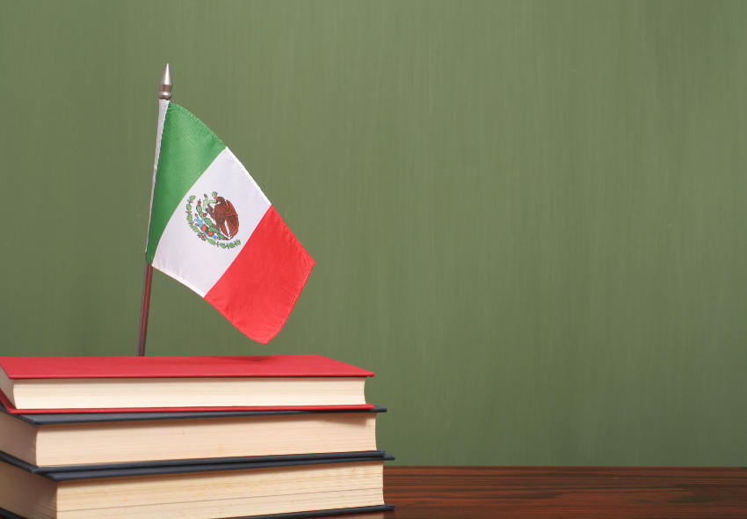

**Aim of the project:**

Give students practice discussing problems and using infinitive clauses and phrases.

This activity will be done in the TEAMS assigned by the teacher.

**Preparation:**

* Visit the following websites and analyze the information about the main problems in Mexico’s educational system.
* <https://www.milenio.com/politica/sep-identifica-seis-problemas-en-sistema-educativo>
* <http://trazandoelrumbo.ibero.mx/la-problematica-persistente-de-la-educacion-en-mexico/#:~:text=El%20acceso%20a%20la%20escuela,han%20concluido%20su%20educaci%C3%B3n%20b%C3%A1sica>.
* <https://merida.anahuac.mx/posgrado/blog/problemas-del-sistema-educativo-en-mexico-y-sus-posibles-soluciones>
* <https://wenr.wes.org/2019/05/education-in-mexico-2>

**Development:**

* Imagine you will elect a Minister of Education for your country. Decide who will be the candidate. Then assign each student a job for the campaign.

Minister of Education (candidate): Cecilia Villanueva

Campaign Manager: Maria Paula Gonzalez

Speechwriter: Lucero de Lourdes García

* Choose the five most important problems in Mexico’s Educational System and list ways you want to improve education or schools in your country. Then write a speech explaining the improvements and how your candidate will achieve them. **Use the passive voice and prepositions to describe the problem, and infinitive clauses to discuss ways in which these problems can be solved.**

The educational reform is being criticized as result of not addressing the main pedagogical, curricular and teacher training problems. It remains to configure an educational model.

One way to change it is to talk to the members of the Secretary of Public Education to make modifications to the reform.

Education is not being guarantee to most of the citizens as result of many families, both in rural and urban communities, require all their members to perform paid work to achieve a minimum income for survival. There are remote communities, mostly indigenous, that do not have nearby educational options, so only those who have the opportunity to travel to other communities on a daily basis receive formal education. Although it is less and less frequent, in families there is still the custom of limiting the educational scope of girls, focusing efforts only on the academic preparation of boys. This has as a consequence not only the female educational lag, but also that girls present a lower performance in subjects such as mathematics and natural sciences.

Some ways to fight against this is to create a way to include preschool education in basic compulsory education, in order to facilitate access to this educational level for vulnerable populations. Propose curricular changes that encourage greater educational equity between boys and girls. Prioritize the learning of indigenous communities. Create regularization programs to combat educational backwardness. Be oriented to combat the relationship of the socio-economic level with academic achievements.

Education is also being damaged as result of the lack of equity and inclusion in education, A way to stop it is to get places where students in Mexico will have equitable and inclusive educational opportunities, to influence their well-being and the development of the country.

A lot of students are being discharged of the school programs due to the low quality of this kind of programs, one way to stop this problem is to get guarantees that students receive a quality, relevant and pertinent education in the different types, levels and modalities of the National Educational System, favoring their integral human development.

Basic needs, such as functional bathrooms and electricity in the classrooms. Educational needs such as access to computer equipment and elementary facilities for the inclusion of students with disabilities are being leaving aside by having very few economic resources for their maintenance and optimization.

A possible solution to stop the little infrastructure in Mexican schools is to get financial planning by public servants that includes not only salaries and supplies, but also the basic infrastructure needs to guarantee comfortable facilities and a much more comprehensive education.

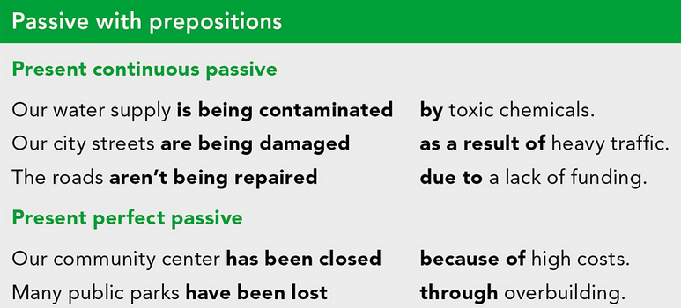

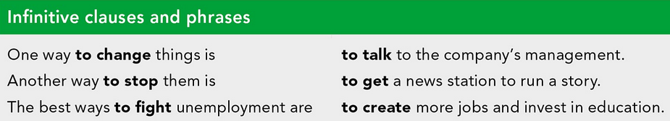

***Example:***

*The most vulnerable groups of our society* ***are not being attended******as a result of*** *the insufficient public expenditure in education and the inequality in its distribution.*

*One way* ***to improve*** *the education in México is* ***to increase*** *the public spending on education and create committees to ensure that these resources are well invested inside schools and communities.*

* Make a presentation with posters, buttons, and signs to help promote your candidate and upload a promotional video to the PADLET. Your classmates will watch your video and use their vote to choose the best Minister of Education for our country.

**Products:**

* Go to <https://padlet.com/alvaradocris87/btrml0zwovpq7dv2> and upload your **video** to the Padlet.

[**https://drive.google.com/file/d/1lRpMYQoA5WONEVQbNeMZUjjUrjgtG50x/view?usp=sharing**](https://drive.google.com/file/d/1lRpMYQoA5WONEVQbNeMZUjjUrjgtG50x/view?usp=sharing)

**DEVELOPMENT OF THE PROJECT**

**Imagine you will elect a Minister of Education for your country. Decide who will be the candidate. Then assign each student a job for the campaign.**

Minister of Education (candidate): Cecilia Villanueva

Campaign Manager: Maria Paula Gonzalez

Speechwriter: Lucero de Lourdes García

**Choose the five most important problems in Mexico’s Educational System and list ways you want to improve education or schools in your country. Then write a speech explaining the improvements and how your candidate will achieve them. Use the passive voice and prepositions to describe the problem, and infinitive clauses to discuss ways in which these problems can be solved.**

**INCLUDE YOUR SPEECH DESCRIBING THE PROBLEMS AND PROVIDING SOLUTIONS HERE:**

I am minister of education Cecilia Villanueva, candidate for the presidency next year.

As country we all know the problems that represent the low-quality education in Mexico taking us to the lowest positions in education globally.

Now I will talk about some problems that for me represent the greatest obstacle in our education.

The educational reform is being criticized as result of not addressing the main pedagogical, curricular and teacher training problems. It remains to configure an educational model.

One way to change it is to talk to the members of the Secretary of Public Education to make modifications to the reform.

Education is not being guarantee to most of the citizens as result of many families, both in rural and urban communities, require all their members to perform paid work to achieve a minimum income for survival. There are remote communities, mostly indigenous, that do not have nearby educational options, so only those who have the opportunity to travel to other communities on a daily basis receive formal education. Although it is less and less frequent, in families there is still the custom of limiting the educational scope of girls, focusing efforts only on the academic preparation of boys. This has as a consequence not only the female educational lag, but also that girls present a lower performance in subjects such as mathematics and natural sciences.

Some ways to fight against this is to create a way to include preschool education in basic compulsory education, in order to facilitate access to this educational level for vulnerable populations. Propose curricular changes that encourage greater educational equity between boys and girls. Prioritize the learning of indigenous communities. Create regularization programs to combat educational backwardness. Be oriented to combat the relationship of the socio-economic level with academic achievements.

Education is also being damaged as result of the lack of equity and inclusion in education, A way to stop it is to get places where students in Mexico will have equitable and inclusive educational opportunities, to influence their well-being and the development of the country.

A lot of students are being discharged of the school programs due to the low quality of this kind of programs, one way to stop this problem is to get guarantees that students receive a quality, relevant and pertinent education in the different types, levels and modalities of the National Educational System, favoring their integral human development.

Basic needs, such as functional bathrooms and electricity in the classrooms. Educational needs such as access to computer equipment and elementary facilities for the inclusion of students with disabilities are being leaving aside by having very few economic resources for their maintenance and optimization.

A possible solution to stop the little infrastructure in Mexican schools is to get financial planning by public servants that includes not only salaries and supplies, but also the basic infrastructure needs to guarantee comfortable facilities and a much more comprehensive education.

Remember, your vote is really important, if you want to see a difference you need to vote, to get a better future for you and your family. Voting is the way to raise your voice.

Let's generate a change as a country starting with the foundations of our education. ¡Vote for me, vote for the future of your children!

**RUBRIC**

