**ESCUELA NORMAL DE EDUCACIÓN PREESCOLAR**

**ENGLISH B1.2**

**UNIT 7 PROJECT**

**USE YOUR VOTE!**

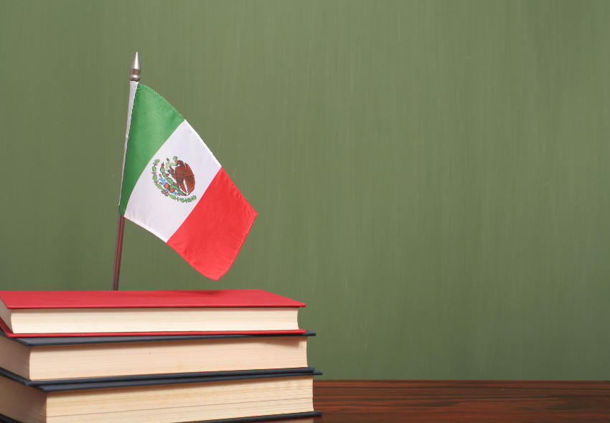

**Aim of the project:**

Give students practice discussing problems and using infinitive clauses and phrases.

This activity will be done in the TEAMS assigned by the teacher.

**Preparation:**

* Visit the following websites and analyze the information about the main problems in Mexico’s educational system.
* <https://www.milenio.com/politica/sep-identifica-seis-problemas-en-sistema-educativo>
* <http://trazandoelrumbo.ibero.mx/la-problematica-persistente-de-la-educacion-en-mexico/#:~:text=El%20acceso%20a%20la%20escuela,han%20concluido%20su%20educaci%C3%B3n%20b%C3%A1sica>.
* <https://merida.anahuac.mx/posgrado/blog/problemas-del-sistema-educativo-en-mexico-y-sus-posibles-soluciones>
* <https://wenr.wes.org/2019/05/education-in-mexico-2>

**Development:**

* Imagine you will elect a Minister of Education for your country. Decide who will be the candidate. Then assign each student a job for the campaign.

Minister of Education (candidate): Daniela Vazquez

Campaign Manager: Susana Rosas

Speechwriter: ___________________________________________

* Choose the five most important problems in Mexico’s Educational System and list ways you want to improve education or schools in your country. Then write a speech explaining the improvements and how your candidate will achieve them. **Use the passive voice and prepositions to describe the problem, and infinitive clauses to discuss ways in which these problems can be solved.**

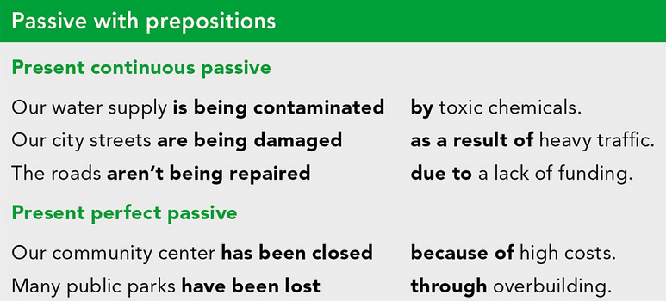

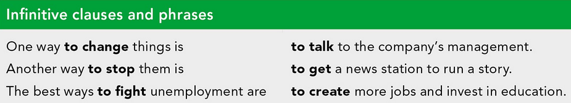

***Example:***

*The most vulnerable groups of our society* ***are not being attended******as a result of*** *the insufficient public expenditure in education and the inequality in its distribution.*

*One way* ***to improve*** *the education in México is* ***to increase*** *the public spending on education and create committees to ensure that these resources are well invested inside schools and communities.*

* Make a presentation with posters, buttons, and signs to help promote your candidate and upload a promotional video to the PADLET. Your classmates will watch your video and use their vote to choose the best Minister of Education for our country.

**Products:**

* Go to <https://padlet.com/alvaradocris87/btrml0zwovpq7dv2> and upload your **video** to the Padlet.

**DEVELOPMENT OF THE PROJECT**

**Imagine you will elect a Minister of Education for your country. Decide who will be the candidate. Then assign each student a job for the campaign.**

Minister of Education (candidate): Daniela Vazquez

Campaign Manager: Susana Rosas

Speechwriter: ___________________________________________

**Choose the five most important problems in Mexico’s Educational System and list ways you want to improve education or schools in your country. Then write a speech explaining the improvements and how your candidate will achieve them. Use the passive voice and prepositions to describe the problem, and infinitive clauses to discuss ways in which these problems can be solved.**

**INCLUDE YOUR SPEECH DESCRIBING THE PROBLEMS AND PROVIDING SOLUTIONS HERE:**

Our country has been damaged due to inequality, girls, boys and young people in disadvantaged situations are those who have less access to school and those who experience the phenomenon of school dropout with more intensity.

The best way to fight this problema is to:

• Invest in early childhood development and early education for girls, boys and their families.

• Open more public schools, as this helps guarantee the right to education for all our young people.

• Expand educational opportunities, to consolidate the fight against school dropouts.

Advancing towards greater educational equity is only possible if equality of opportunities is ensured, only an education adjusted to the needs of each one will ensure that all people have the same opportunities to make their rights effective and achieve the porpuse of education in adequate conditions of equality.

Many students in México are being affected by poor educacional quality. With the results of the last PISA test we observe that Mexico has a score below the minimum in all areas (mathematics, science and reading comprehension).

One thing yo do is to provide teachers with options for continuous updating and training opportunities, from complementary courses to postgraduate courses relevant to their teaching areas and pedagogical techniques.

Education is the key to achieving many other Sustainable Development Goals; When people can access quality education, they can escape the cycle of poverty. Thus, education contributes to reducing inequalities and achieving gender equality.

**RUBRIC**

