**ESCUELA NORMAL DE EDUCACIÓN PREESCOLAR**

**ENGLISH B1.2**

**UNIT 7 PROJECT**

**USE YOUR VOTE!**

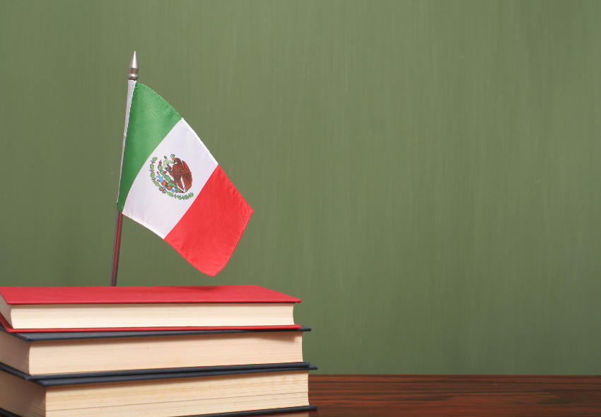

**Aim of the project:**

Give students practice discussing problems and using infinitive clauses and phrases.

This activity will be done in the TEAMS assigned by the teacher.

**Preparation:**

* Visit the following websites and analyze the information about the main problems in Mexico’s educational system.
* <https://www.milenio.com/politica/sep-identifica-seis-problemas-en-sistema-educativo>
* <http://trazandoelrumbo.ibero.mx/la-problematica-persistente-de-la-educacion-en-mexico/#:~:text=El%20acceso%20a%20la%20escuela,han%20concluido%20su%20educaci%C3%B3n%20b%C3%A1sica>.
* <https://merida.anahuac.mx/posgrado/blog/problemas-del-sistema-educativo-en-mexico-y-sus-posibles-soluciones>
* <https://wenr.wes.org/2019/05/education-in-mexico-2>

**Development:**

* Imagine you will elect a Minister of Education for your country. Decide who will be the candidate. Then assign each student a job for the campaign.

Minister of Education (candidate):

Campaign Manager:

Speechwriter:

* Choose the five most important problems in Mexico’s Educational System and list ways you want to improve education or schools in your country. Then write a speech explaining the improvements and how your candidate will achieve them. **Use the passive voice and prepositions to describe the problem, and infinitive clauses to discuss ways in which these problems can be solved.**

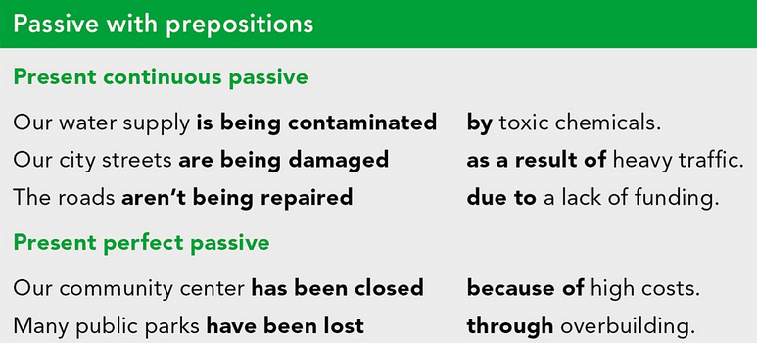

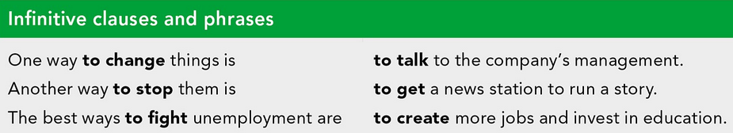

***Example:***

*The most vulnerable groups of our society* ***are not being attended******as a result of*** *the insufficient public expenditure in education and the inequality in its distribution.*

*One way* ***to improve*** *the education in México is* ***to increase*** *the public spending on education and create committees to ensure that these resources are well invested inside schools and communities.*

* Make a presentation with posters, buttons, and signs to help promote your candidate and upload a promotional video to the PADLET. Your classmates will watch your video and use their vote to choose the best Minister of Education for our country.

**Products:**

* Go to <https://padlet.com/alvaradocris87/btrml0zwovpq7dv2> and upload your **video** to the Padlet.

**DEVELOPMENT OF THE PROJECT**

**Imagine you will elect a Minister of Education for your country. Decide who will be the candidate. Then assign each student a job for the campaign.**

Minister of Education (candidate): ____________________________________

Campaign Manager: ______________________________________

Speechwriter: ___________________________________________

**Choose the five most important problems in Mexico’s Educational System and list ways you want to improve education or schools in your country. Then write a speech explaining the improvements and how your candidate will achieve them. Use the passive voice and prepositions to describe the problem, and infinitive clauses to discuss ways in which these problems can be solved.**

**INCLUDE YOUR SPEECH DESCRIBING THE PROBLEMS AND PROVIDING SOLUTIONS HERE:**

**1. Educational inequality**

One educational problem in Mexico is the inequality in access to education, which is more common in rural areas but not leaving urban areas out of this problem.

One way is the budget for education to focus on the most vulnerable population sectors.

Another way is to have people in charge who supervise daily each institution in marginalized areas.

The best ways to fight for the problems in Mexico’s educational system is programs with extracurricular activities such as activities in visual arts and sports for physical development in students.

**2. Coverage and quality**

The State guarantees quality in compulsory education so that educational materials and methods, school organization, educational infrastructure and the suitability of teachers and managers guarantee the maximum achievement of student learning.

one way to change this thing is to ensure operation for all schools.

* Another way to stop the bad education is to evaluate to help improve.
* The best way to change the education in Mexico is Interactive and complete classrooms.
* Another way is to strengthen initial teacher training.

**3. Few opportunities for teachers ....**

From the current situation, our education is being seriously affected by the lack of training that we have as teachers.

Due to the little familiarity they have with respect to technological means.

A solution to this problem is to provide constant training to teachers to generate increases with respect to their performance both in the work and in the use of ICT.

Another way is by providing the necessary tools so that they are not only trained in theory, but also in practice.

**4. Lack of parental interest**

The lack of interest from the part of the parents is detrimental to the development of the students, since they do not show participation with respect to the cognitive advancement of their children.

A solution for this would be to implement academic activities where not only the progress of the student is evidenced, but also the participation of the father,

Another of them would be to work activities where parents go to the educational center to participate in these.

**5. School dropout**

The school have been abandoned by the students because they need to provide to their home.

One way to solve this huge problem is to give some financial aid scholarships for those who really need it.

And making some incentives at the end of the scholar year to the students so they like to go to school.

**RUBRIC**

