**Escuela Normal de Educación Preescolar**

Licenciatura en educación preescolar

CICLO ESCOLAR 2020 - 2021



**Course**

English B1.1

**Teacher**

Cristina Aracely Alvarado Chavarria

**Students**

Andrea Flores Sandoval

Vanessa Elizabeth Sanchez Gallegos

Yamile Margarita Mercado Esquivel

3°

**UNIT 7 PROJECT**

Saltillo, Coahuila May 27, 2021

**ESCUELA NORMAL DE EDUCACIÓN PREESCOLAR**

**ENGLISH B1.2**

**UNIT 7 PROJECT**

**USE YOUR VOTE!**



**Aim of the project:**

Give students practice discussing problems and using infinitive clauses and phrases.

This activity will be done in the TEAMS assigned by the teacher.

**Preparation:**

* Visit the following websites and analyze the information about the main problems in Mexico’s educational system.
* <https://www.milenio.com/politica/sep-identifica-seis-problemas-en-sistema-educativo>
* <http://trazandoelrumbo.ibero.mx/la-problematica-persistente-de-la-educacion-en-mexico/#:~:text=El%20acceso%20a%20la%20escuela,han%20concluido%20su%20educaci%C3%B3n%20b%C3%A1sica>
* <https://merida.anahuac.mx/posgrado/blog/problemas-del-sistema-educativo-en-mexico-y-sus-posibles-soluciones>
* <https://wenr.wes.org/2019/05/education-in-mexico-2>

**Development:**

* Imagine you will elect a Minister of Education for your country. Decide who will be the candidate. Then assign each student a job for the campaign.

Minister of Education (candidate): ____________________________________

Campaign Manager: ______________________________________

Speechwriter: ___________________________________________

* Choose the five most important problems in Mexico’s Educational System and list ways you want to improve education or schools in your country. Then write a speech explaining the improvements and how your candidate will achieve them. **Use the passive voice and prepositions to describe the problem, and infinitive clauses to discuss ways in which these problems can be solved.**

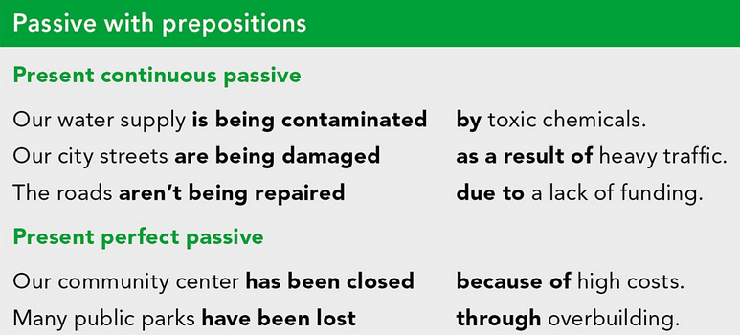

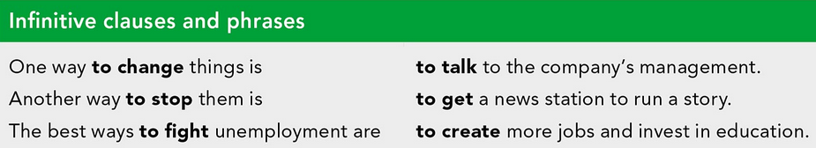

***Example:***

*The most vulnerable groups of our society* ***are not being attended******as a result of*** *the insufficient public expenditure in education and the inequality in its distribution.*

*One way* ***to improve*** *the education in México is* ***to increase*** *the public spending on education and create committees to ensure that these resources are well invested inside schools and communities.*

* Make a presentation with posters, buttons, and signs to help promote your candidate and upload a promotional video to the PADLET. Your classmates will watch your video and use their vote to choose the best Minister of Education for our country.

**Products:**

* Go to <https://padlet.com/alvaradocris87/btrml0zwovpq7dv2> and upload your **video** to the Padlet.

**DEVELOPMENT OF THE PROJECT**

**Imagine you will elect a Minister of Education for your country. Decide who will be the candidate. Then assign each student a job for the campaign.**

Minister of Education (candidate): **Yamile Margarita Mercado Esquivel**

Campaign Manager: **Andrea Flores Sandoval**

Speechwriter: **Vanessa Elizabeth Sanchez Gallegos**

**Choose the five most important problems in Mexico’s Educational System and list ways you want to improve education or schools in your country. Then write a speech explaining the improvements and how your candidate will achieve them. Use the passive voice and prepositions to describe the problem, and infinitive clauses to discuss ways in which these problems can be solved.**

1. **Our education is not being offered coverage to all students in the country by the national education system.**

**SOLUTION: The best ways to fight for coverage in less resourced communities is to promote the learning of indigenous communities with interested teachers who want to help this noble cause, and to create regularization programs to combat educational lag primarily in communities with greater problems and then encompass the entire country.**

1. **One of the main educational problems is that teaching staff, managers and supervisors are not being recognized, trained, and supported in their educational process.**

**SOLUTION: One way to change things is to provide teachers and managers with opportunities and scholarships for their ongoing updating and training, each week with the responsibility of not neglecting their educational work.**

1. **Our education system is being damaged as a result of not giving the necessary importance for physical education, sport, health, and other extracurricular subjects.**

**SOLUTION: One way to help give importance is to create opportunities for the development of physical activities from childhood, this helps them develop their social and intellectual abilities, stimulates their creativity and strengthens their self-esteem, and with these subjects they have more alternatives to practice professionally in the future.**

1. **The infrastructure of schools has been classified as bad due to lack of resources, furniture, internet, chairs, sly beds and in some cases drinking water.**

**SOLUTION: Another way to stop the problem is to prioritize resources in marginalized areas, create committees with parents to run fundraising campaigns, and win to improve each of the schools.**

1. **Educational values are not being promoted in a good way due to the lack of equitable and inclusive opportunities that are most promoted in indigenous communities.**

**SOLUTION: The best ways to promote inclusive values are to create sectioned educational programs that manage the most current problems in each region and the way to meet the most basic and forceful needs in the classroom.**

**INCLUDE YOUR SPEECH DESCRIBING THE PROBLEMS AND PROVIDING SOLUTIONS HERE:**

**Campaign Commitments**

For an Inclusive and Transformative Education.

**We know that today the education sector undergoes many changes and has needs that are very demanding and that need to be met. We take into account the most serious problems and have a number of solutions and proposals that can only be realized with your vote.**

**Our education is not being offered coverage to all students in the country by the national education system. The best ways to fight for coverage in less resourced communities is to promote the learning of indigenous communities with interested teachers who want to help this noble cause, and to create regularization programs to combat educational lag primarily in communities with greater problems and then encompass the entire country.**

**One of the main educational problems is that teaching staff, managers and supervisors are not being recognized, trained, and supported in their educational process. One way to change things is to provide teachers and managers with opportunities and scholarships for their ongoing updating and training, each week with the responsibility of not neglecting their educational work.**

**Our education system is being damaged as a result of not giving the necessary importance for physical education, sport, health, and other extracurricular subjects.**

**One way to help give importance is to create opportunities for the development of physical activities from childhood, this helps them develop their social and intellectual abilities, stimulates their creativity and strengthens their self-esteem, and with these subjects they have more alternatives to practice professionally in the future.**

**The infrastructure of schools has been classified as bad due to lack of resources, furniture, internet, chairs, sly beds and in some cases drinking water. Another way to stop the problem is to prioritize resources in marginalized areas, create committees with parents to run fundraising campaigns, and win to improve each of the schools.**

**Educational values are not being promoted in a good way due to the lack of equitable and inclusive opportunities that are most promoted in indigenous communities.**

**The best ways to promote inclusive values are to create sectioned educational programs that manage the most current problems in each region and the way to meet the most basic and forceful needs in the classroom.**

**We believe in educational transformation, that's why we need your support in the upcoming elections, remember we are your best choice. For an inclusive and transformative education.**

**RUBRIC**

