**ESCUELA NORMAL DE EDUCACIÓN PREESCOLAR**

**ENGLISH B1.2**

**UNIT 7 PROJECT**

**USE YOUR VOTE!**

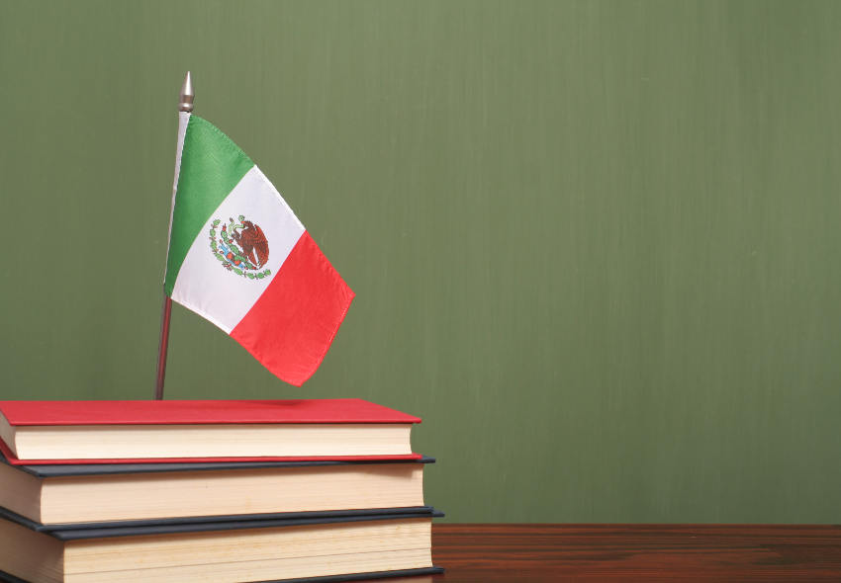

**Aim of the project:**

Give students practice discussing problems and using infinitive clauses and phrases.

This activity will be done in the TEAMS assigned by the teacher.

**Preparation:**

* Visit the following websites and analyze the information about the main problems in Mexico’s educational system.
* <https://www.milenio.com/politica/sep-identifica-seis-problemas-en-sistema-educativo>
* <http://trazandoelrumbo.ibero.mx/la-problematica-persistente-de-la-educacion-en-mexico/#:~:text=El%20acceso%20a%20la%20escuela,han%20concluido%20su%20educaci%C3%B3n%20b%C3%A1sica>.
* <https://merida.anahuac.mx/posgrado/blog/problemas-del-sistema-educativo-en-mexico-y-sus-posibles-soluciones>
* <https://wenr.wes.org/2019/05/education-in-mexico-2>

**Development:**

* Imagine you will elect a Minister of Education for your country. Decide who will be the candidate. Then assign each student a job for the campaign.

**Minister of Education (candidate): __________________________________________**

**Campaign Manager: ______________________________________________________**

**Speechwriter: ____________________________________________________________**

* Choose the five most important problems in Mexico’s Educational System and list ways you want to improve education or schools in your country. Then write a speech explaining the improvements and how your candidate will achieve them. **Use the passive voice and prepositions to describe the problem, and infinitive clauses to discuss ways in which these problems can be solved.**

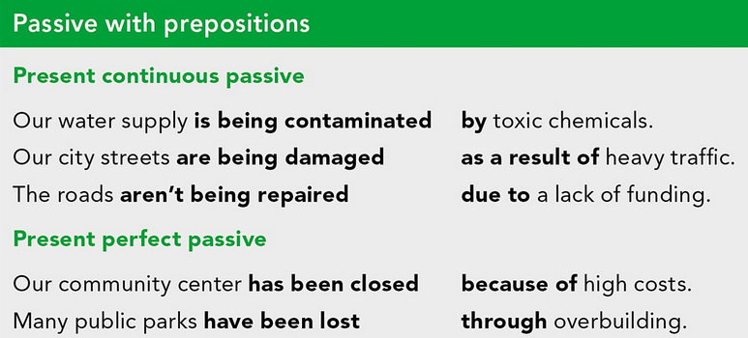

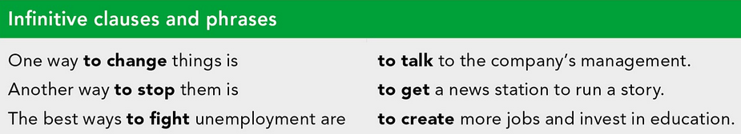

***Example:***

*The most vulnerable groups of our society* ***are not being attended******as a result of*** *the insufficient public expenditure in education and the inequality in its distribution.*

*One way* ***to improve*** *the education in México is* ***to increase*** *the public spending on education and create committees to ensure that these resources are well invested inside schools and communities.*

* Make a presentation with posters, buttons, and signs to help promote your candidate and upload a promotional video to the PADLET. Your classmates will watch your video and use their vote to choose the best Minister of Education for our country.

**Products:**

* Go to <https://padlet.com/alvaradocris87/btrml0zwovpq7dv2> and upload your **video** to the Padlet.

**DEVELOPMENT OF THE PROJECT**

**Imagine you will elect a Minister of Education for your country. Decide who will be the candidate. Then assign each student a job for the campaign.**

Minister of Education (candidate): Katya Rocio Quintana Rangel

Campaign Manager: Aneth Giselle Saavedra Salais

Speechwriter: Sofía Mali Siller Valdes

**Choose the five most important problems in Mexico’s Educational System and list ways you want to improve education or schools in your country. Then write a speech explaining the improvements and how your candidate will achieve them. Use the passive voice and prepositions to describe the problem, and infinitive clauses to discuss ways in which these problems can be solved.**

**INCLUDE YOUR SPEECH DESCRIBING THE PROBLEMS AND PROVIDING SOLUTIONS HERE:**

**1. Education coverage.**

One of the main problems of the Mexican educational system is that it does not guarantee education to the majority of citizens, this is being caused by the fact that many families, both in rural and urban communities, require that all their members carry out paid work to earn an income. In addition, there are remote communities, mostly indigenous, that do not have nearby educational options, so only those who have the opportunity to travel to other communities on a daily basis receive formal education. Among the most vulnerable groups are: rural population, marginal urban, indigenous, migrant agricultural laborers, and the population with disabilities.

**Solution:**

The best ways to change would be to implement educational centers in places where there are none so that children can receive education or implement strategies to take education where there is none.

**2.** **Educational quality.**

The proposed educational reform does not address the main pedagogical, curricular and teacher training problems, this is being caused because the quality of the educational offer is deficient, both in the curriculum at all educational levels and in the training and performance of teachers and managers, for example. what we have learning outcomes far from desirable. National and international evaluations report that Mexican children and young people do not reach the learning achievements essential for their development.

**Solution:**

one way to improve reform is to meet the needs of all those who receive education in order to employ strategies

**3. Management problems within the educational system.**

The lack of commitment of the latest educational systems, and even the same lack of preparation in education of public servants and managers, falls on a management far below what is desirable, this has been because of union dissent, misuse management of human capital (especially in the teaching area) and deficient administrative logistics. This has triggered, for example, the start of classes without teachers, textbooks and therefore very low levels of student motivation.

**Solution:**

**4.** **Lack of resources and investment in infrastructure for education.**

Public schools, especially in rural communities, have very few economic resources for their maintenance and optimization, basic needs have been neglected, such as functional bathrooms and electricity in the classrooms. Also, educational needs such as access to computer equipment and elementary facilities for the inclusion of students with disabilities.

**Solution:**

Another way to stop the problem is to give rural public schools the importance they deserve, attend to them and give them follow-up in order to improve the quality of education in those communities.

**5.** **Educational model**

Article 3 of the Constitution says that all the faculties of the human being will be developed harmoniously in a comprehensive education, but it is observed that this is not the case. The curriculum has been prioritizing instrumental subjects (Spanish, mathematics, science) and marginalizes comprehensive training that promotes other talents and interests: artistic and cultural expressions, ethical values and community knowledge. For example, physical culture and sports practice create opportunities for the development of physical culture from early childhood, thus reducing the high rates of sedentary lifestyle of the population in Mexico.

**Solution:**

One way to improve would be to attend to the areas of personal and social development as well as the training bosses, since they have the same importance to be able to give a comprehensive education.

especially social and social education in children, because in this confinement children can feel too many emotions and not know how to express them

**RUBRIC**

