**ESCUELA NORMAL DE EDUCACIÓN PREESCOLAR**

**ENGLISH B1.2**

**UNIT 7 PROJECT**

**USE YOUR VOTE!**

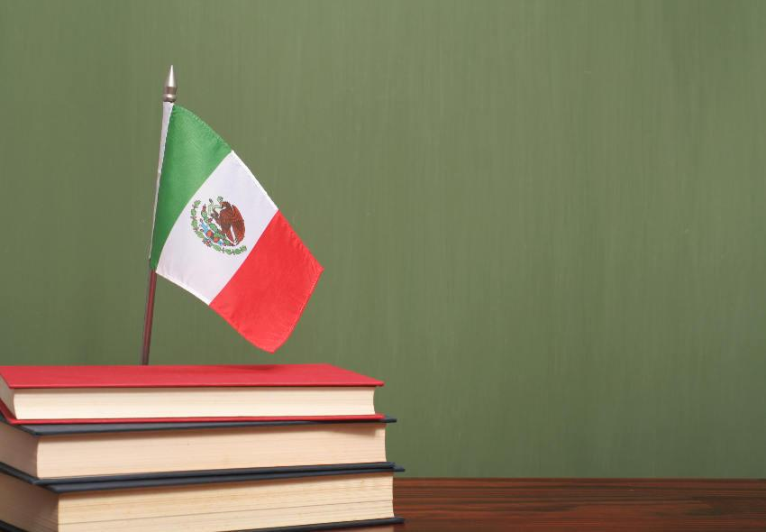

**Aim of the project:**

Give students practice discussing problems and using infinitive clauses and phrases.

This activity will be done in the TEAMS assigned by the teacher.

**Preparation:**

* Visit the following websites and analyze the information about the main problems in Mexico’s educational system.
* <https://www.milenio.com/politica/sep-identifica-seis-problemas-en-sistema-educativo>
* <http://trazandoelrumbo.ibero.mx/la-problematica-persistente-de-la-educacion-en-mexico/#:~:text=El%20acceso%20a%20la%20escuela,han%20concluido%20su%20educaci%C3%B3n%20b%C3%A1sica>.
* <https://merida.anahuac.mx/posgrado/blog/problemas-del-sistema-educativo-en-mexico-y-sus-posibles-soluciones>
* <https://wenr.wes.org/2019/05/education-in-mexico-2>

**Development:**

* Imagine you will elect a Minister of Education for your country. Decide who will be the candidate. Then assign each student a job for the campaign.

Minister of Education (candidate): Paulina Guerrero

Campaign Manager: Karen Guadalupe Morales

Speechwriter: Alondra Martinez

* Choose the five most important problems in Mexico’s Educational System and list ways you want to improve education or schools in your country. Then write a speech explaining the improvements and how your candidate will achieve them. **Use the passive voice and prepositions to describe the problem, and infinitive clauses to discuss ways in which these problems can be solved.**

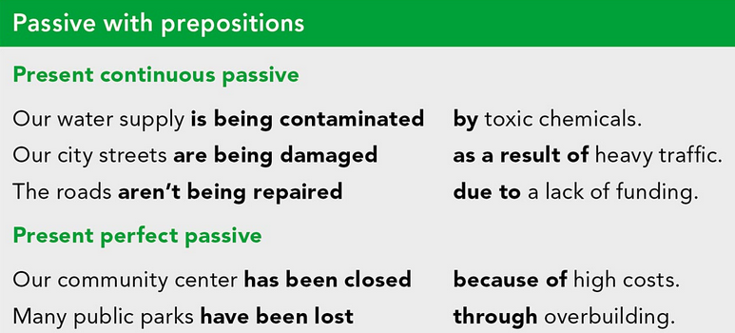

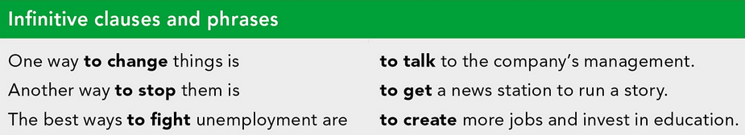

***Example:***

*The most vulnerable groups of our society* ***are not being attended******as a result of*** *the insufficient public expenditure in education and the inequality in its distribution.*

*One way* ***to improve*** *the education in México is* ***to increase*** *the public spending on education and create committees to ensure that these resources are well invested inside schools and communities.*

* Make a presentation with posters, buttons, and signs to help promote your candidate and upload a promotional video to the PADLET. Your classmates will watch your video and use their vote to choose the best Minister of Education for our country.

**Products:**

* Go to <https://padlet.com/alvaradocris87/btrml0zwovpq7dv2> and upload your **video** to the Padlet.

**DEVELOPMENT OF THE PROJECT**

**Imagine you will elect a Minister of Education for your country. Decide who will be the candidate. Then assign each student a job for the campaign.**

**Minister of Education (candidate):** Paulina Guerrero

**Campaign Manager:** Karen Guadalupe Morales

**Speechwriter:** Alondra Martinez

**Choose the five most important problems in Mexico’s Educational System and list ways you want to improve education or schools in your country. Then write a speech explaining the improvements and how your candidate will achieve them. Use the passive voice and prepositions to describe the problem, and infinitive clauses to discuss ways in which these problems can be solved.**

**INCLUDE YOUR SPEECH DESCRIBING THE PROBLEMS AND PROVIDING SOLUTIONS HERE:**

**MÉXICO, STAGNED IN EDUCATION**

Mexico's education system is currently facing a multitude of problems that make education not stay stagnant and it is the result of a bad and corrupt government.

BUT WE HAVE A NEW OPPORTUNITY TO HAVE A BETTER COUNTRY

MY NAME IS PAULINA GUERRERO AND I WANT TO BE YOUR NEW MINISTER OF EDUCATION.

THIS ARE THE 5 BIGGEST PROBLEMS ABOUT EDUCATION IN MÉXICO THAT I'M GOING TO SOLVE, BUT ONLY WITH YOUR HELP!

1. **Ineffective educational system**

The educational reform proposed this six-year term doesn´t address the main pedagogical, curricular and teacher training problems. The educational system is ineffective and inefficient, it works like a funnel: of the 100% who enter primary school, only 1.5% go to graduate school.As a result of the bad government it is necessary to change and configurate a new educational model.

**2. Equity and inclusion**

Currently we are faced with the problem of inequality and exclusion among students and in some cases on the part of teachers as a result of the lack of empathy and professionalism. One way to promote equity and inclusion is by holding conferences and campaigns on inequality and its consequences to raise awareness.

**3. Lack of resources**

Public schools, especially in rural communities, have very few economic resources for their maintenance and optimization, leaving aside:

Educational basic needs, and specially because of the pandemic are such as access to computer equipment and elementary facilities for the inclusion of students with disabilities. To fight with this problems we can make financial planning by public servants that includes a monetary benefit or some computer equipment

**4. Education coverage**

Indigenous communities have been marginalized over the years, the education they receive is very low, as a result, many children are not educated. To change this situation, improving the means of transportation for the community due to sometimes this is not available. Another element is to provide pre and in-service training teachers with up-to-date teaching methods.

**5. Foreign mobility scholarships**

Foreing mobilities is very important for students to achieve a high degree of proficiency in the english language. One of the ways to promote mobility is by awarding scholarships to students that allow them to acquire better bases of academic preparation.

**RUBRIC**

