**ESCUELA NORMAL DE EDUCACIÓN PREESCOLAR**

**ENGLISH B1.2**

**SPEAKING PRACTICE ACTIVITIES**

Go to your Padlet (<https://padlet.com/alvaradocris87/jnckd60tzhz81oe3>) and play “Spin the Wheel”. Spin ten times and write the questions with complete responses in this document. Upload it to Escuela en red.

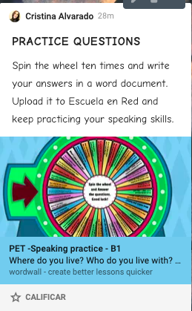

1. Which do you prefer, reading books or playing video games? Why?  
   I don't have a favorite, I love to do both.
2. How are you feeling right now?  
   A little stressed, I have a lot of work.
3. Is travelling to a different country the best way to learn a language?  
   Yes, because you can practice the language with the people, you can also hear how they use it in their day.
4. Have you celebrated anything recently?  
   Yes, I met old friends who had not seen for a long time.
5. What would you do if you won the lottery? Why?  
   Build a great house and buy all kinds of things that I like, books, video games, etc.
6. What makes you happy?  
   Spending a lot of time talking about memories with the people I love.
7. What are three things that you do every day?  
   Take classes online, feed my rabbit and playing video games.
8. Who is the most important person in your life? Why?  
   My grandmother, because she has always taken care of me since I was born and has been very attached to me

And my boyfriend, because always believes in me, supports me when I need it most

1. Do you use the internet much? Why?  
   Yes, I use the internet to my online class, and to play some videogames because I’m streamer and I play with friends or to see movies, etc.
2. Do you ever listen to the radio? What programmes do you like? Why?  
   Yes, I used to listen to a program called "La Tremenda Corte", a comedy radio show. it was my grandfather's favorite show