**ESCUELA NORMAL DE EDUCACIÓN PREESCOLAR**

**ENGLISH B1.2**

**SPEAKING PRACTICE ACTIVITIES**

Go to your Padlet (<https://padlet.com/alvaradocris87/jnckd60tzhz81oe3>) and play “Spin the Wheel”. Spin ten times and write the questions with complete responses in this document. Upload it to Escuela en red.

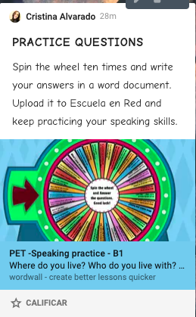

1. What would you do if you won the lottery? Why?

If I won the lottery, I would invest the money in creating a food or beauty business because it could make more money in the long run. I would also buy a house and a car.

1. Where did you go on holiday last summer? What did you do?

Last summer I did not go anywhere because the covid situation was very strong in the cities, I just spent my vacations at home, watching movies and spending time with my family, in addition to that we were infected on those vacations and we were in quarantine.

1. How often do you use your mobile phone? For what?

Very often, I use it in the mornings to take some classes and spend time on social media, I also like to watch videos.

1. Do you like music? Do you listen to music every day? What music do you like best?

Yes I like music and I listen to it all the time. The music I like the most is pop, romantic ballads and reggaeton.

1. How are you feeling right now?

I feel good, but worried about the planning of the practices that come in two weeks.

1. If you had three whises what would they be?

1. Eat without getting fat

2. Have the ability to teleport to any time in the past or future.

3. That diseases did not exist.

1. Who is the most important person in your life? Why?

My mom is the most important person because she is the one I can talk to, she listens to me, supports me and accompanies me everywhere.

1. What do you do in your spare time?

I listen to music and watch movies or videos.

1. Which do you prefer, Reading books or playing video games? Why?

I prefer to read books because I am not very good at playing video games apart from that I do not find them fun.

1. Which do you like best, the morning or the afternoon?

I like the morning because I take a bath and even if I am sleepy I like to think that the day starts correctly, besides that the weather is more pleasant in the morning.