**ESCUELA NORMAL DE EDUCACIÓN PREESCOLAR**

**ENGLISH B1.2**

**SPEAKING PRACTICE ACTIVITIES**

Go to your Padlet (<https://padlet.com/alvaradocris87/jnckd60tzhz81oe3>) and play “Spin the Wheel”. Spin ten times and write the questions with complete responses in this document. Upload it to Escuela en red.

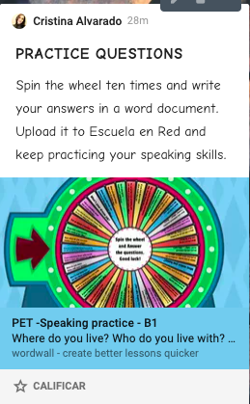

Answers:

1. **How often do you see your friends? What do you like doing whit your friends?**

Not very often, at least twice a month, we go out to dinner, or just to talk and have fun.

1. **If you had a superpower. What would it be? Why?**

I would fly, could easily get everywhere.

1. **What’s your dream job?**

I've always dreamed of working at Disneyland.

1. **What do you usually do at weekend?**

I usually go out to eat with my boyfriend or my friends

1. **What makes you happy?**

Be with my family and the people I love.

1. **What are three tings that you do every day?**

* I do homework
* I go to the gym
* I go out with my dogs

1. **Where would you like to be right now?**

Resting in my bed, but I have a lot of homework.

1. **Have you celebrated anything recently? What?... How?...**

Yes, my sister's birthday, we went to her house, we bought a cake and dinner

1. **Have you got a boyfriend?**

Yes, I have

1. **If you go have dinner with anyone living or deceased who will it be and why?**

With my grandmother, so I can see her again