**ESCUELA NORMAL DE EDUCACIÓN PREESCOLAR**

**ENGLISH B1.2**

**SPEAKING PRACTICE ACTIVITIES**

Go to your Padlet (<https://padlet.com/alvaradocris87/jnckd60tzhz81oe3>) and play “Spin the Wheel”. Spin ten times and write the questions with complete responses in this document. Upload it to Escuela en red.

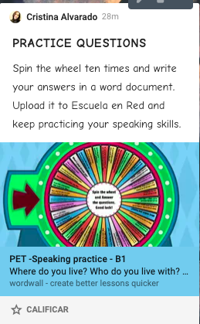

1. **What did you do on your last birthday?**

I went to eat with my husband and my son, then I went to my grandmother's house and there we cut a cake

1. **Where wuld you like to be right now?**

I would like to be at the beach with my husband and my son enjoying more time with them

1. **What are three thing that you do every day?**

be in class, play with my son and go with my grandmother

1. **What is one thing that yu like abut yourself?**

I like that sometimes I am strong and I try to solve my problems on my own before I can tell someone, I like my eyes, and I like that I am very happy and funny.

1. **Tell us about a teacher you like**

I like how the teacher Miguel teaches, because he is always cheerful, and motivates us to continue in the class and puts different dynamics.

1. **Where did you go on holiday last sumer? What did you do?**

nowhere, because there was the health contingency and you couldn't go out

1. **What do you usually do at the weekend**?

If there is a possibility, we will go somewhere as a family, my husband, my son and I. I also help my grandmother in a food stall that she has

1. **what do you do in your spare time?**

I try to relax a little, spend more time with my son

1. **Have you celebrated anyhting recently? (What, How?)**

Yes, we celebrated my son's birthday on May 29, although he had his birthday on January 24, his party was until May

1. **What makes you happy?**

have my son and his unconditional love, count on my family for everything