**ESCUELA NORMAL DE EDUCACIÓN PREESCOLAR**

**ENGLISH B1.2**

**SPEAKING PRACTICE ACTIVITIES**

Go to your Padlet (<https://padlet.com/alvaradocris87/jnckd60tzhz81oe3>) and play “Spin the Wheel”. Spin ten times and write the questions with complete responses in this document. Upload it to Escuela en red.

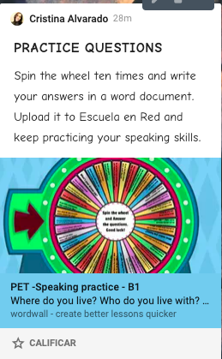

1. Which do you like best, the morning or the afternoon? Why?

I like the morning better because it lasts longer and we can do more things.

1. What do you enjoy doing with your family?

I like to eat as a family on Sundays and be all together.

1. Where did you go on holiday last summer? What did you do?

Last summer I stayed home because of the pandemic, I just stayed home with my family.

1. What is something that you really want to do in your lifetime?

Finish my degree, have a stable job, travel a lot and see different parts of the world.

1. Do you like music? Do you listen to music every day? What music do you like best?

Yes I really like music, every day I listen Ha Ash.

1. Do you use the internet much? Why… why not?

I do use the internet a lot because all the classes and homework are online, I also use it at work because I send emails.

1. Have you celebrated anything recently? What… how?

Yes, on Sunday I celebrated my birthday with just a family meal and cake.

1. Where would you like to be right now?

Right now I would like to be on the beach sunbathing and enjoying the sea.

1. Do you prefer to go on holiday with your friends or with your family? Why?

I prefer with both of them because I had a lot of fun with my cousins ​​but also with my friends.

1. How are you feeling right now?

I feel sad and burdened.