**ESCUELA NORMAL DE EDUCACIÓN PREESCOLAR**

**ENGLISH B1.2**

**SPEAKING PRACTICE ACTIVITIES**

Go to your Padlet (<https://padlet.com/alvaradocris87/jnckd60tzhz81oe3>) and play “Spin the Wheel”. Spin ten times and write the questions with complete responses in this document. Upload it to Escuela en red.

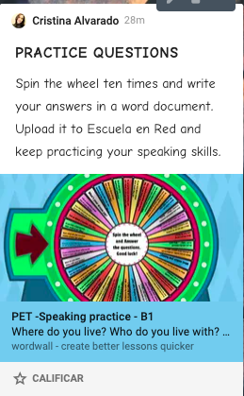

1. What´s your dream job?

In addition to being a teacher, my dream job is to be a model and a singer.

1. What is one thing that you like about yourself?

I really like my eyes and my hands

1. What do you usually do at the weekend?

I always go to church on Fridays, Saturdays and Sundays and sometimes I go out with my friends.

1. How often do you use your mobile phone? For what?

Yes, I use it frequently to watch videos, look for beautiful clothes that I will never buy and listen to music.

1. How are you feeling right now?

I feel very tired and scared about my final exams

1. Tell us about a teache you like

My favorite teacher is the teacher Gaby Palmares because she is very cute and understanding, she teaches very well and knows how to give good advice

1. Pick a Word to describe your future. Why did you choese that word?

Exciting, I think it is exciting to see what will come both good and bad since you learn from everything.

1. What is something that you really want to do in your lifetime

Strive in everything I do

1. Which do you like the best, the morning or the afternoon?Why?

Neither of the two, I think I prefer the night because you can do everything with more calm and comfort

1. Do you ever listen to the radio? What programs de you like? Why?

I don't like the radio, I think it's boring