**ESCUELA NORMAL DE EDUCACIÓN PREESCOLAR**

**ENGLISH B1.2**

**SPEAKING PRACTICE ACTIVITIES**

**Ana Cecilia Villanueva García**

Go to your Padlet (<https://padlet.com/alvaradocris87/jnckd60tzhz81oe3>) and play “Spin the Wheel”. Spin ten times and write the questions with complete responses in this document. Upload it to Escuela en red.

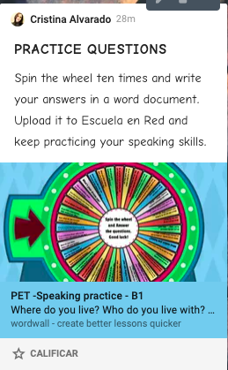

1. Do you use the internet much? Yes, I did, because of my homework.
2. Do you ever listen to the radio? No, I don´t, because I don´t have a radio.
3. How are you feeling right now? Tired.
4. Pick a word to describe your future? Mystery, because I don´t think about my future I live the present, the moment.
5. What makes you happy? Sleep
6. How often do you use your mobile phone? Every time of every day, for everything.
7. If you were to live in mars…? My phone, food, the charger of my phone, water and a surviving kit.
8. What is something that you really want to do in your lifetime? Sleep, eat and chill.
9. If you could have a dinner…? Nobody, I like to eat alone.
10. How often do you go to the cinema? Before quarantine, every week now I don´t. With my best friend.