**ESCUELA NORMAL DE EDUCACIÓN PREESCOLAR**

**ENGLISH B1.2**

**SPEAKING PRACTICE ACTIVITIES**

Go to your Padlet (<https://padlet.com/alvaradocris87/jnckd60tzhz81oe3>) and play “Spin the Wheel”. Spin ten times and write the questions with complete responses in this document. Upload it to Escuela en red.

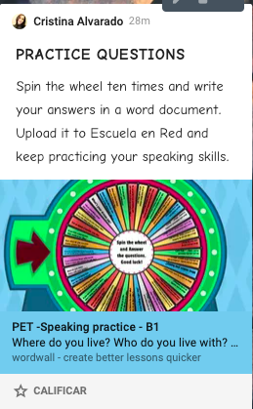

1. Where would you like to be right now?

I would like to be in my house, because I miss being with my brothers and playing with my pets, also I miss my bed and miss my neighborhood.

1. What do you enjoy doing with your family?

I enjoy being with them in our house, I like so much to talk with them about our activities while we eat my mom’s food, and I enjoy when we go together to the cinema.

1. What is something that you really want to do in your lifetime?

I really want to get my University title, and to be preeschool teacher. And I want to start to work to get money and move me in my own house, then I want to buy a car and travel around Mexico.

1. If you had a superpower what would it be? Why?

My superpower would be fly, because I dont have car and sometimes I have to arrive to a place far away or I have to arrive to my house in the night and that`s could be dangerous for me walk alone on the streets, and I could be move to a place to another more fast.

1. If you could travel to one country in the world, where would you go? Why?

I would go to United States because I want to learn how money is handled to get it and to practice the english lenguage, and I would like to know New York City, and learning about the culture.

1. Talk about funny or worry adventure you had which a friend or which your family.

Five years ago my friends and me had a party, so we bought a white dress and we maked up to the celebration. On the day of the party we left to the my friend’s house, and when we were waiting the taxi unfortunately it started to rain and we arrived to the party dripping water with our dirty dresses.

1. What is one thing that you like about yourself?  
   One thing that I like about myself is my hair because when I cut it short it grows fast and I have a lot of hair.
2. What makes me happy?

My familiy makes me happy when they worried about me and when we are together. Also when my boyfriend comes to visit me I came happy, and when we are together and go out to different places.

1. What would you do if you won the lottery? Why?

If I won the lottery I would buy a house for my mom and a house for me, because when my brothers and me make our own lifes my mom would be in her own house, and when I get married or make me indepent I would have a place to live and I wouldn’t have to pay rent.

1. Do you prefer to go on holiday with your friends or with your family?

I would to go on holiday with my Friends because I have not gone on vacation with them and I would like to live that experience, so I would like to go to the beach with them and have fun.