**ESCUELA NORMAL DE EDUCACIÓN PREESCOLAR**

**ENGLISH B1.2**

**SPEAKING PRACTICE ACTIVITIES**

Go to your Padlet (<https://padlet.com/alvaradocris87/jnckd60tzhz81oe3>) and play “Spin the Wheel”. Spin ten times and write the questions with complete responses in this document. Upload it to Escuela en red.

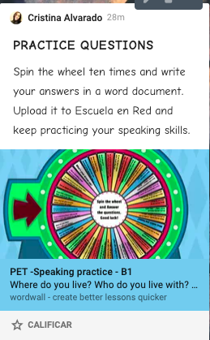

1. what makes you happy? go out to talk with my Friends
2. where would you like to be right now? in the House of my grand parents
3. what your dream job? My dream job has always been to be a teacher
4. Tell us about a teacher you like. all my teachers are cute and understanding
5. what do you enjoy doing with your family? go out to eat together
6. if you had three wishes what would they be? health for all my family, have a nice house and a lot of money
7. how you feeling right now? stressed
8. whats is one things that you like about yourself? my eyes
9. do you use the internet much? Yes. Why? I use it for entertainment and homework
10. tell us something about one your Friends? all my friends are very funny and support me in my problems