**ESCUELA NORMAL DE EDUCACIÓN PREESCOLAR**

Susana Abigail Rosas López

**ENGLISH B1.2**

**SPEAKING PRACTICE ACTIVITIES**

Go to your Padlet (<https://padlet.com/alvaradocris87/jnckd60tzhz81oe3>) and play “Spin the Wheel”. Spin ten times and write the questions with complete responses in this document. Upload it to Escuela en red.

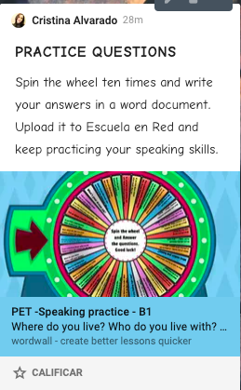

**Responses**

**Have you got a boyfriend?**

No, I’ve never had a boyfriend, and i’m not actually interested in having one, it would require a lot of time and I really don’t have any now that I’m in college, so now it’s not my priority for the moment.

**How are you feeling right now?**

Honestly, I feel overwhelmed most of the times because of all the homework, an final evidenes, also I’m a little tired since I’m alost at the end of my 1st year in college, I really want vacations to start.

**How often do you use your mobile pone? For what?**

I use it really often mostly because of matters of school besides that I don’t use it that much, just to check Instagram and to do my workout routine.

**If you had 3 wishes what would they be?**

First of all, I would ask the hability to make apear every book that I want in my hand just by saying the name of it, I love reading and there is a long list of books that I want, then probably I would ask for my dream house so when I’m older I don’t have to make that purchase, and finally I would ask for the hability to teletransport myself to any place in the world, there are a lot of places that I would love to visit.

**What are 3 things that you do everyday?**

Eat, do my homework and watch series.

**Where do you live? Who do you live with? Do you get on with all the members of your family?**

I live in Saltillo, but I´m from Piedras Negras, I live with my family, my mom, my dad and my bother and sister, most of the times we do get on well, we really like to spend time together and we don’t like fighting.

**If you could have dinner with anyone living or dead, who would it be and why?**

Probably my grandfather from my mom’s side, because he never get to know 3 of my cousins and my little borther was a baby when he passed away, so I would like very much to have dinner one more time with him.

**What would you do if you won the lottery? Why?**

I would donate a part for the people in need, I would give my parents another part and the rest I would save it for my future.

**What did you do on your last birthday?**

I celebrated in my house with my family because covid already had started, so we couldn’t do anything else.

**What are your favorite school subjects? Wich school subject is the most difficult? Why?**

I like English because is the easier one and Planeación y Evaluación, because I like the way the professor explain the class. I think the most diffcult is Prácticas sociales del Lenguaje because it’s a lot of theory.