**ESCUELA NORMAL DE EDUCACIÓN PREESCOLAR**

**ENGLISH B1.2**

**SPEAKING PRACTICE ACTIVITIES**

Go to your Padlet (<https://padlet.com/alvaradocris87/jnckd60tzhz81oe3>) and play “Spin the Wheel”. Spin ten times and write the questions with complete responses in this document. Upload it to Escuela en red.

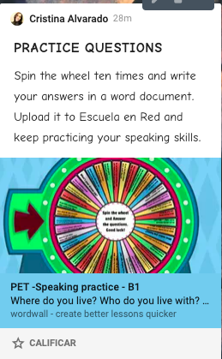

Questions

1. Dou you use the internt much? Why?
2. Yes, because I use the internet for my homework, I like to watch videos, series and movies, I also talk with my Friends
3. What do you usually do at the weekend?
4. I usually use those days to relax, or clean my room, started tasks depends on what I need to do
5. Who is the most important person in your life? Why?
6. The most important people for me are my mom and dad, since they support me, take care of me, etc.
7. If you could travel to one country in the world, where would you go? Why?
8. I think it would be Bali, since I have seen many photos and I really like the place.
9. Tell me something about one of your Friends
10. My best friend Sofia, she is very smart and I admire her a lot.
11. Which do you prefer, Reading books or playing video games? Why?
12. I prefer to play video games, since sometimes I do it with my friends and it becomes a lot of fun.
13. If you could have dinner with anyone living or dead, who would it be and why?

A. It would be Bad Bunny because he is my favorite artist of the moment.

1. How often do you see your Friends? What do you like doing whith your Friends?

A. Not very often since they are in Monclova right now, and less because of the pandemic. We like to eat and talk or go for a walk around.

1. What is one thing that you like about yourself?

A. Maybe that I can become very friendly or funny.

1. What do you do in your spare time?
2. Play with my friends, do my homework, clean, whatever as long as I don't get bored.