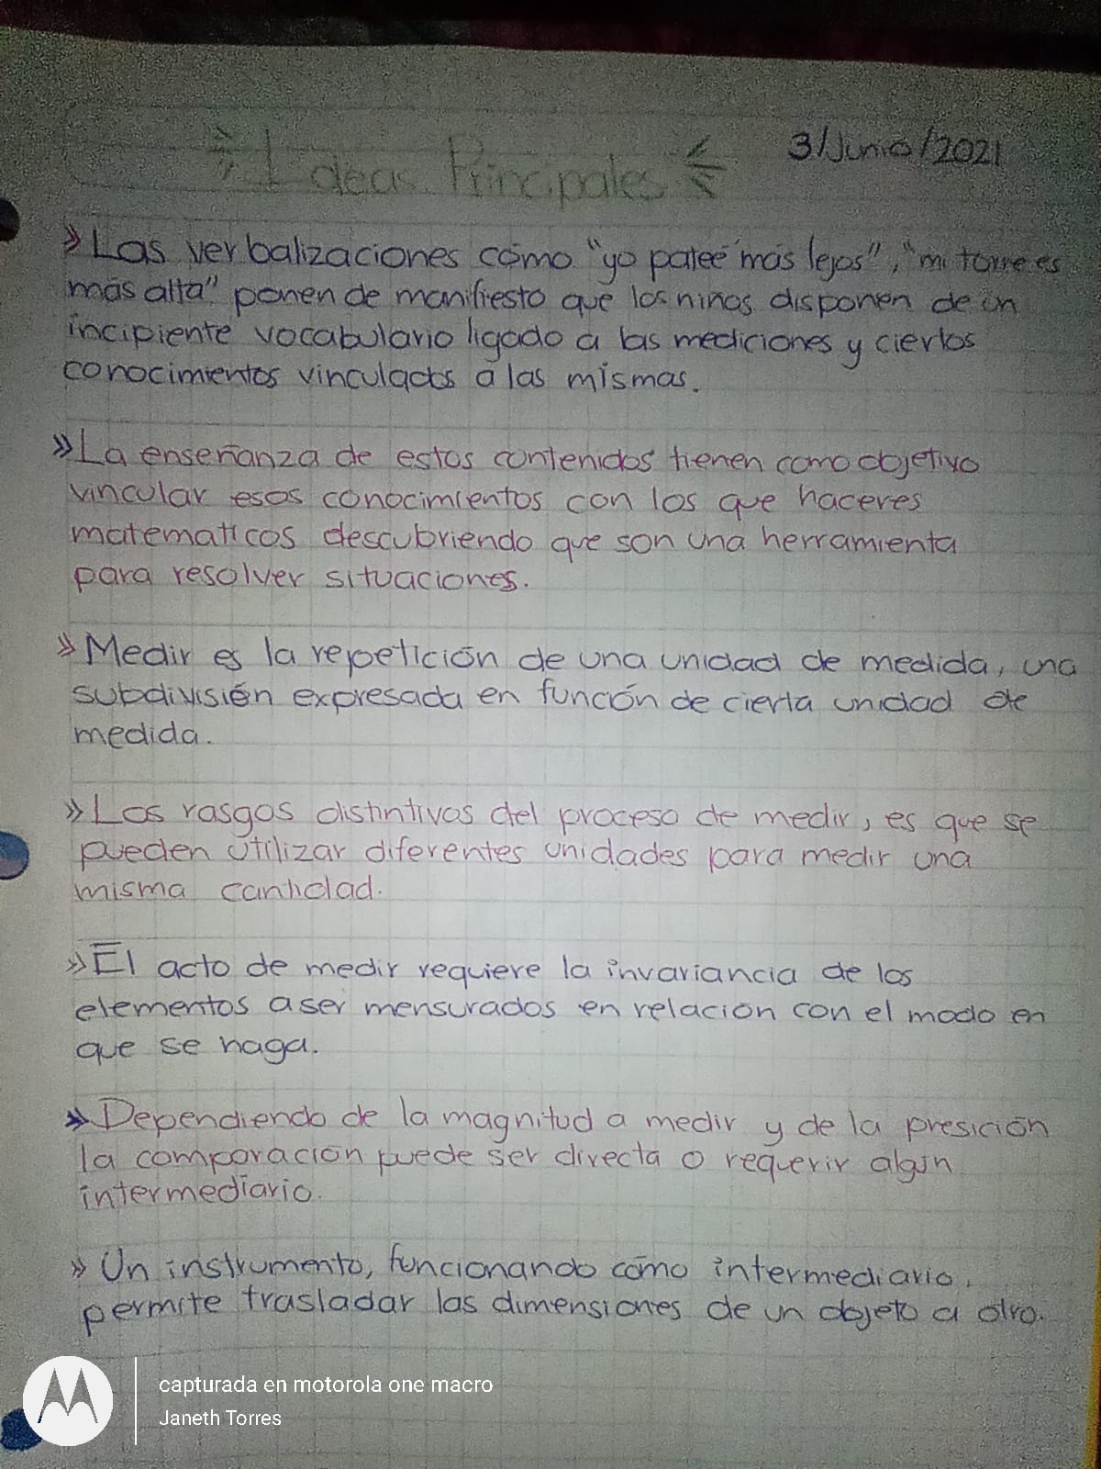Janeth Guadalupe Torres Rubio. #17