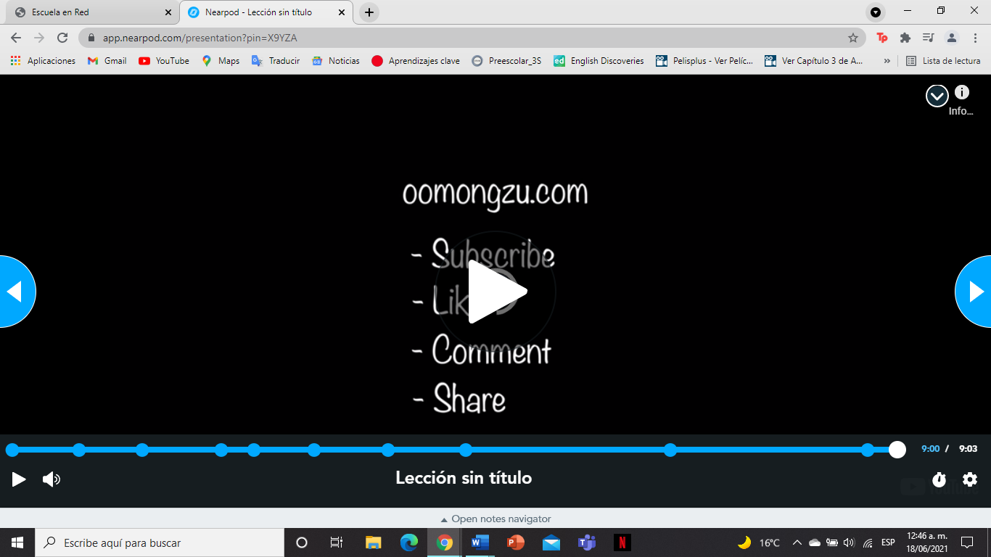
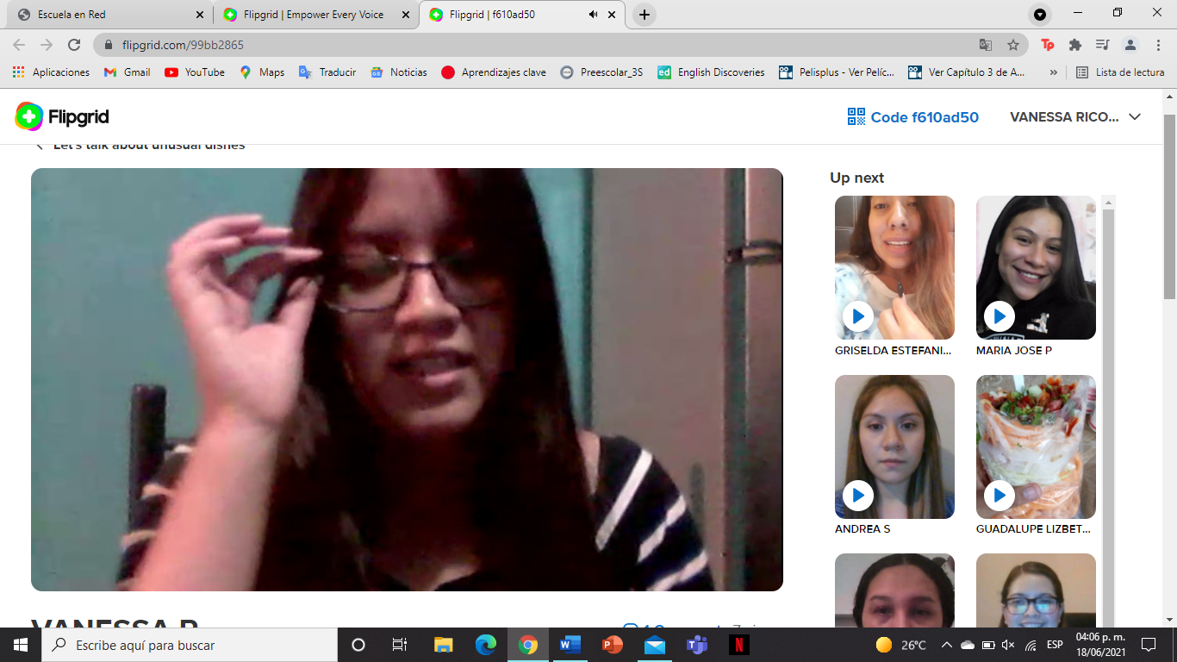

Nearpod activities completed, flipgrid video, and at least 1 response to a partner's posts= 20% of project evaluation

Not done =0% of your project evaluation
criteria | excellent | Good | needs improvement
PRODUCT | The product includes all the activities in the Nearpod completed and one video in Flipgrid  5 pts | The product includes partially completed activities and a video in flipgrid  4 pts | The product does not contain a video or the activities in the Nearpod are missing  2 pts
Language & delivery of speech | Language is used correctly and creatively, words varied and easy to follow. Good fluency Includes grammar structures seen in the unit  5 pts | Most language is clear, easy to follow and understand. Most of the words are well pronounced. Voice is often clear and there is evidence of some grammar structures seen in the unit  4 pts | Language is unclear and hard to understand. Lots of grammar, vocabulary and pronunciation mistakes. Lack of fluency. Poor evidence of grammar structures seen in the unit.  3 pts

