Escuela Normal De Educación Preescolar

Licenciatura en Educación Preescolar

Ciclo Escolar 2020-2021

Maestro: Brenda Bollain Y Goytia De La Peña

Asignatura: Inglés A2.2 1



UNIT 3

How does she look like?

Final project

Alumna:

Verónica Esmeralda Gonzalez Mata #9

2° “A”

Junio del 2021

Saltillo, Coahuila

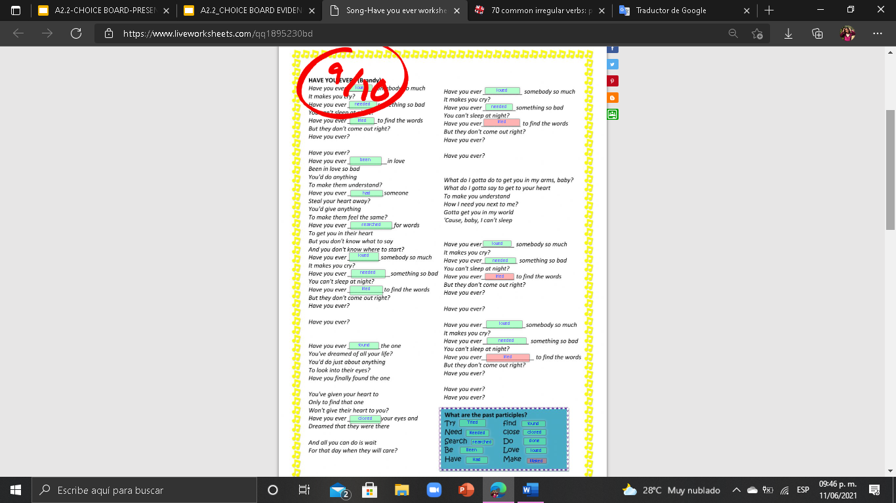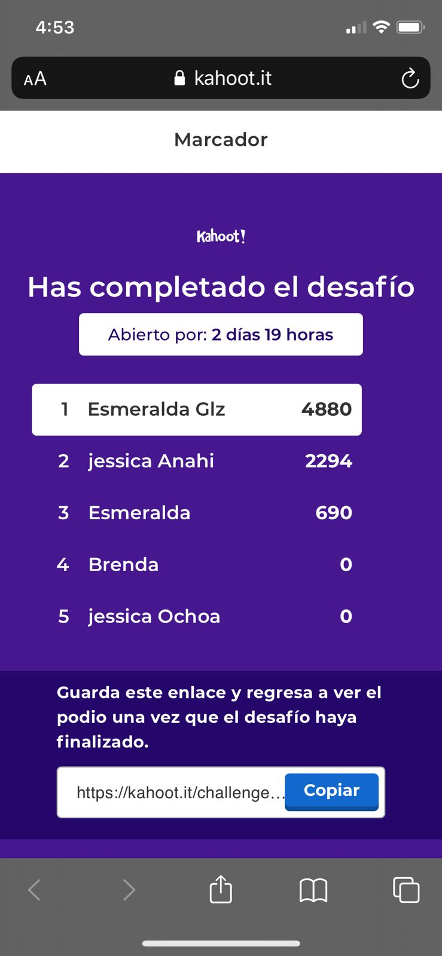

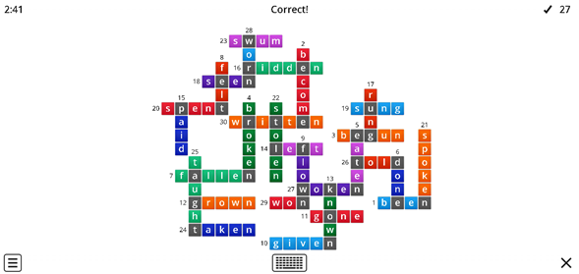

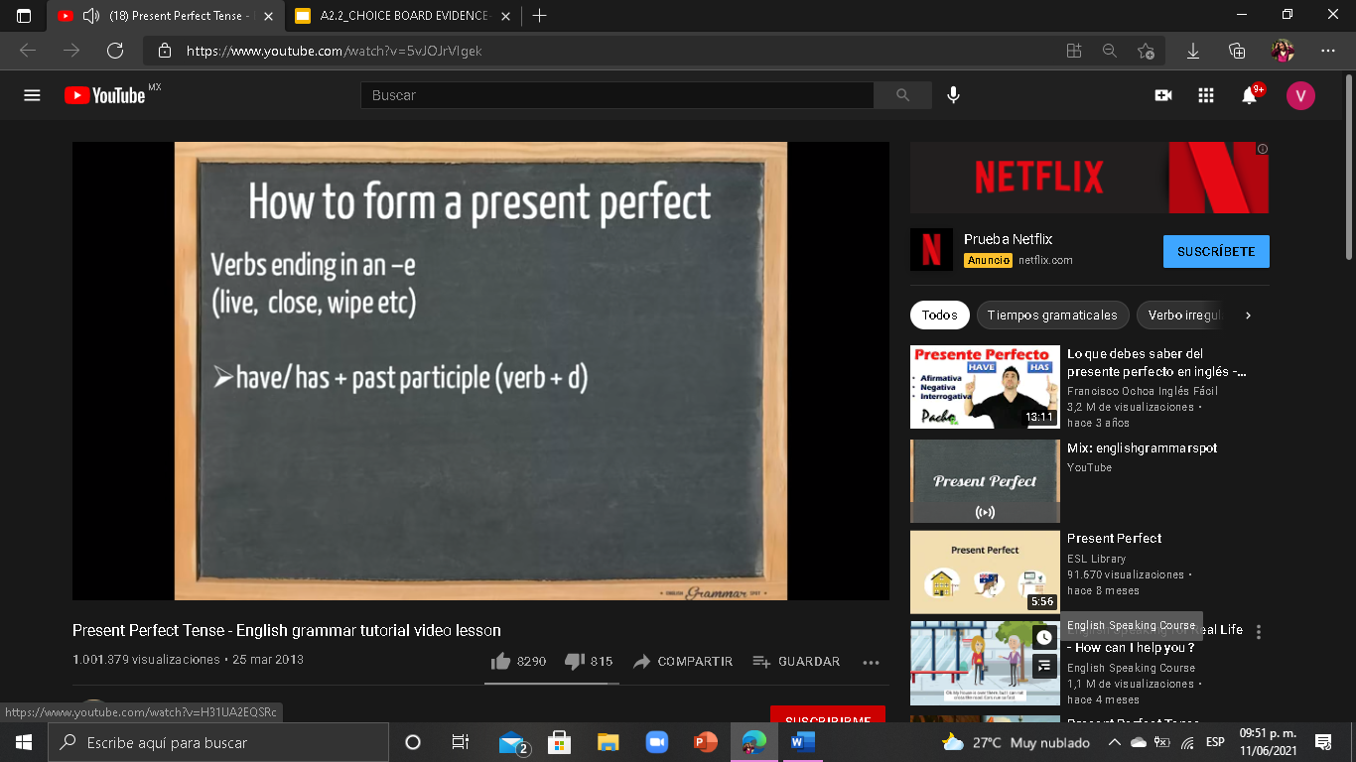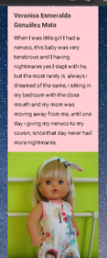

Reflection

During this unit I learned many new things, which I have not mastered well yet, but knowing the verbs in the past participle was a great challenge because although there are some rules it is complicated