ESCUELA NORMAL DE EDUCACIÓN PREESCOLAR

Ciclo 2020 – 2021



Student: Dibeth Atziri Carreón

4th Semester, Section B

Teacher: Mayela Alejandra del Carmen Gaona García

Course: ENGLISH B2 ONLINE

“Languaskill Practice”

Unit. 3

June 6th, 2021 Saltillo, Coahuila

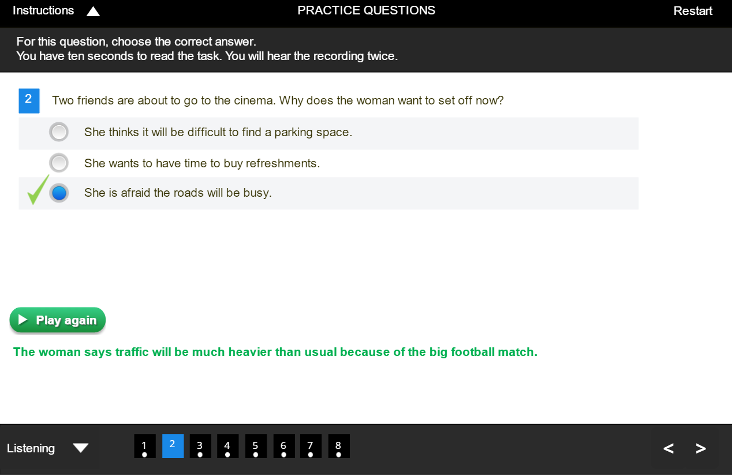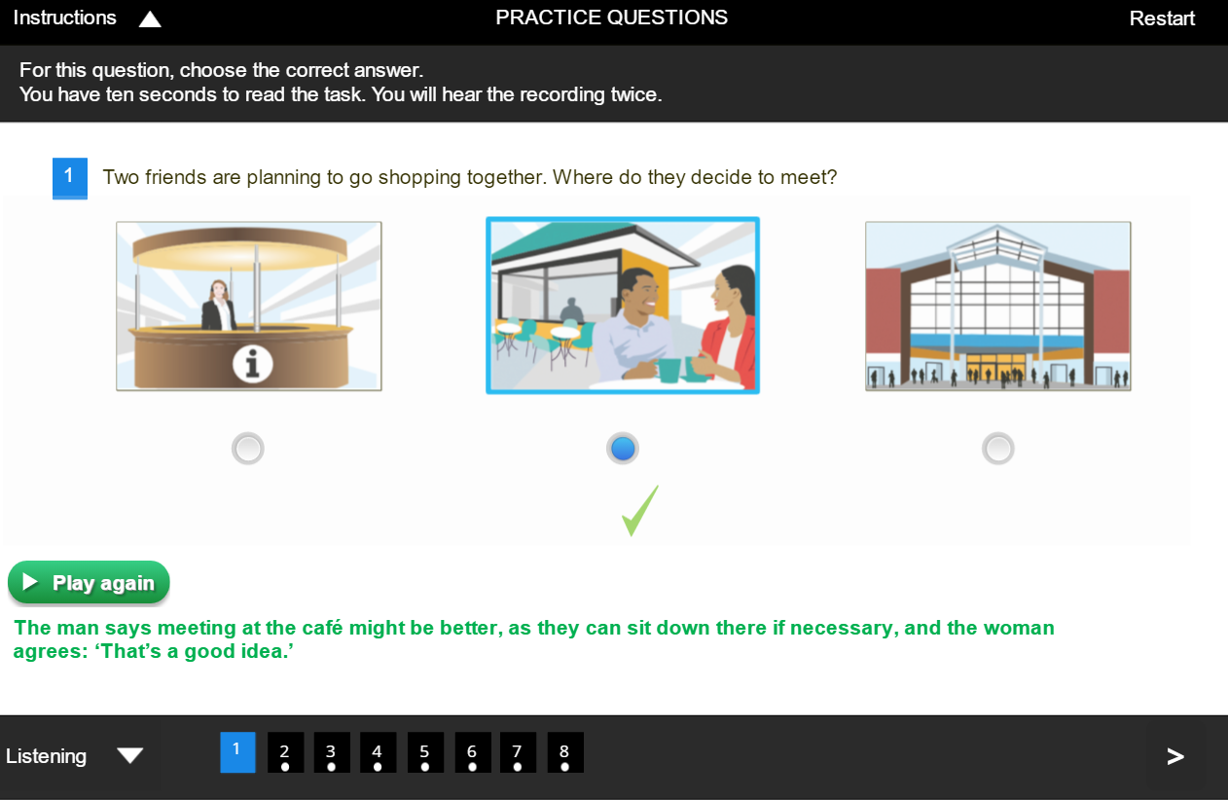

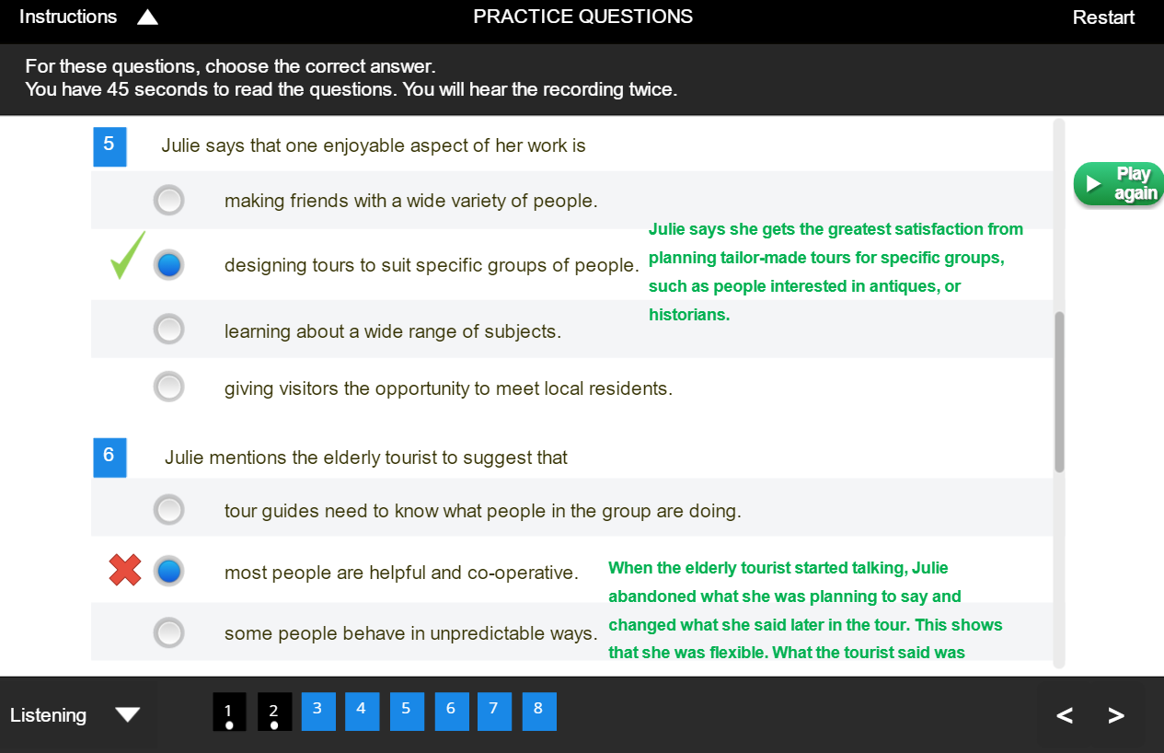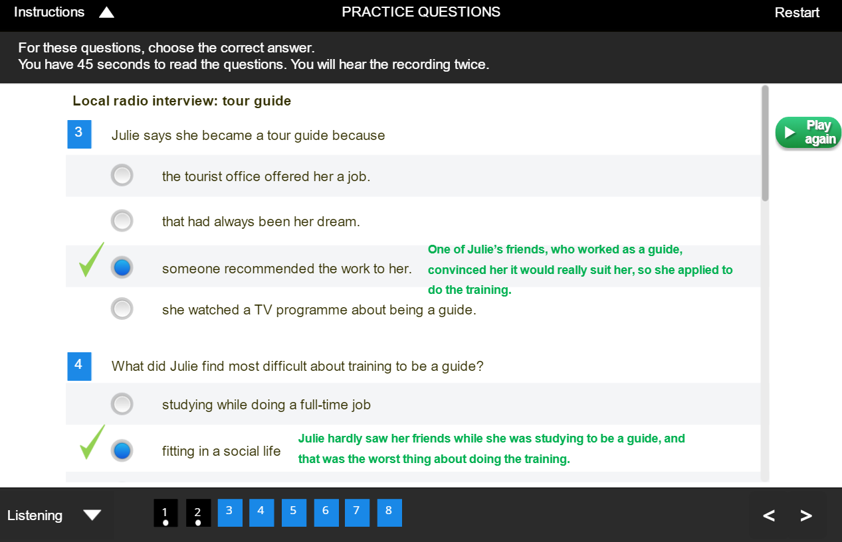

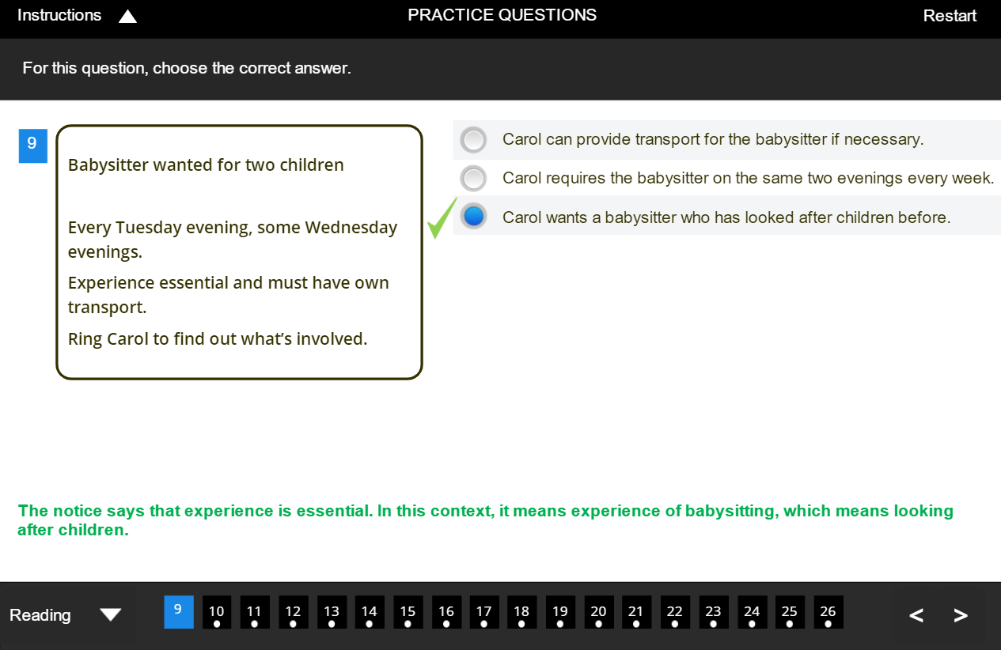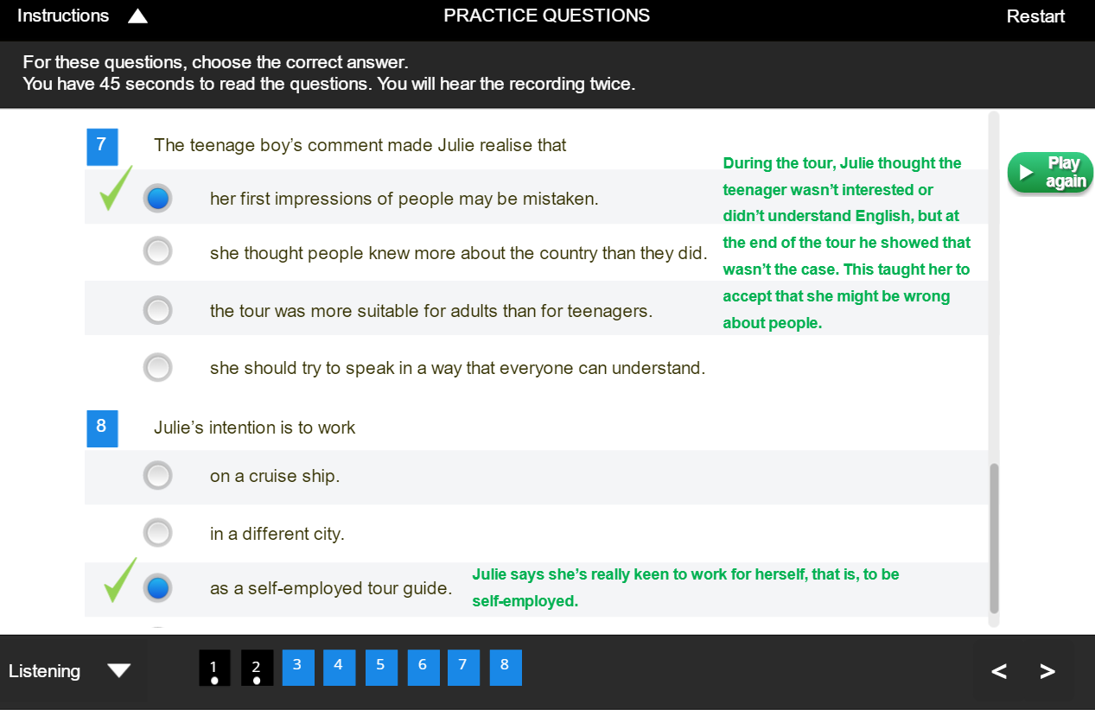

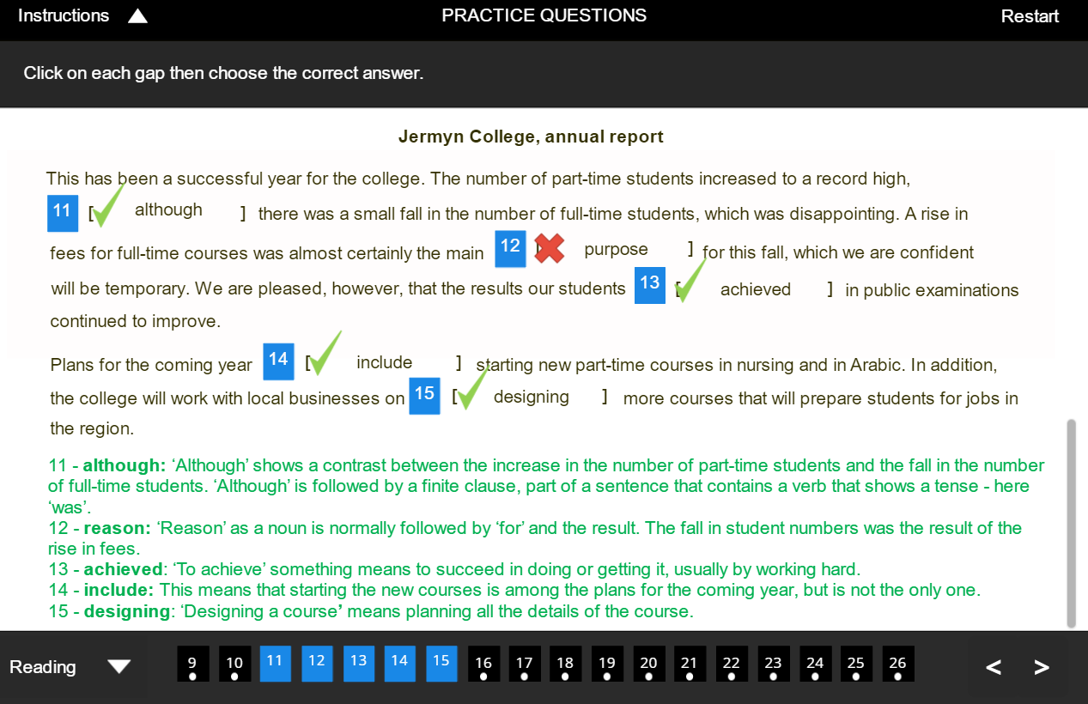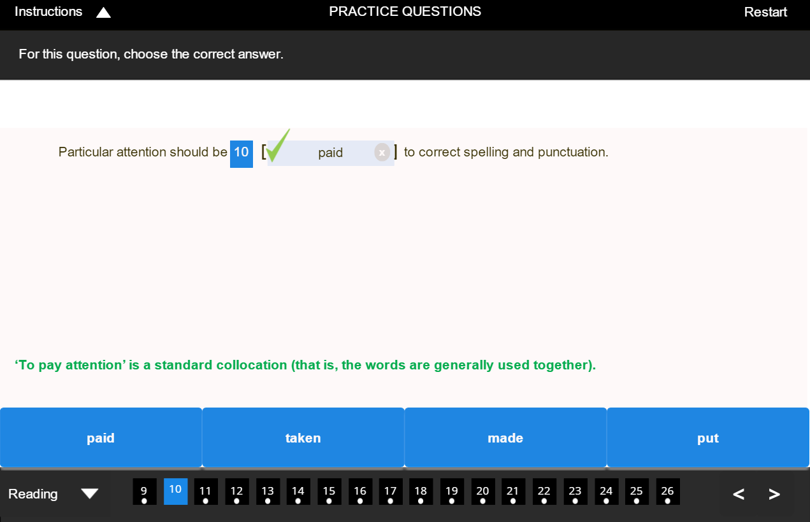

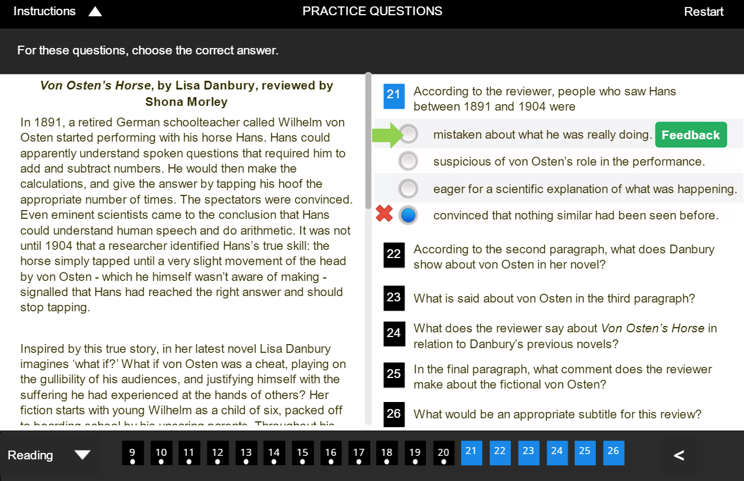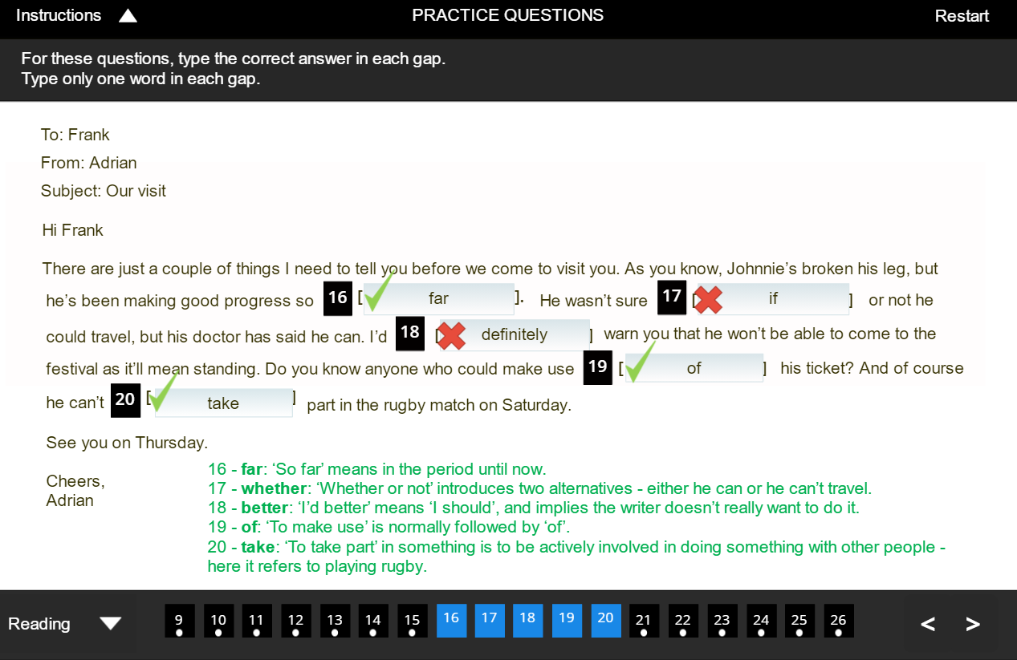

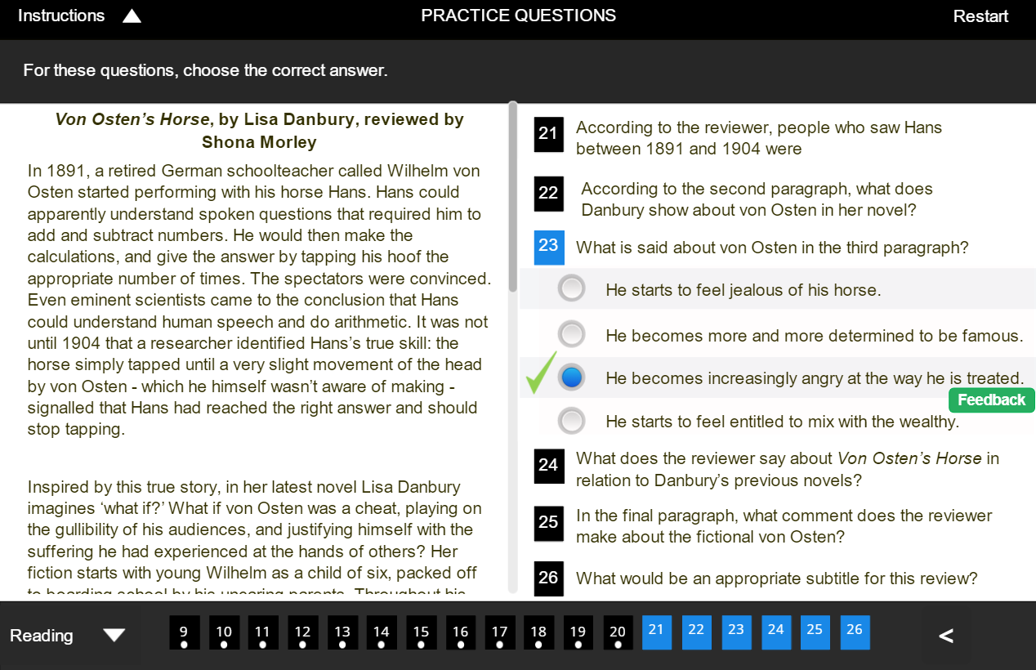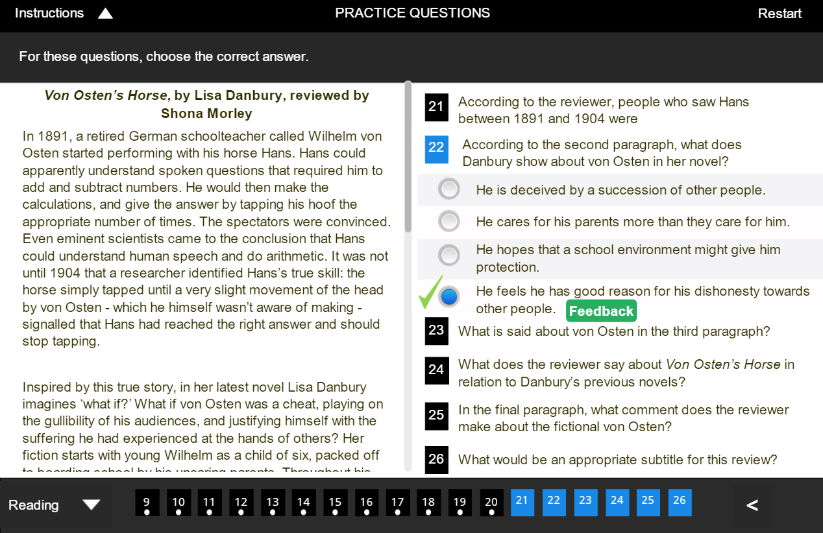

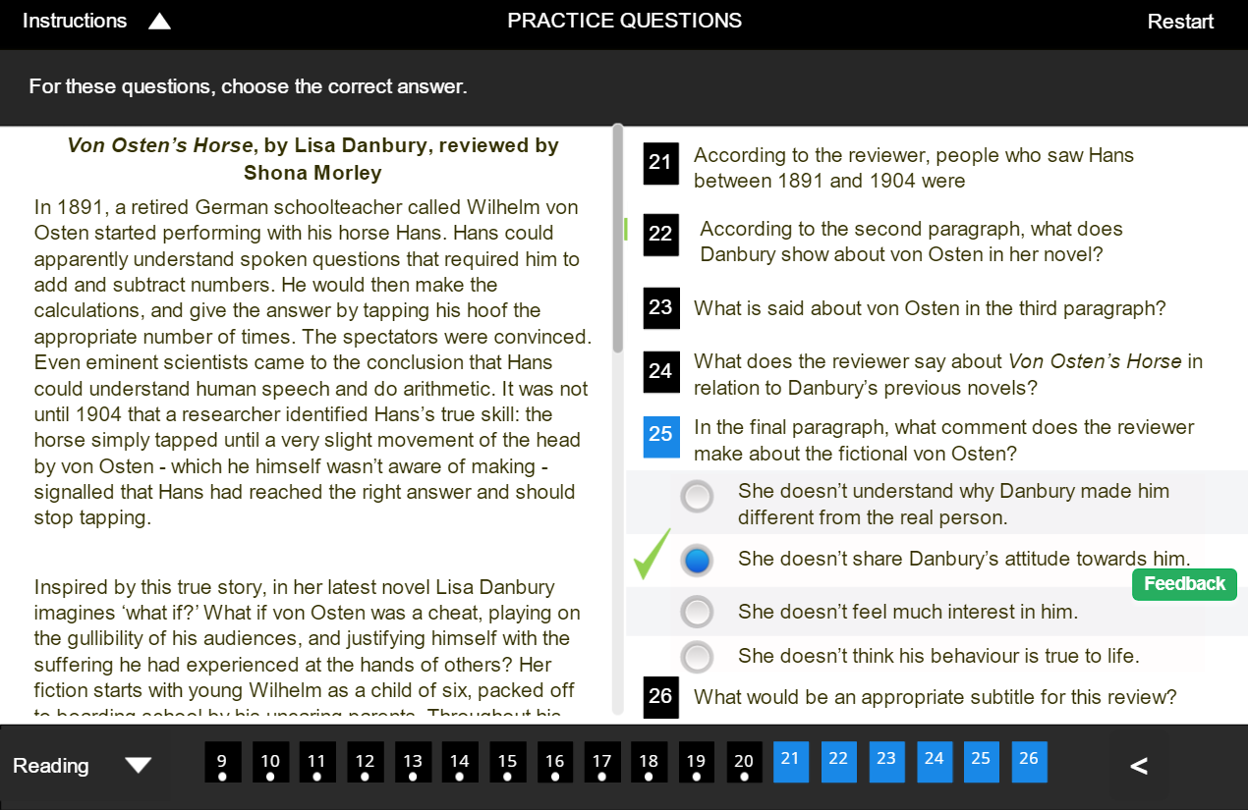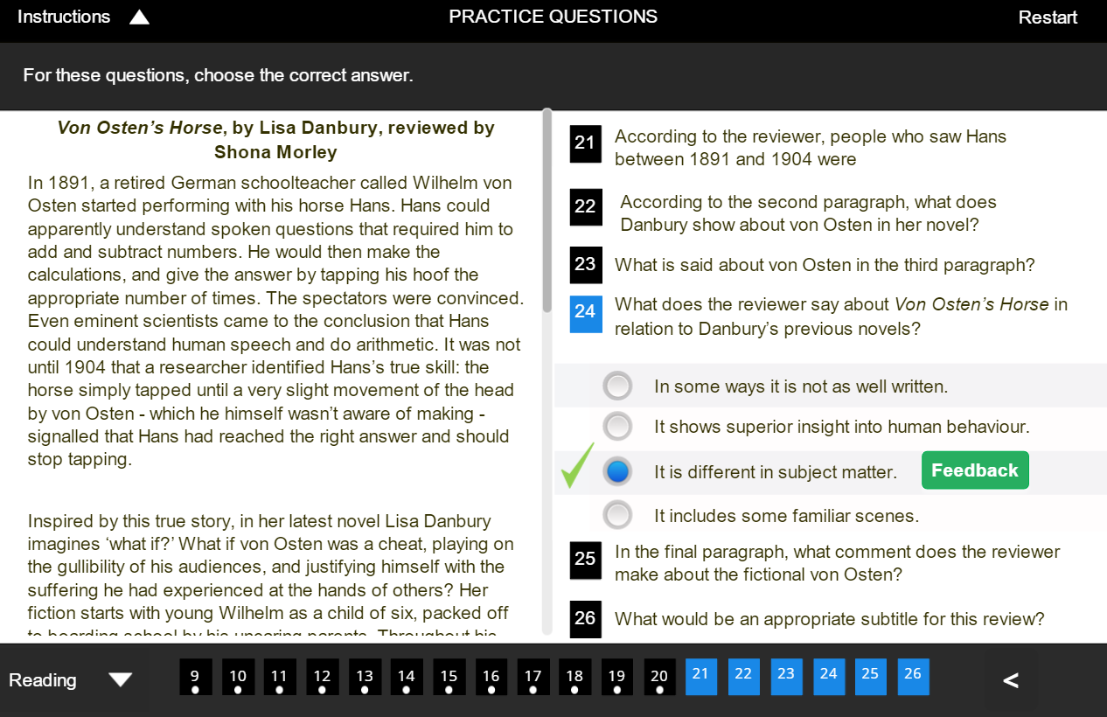

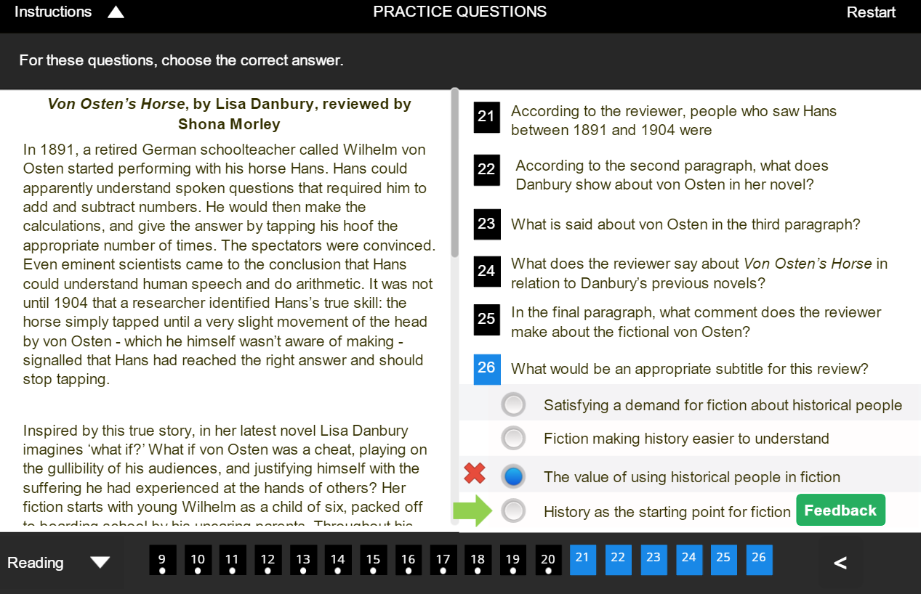

**LETTER TO JAN**

*Dear Jan,*

*Oh my goodness! Has it been that long already? It feels like it was only yesterday when we graduated college, it’s crazy how time flies now that we’re grown adults. We should definitely get together and catch up on life because I miss everyone. There is this beautiful outdoor restaurant-bar located in the downtown area of the city, with an amazing view of it all, plus, the food and drinks have super accessible prices. I think it would be a great idea to meet up there either Friday or Saturday so that everyone can join! We could meet around 6:00 pm so that everyone can go home early if they wish. I’ll call the place to make a reservation if you need me to. I’ll just need everyone to RSVP. This will be so fun! I can’t wait.*

*Dibeth Carreón*