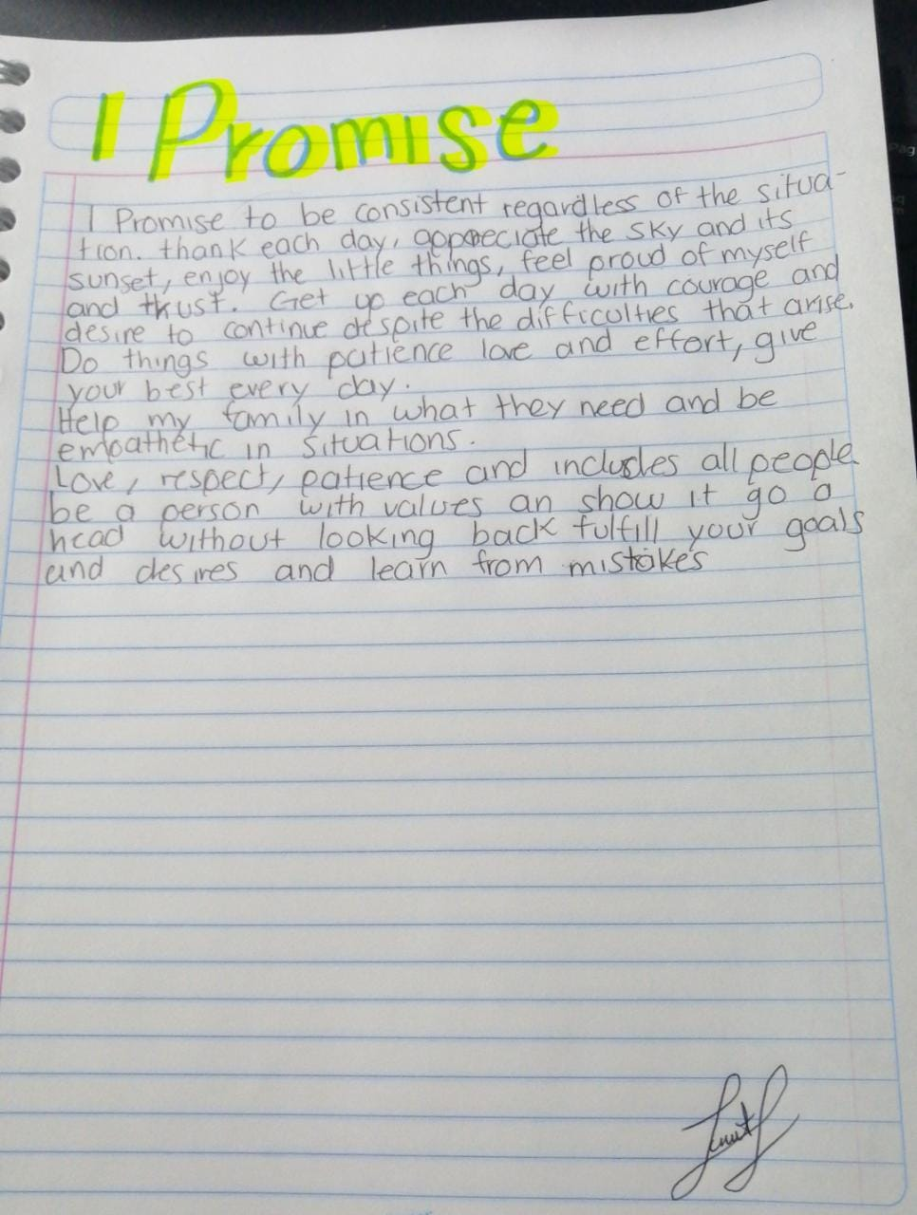

<https://flipgrid.com/s/AzFCYvUsuzu3>