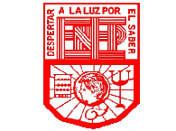 Escuela Normal de Educación Preescolar del Estado de Coahuila

Licenciature in preschool education

2020-2021 school year

English

-Workbook-

Student. Paulina García Sánchez

1” A”

Teacher. Beatriz Eugenia Valdés Rodríguez

Saltillo, Coahuila June 2021

