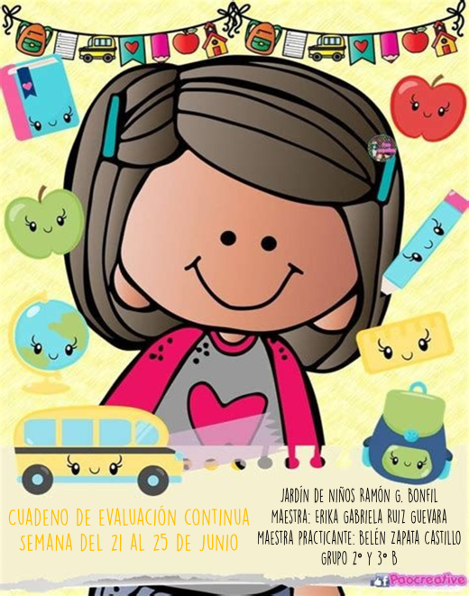

https://drive.google.com/drive/folders/1FkOIh644z72i6c44VnY0xTeQ30ho8EZx?usp=sharing