**Units 1–10 *TEST B***

Listen to Stephanie and Robert talking. Check (✓) the correct answers. **(2 POINTS)** 

|  |  |
| --- | --- |
| 1. Robert works ______ . | 2. Stephanie doesn’t _____ . |
| ⬜ in the morning | * ~~⬜work~~ |
| ⬜ in the afternoon | ⬜ study |
| * ~~⬜at night~~ | ⬜ have classes |

Listen to John and Andrea talking. Check (✓) the correct answers. **(2 POINTS)** 

|  |  |  |
| --- | --- | --- |
| 1. On Saturday night, Andrea usually _____ . | 2. Andrea enjoyed the dinner because _____ . | |
| ⬜ stays home | ⬜ she likes to eat late | |
| ⬜ goes dancing | * ~~⬜she was hungry~~ | |
| * ~~⬜sees a movie~~ | ⬜ the food was good | |

Complete each conversation. Use the correct form of *be* or *do*. **(4 POINTS)**

1. A: What’s his name?

B: His name _is_ Paul.

2. A: What do you do?

B: I’m a chef.

3. A: Are you from Brazil?

B: No, we _______________ .

4. A: What kind of music does Vicky like?

B: She likes reggae music.

Complete this story. Use the words from the box. One word will not be used. **(5 POINTS)**

|  |  |  |
| --- | --- | --- |
| a few | many | nearly all |
| a little | much | no one |

I spent the summer at my cousin’s house in Royal Oak. It’s a great city. There isn’t much crime,

(1)

so I felt very safe. There are many restaurants in Royal Oak, but nearly all of them are

(2) (3)

expensive, so we also ate home a lot. There are a few cheap ones, but they aren’t very good.

(4)

There was only a little rain this summer. Most days were sunny and beautiful.

(5)

Read Rod’s composition. Then circle **T** (true) or **F** (false). **(4 POINTS)**

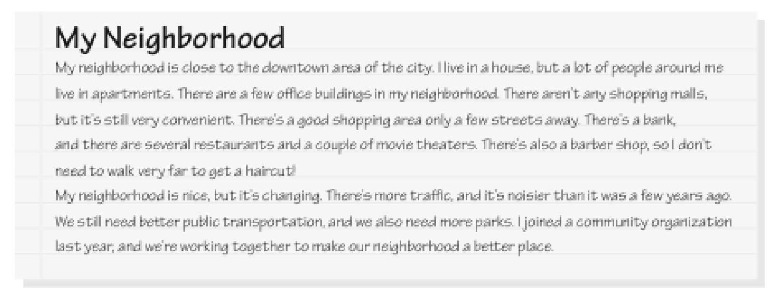

1. T. F No one in Rod’s neighborhood lives in a house.

2. T F.There are some office buildings in his neighborhood.

3. T. FHe can walk to get a haircut.

4. T F.He thinks public transportation is better than it was before.

Dan is introducing himself and his family. Complete the sentences. Use the simple present or the present continuous of the verbs given. **(6 POINTS)**

1. My name is Dan, and I study (study) English at a university now.

(1)

2. I _have___ (have) one sister, Laura.

(2)

3. She’s a server, and she ___works____ (work) at a restaurant four days a week.

(3)

4. My parents _doesn’t work_____ (not work) now. They’re in their seventies.

(4)

5. They __live___ (live) in Miami.

(5)

6. But, they ___taken___ (take)a vacation in Australia right now.

(6)

Check (✓) the correct words to complete the sentences. **(5 POINTS)**

1. Louisa answers the phone and greets visitors to the office. She’s a _________ .

⬜ cashier ⬜ receptionist⬜ flight attendant

2. Carrie is my aunt’s daughter. She’s my _____ .

⬜ niece ⬜ cousin⬜ sister

3. I didn’t feel well yesterday, so I _________ the afternoon off.

⬜ did⬜ took⬜ made

4. I listen to music a lot. I especially enjoy _________ .

⬜ soap operas⬜ pop⬜ action

5. Maria does __________ every morning before breakfast.

⬜ yoga⬜ tennis⬜ swimming

Complete this conversation. Use the past tense of the verbs given. **(6 POINTS)**

A: ____When did___ (be) you at home last night?

(1)

B: I ___was___ (be) at home until 8:00. Why?

(2)

A: Well, I ___called___ (call) around 8:30, but you __didn’t answer____ (not answer).

(3) (4)

B: Why ____did____ you ____call__ (call)?

(5)

A: Oh, I just ____wanted___ (want) to chat.

(6)

Match the answers with the questions. **(6 POINTS)**

|  |  |
| --- | --- |
| 1. How often do you watch TV? __c____ | a. Yes, I’d love to. |
| 2. What kinds of TV shows do you like? ___d___ | b. No, there aren’t. |
| 3. What are you watching now? _e___ | c. Usually every day. |
| 4. Are there any good programs on TV tonight? _b___ | d. I love game shows. |
| 5. Would you like to watch a football game with me? __a__ | e. I’m watching a talk show. |
| 6. Do you like soap operas? ___f___ | f. No, I don’t like them. |

Check (✓) the correct word or phrase to complete each conversation. **(6 POINTS)**

1. A: Which camera do you like?

B: I like _________ .

⬜ this small ⬜ the one ⬜ the small one

2. A: When do you usually go to bed?

B: _________ midnight.

⬜ In ⬜ At ⬜ On

3. A: Is the ring expensive?

B: Yes, but it’s _________ the necklace.

⬜ the cheap ⬜ cheaper ⬜ cheaper than

4. A: How _________ are you at tennis?

B: I don’t play tennis.

⬜ good⬜ often⬜ well

5. A: _________ you like to go out to dinner tonight?

B: I’m sorry. I can’t.

⬜ Do ⬜ Would ⬜ Are

6. A: I need to mail this letter.

B: _________ a post office on Oak Street.

⬜ It’s ⬜ There’s ⬜ That’s

Arrange these words to make sentences. **(8 POINTS)**

1. in / last / Marcos / was / Peru / week / ?

__Marcos was in Peru last week______ ?

2. goes / on / vacation / never / Lynn / away / almost

____Lynn almost never goes away on vacation_________ .

3. than / cheaper / is / this sweater / one / that

__This sweater is cheaper than that one____________________ .

4. often / do / go / grocery store / you / the / how / to / ?

__How often do you go to the grocery store_______ ?

5. you/ ever / Mexico / been / have / to / city / ?

____Have you ever been to Mexico city______?

6. never / They / it's / eaten / expensive / with truffles / have / pizza / because / too /

____They never eaten pizza with truffles because it’s too expensive_____________

7. have / gotten / parents / My / already / for / vaccination / Covid-19

____My parents have already gotten Covid-19 for vacation _____________________

8. yet / she / has / abroad / traveled / ?

____Has she traveled aboard yet?

__________________________________________________________________________?

**L. Use the present perfect and for and since appropriately. (8 points)**

**1. I´ve_studied (study) at Enre _since_ 2019.**

**2. Miss Beatriz Valdes _was_ (be) my English teacher _for__ ten months.**

**3. They´re_went_ (go) out together __since__ she broke up with her last boyfriend.**

**4. John has worked_ (work) for General Motors Co._since_ the past four years.**