**Units 1–10 *TEST B***

Name: Nataly Melissa Reynoso Pérez

Date: 22/06/2021

Score: 75+100+80+50+100+83+80+67+62+100+62= 854/11= 7.8

Listen to Stephanie and Robert talking. Check (✓) the correct answers. **(2 POINTS) ¾= 75**

|  |  |
| --- | --- |
| 1. Robert works ______ . | 2. Stephanie doesn’t _____ . |
| ⬜ in the morning | ✓ work ✓ |
| ⬜ in the afternoon | ⬜ study |
| ✓ at night ✓ | ⬜ have classes |

Listen to John and Andrea talking. Check (✓) the correct answers. **(2 POINTS)** 

|  |  |
| --- | --- |
| 1. On Saturday night, Andrea usually _____ . | 2. Andrea enjoyed the dinner because _____ . |
| ⬜ stays home | ⬜ she likes to eat late |
| ✓ goes dancing | ✓ she was hungry ✓ |
| ⬜ sees a movie | ⬜ the food was good |

Complete each conversation. Use the correct form of *be* or *do*. **(4 POINTS) 4/4=100**

1. A: What’s his name?

B: His name **Is** Paul.

2. A: What **do** you do?

B: I’m a chef.

3. A: Are you from Brazil?

B: No, we **aren´t**

4. A: What kind of music **does** Vicky like?

B: She likes reggae music.

Complete this story. Use the words from the box. One word will not be used. **(5 POINTS) ⅘=80**

|  |  |  |
| --- | --- | --- |
| ~~a few~~ | ~~many~~ | ~~nearly all~~ |
| ~~a little~~ | much | ~~no one~~ |

I spent the summer at my cousin’s house in Royal Oak. It’s a great city. There isn’t **no one** crime,

(1)

so I felt very safe. There are **many**  restaurants in Royal Oak, but **nearly all** of them are

(2) (3)

expensive, so we also ate home a lot. There are **a few** cheap ones, but they aren’t very good.

(4)

There was only **a little** rain this summer. Most days were sunny and beautiful.

(5)

Read Rod’s composition. Then circle **T** (true) or **F** (false). **(4 POINTS) 2/4= 50**

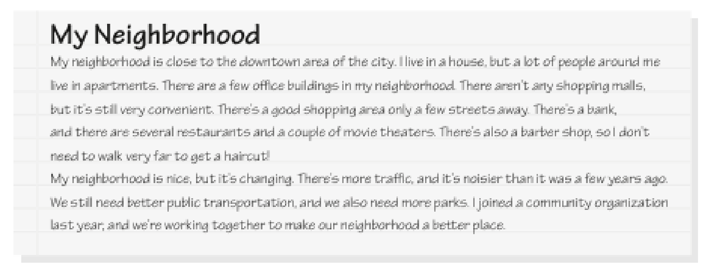

1. T F No one in Rod’s neighborhood lives in a house.✓

2. T FThere are some office buildings in his neighborhood.

3. T FHe can walk to get a haircut.

4. T FHe thinks public transportation is better than it was before.✓

Dan is introducing himself and his family. Complete the sentences. Use the simple present or the present continuous of the verbs given. **(6 POINTS) 4/6=** **6.7**

1. My name is Dan, and I**´m studying** (study) English at a university now.

(1)

2. I **have** (have) one sister, Laura.

(2)

3. She’s a server, and she **works** (work) at a restaurant four days a week.

(3)

4. My parents **doesn’t work** (not work) now. They’re in their seventies.

(4)

5. They**´ve** **living** (live) in Miami.

(5)

6. But, they**´re taking** (take)a vacation in Australia right now.

(6)

Check (✓) the correct words to complete the sentences. **(5 POINTS) ⅘=80**

1. Louisa answers the phone and greets visitors to the office. She’s a _________ .

⬜ cashier ✓ receptionist⬜ flight attendant

2. Carrie is my aunt’s daughter. She’s my _____ .

⬜ niece ✓ cousin⬜ sister

3. I didn’t feel well yesterday, so I _________ the afternoon off.

⬜ did✓ took⬜ made

4. I listen to music a lot. I especially enjoy _________ .

⬜ soap operas✓ pop⬜ action

5. Maria does __________ every morning before breakfast.

✓ yoga⬜ tennis⬜ swimming

Complete this conversation. Use the past tense of the verbs given. **(6 POINTS) 4/6= 67**

A: **Were** (be) you at home last night?

(1)

B: I **was** (be) at home until 8:00. Why?

(2)

A: Well, I **called** (call) around 8:30, but you **didn’t answered**  (not answer).

(3) (4)

B: Why **did** you **called** (call)?

(5)

A: Oh, I just **wanted** (want) to chat.

(6)

Match the answers with the questions. **(6 POINTS) 6/6=100**

|  |  |
| --- | --- |
| 1. How often do you watch TV? **c** | ~~a. Yes, I’d love to.~~ |
| 2. What kinds of TV shows do you like? **d** | ~~b. No, there aren’t.~~ |
| 3. What are you watching now? **e** | ~~c. Usually every day.~~ |
| 4. Are there any good programs on TV tonight? **b** | ~~d. I love game shows.~~ |
| 5. Would you like to watch a football game with me? **a** | ~~e. I’m watching a talk show.~~ |
| 6. Do you like soap operas? **f** | f. No, I don’t like them. |

Check (✓) the correct word or phrase to complete each conversation. **(6 POINTS) ⅚=83**

1. A: Which camera do you like?

B: I like _________ .

⬜ this small ⬜ the one ✓ the small one

2. A: When do you usually go to bed?

B: _________ midnight.

⬜ In ✓ At ⬜ On

3. A: Is the ring expensive?

B: Yes, but it’s _________ the necklace.

⬜ the cheap ⬜ cheaper ✓ cheaper than

4. A: How _________ are you at tennis?

B: I don’t play tennis.

⬜ good✓ often⬜ well

5. A: _________ you like to go out to dinner tonight?

B: I’m sorry. I can’t.

⬜ Do ✓ Would ⬜ Are

6. A: I need to mail this letter.

B: _________ a post office on Oak Street.

⬜ It’s ✓ There’s ⬜ That’s

Arrange these words to make sentences. **(8 POINTS) 8/8=** **90**

1. in / last / Marcos / was / Peru / week / ?

**Was Marcos in Peru last week**? ✓

2. goes / on / vacation / never / Lynn / away / almost

**Lyn almost never goes away on vacation**. ✓

3. than / cheaper / is / this sweater / one / that

**This sweater is cheaper than that one** .✓

4. often / do / go / grocery store / you / the / how / to / ?

**How often do you go to the grocery store** ? ✓

5. you/ ever / Mexico / been / have / to / city / ?

**Have you ever been to Mexico city**? ✓

6. never / They / it´s / eaten / expensive / with truffles / have / pizza / because / too /

**They have never eaten pizza with truffles because it´s too expensive** ✓

7. have / gotten / parents / My / already / for / vaccination / Covid-19

**My parents already have gotten for vaccination Covid-19** ✓

8. yet / she / has / abroad / traveled / ?

**Has she traveled abroad yet?**✓

__________________________________________________________________________?

**L. Use the present perfect and for and since appropriately. (8 points) 5/8=62**

**1. I studied (study) at Enre since 2019.**

**2. Miss Beatriz Valdes was (be) my English teacher for ten months.**

**3. They have gone (go) out together since she broke up with her last boyfriend.**

**4. John Worked (work) for General Motors Co., for the past four years.**