**ESCUELA NORMAL DE EDUCACIÓN PREESCOLAR**

**ENGLISH A1.2 DEVELOPING ELEMENTARY CONVERSATIONS**

**UNIT 10 – What sports do you like?**

**Dear students,**

In this activity you will listen for details in a conversation about people’s abilities using can

(Your teacher will send the audio via WhatsApp)

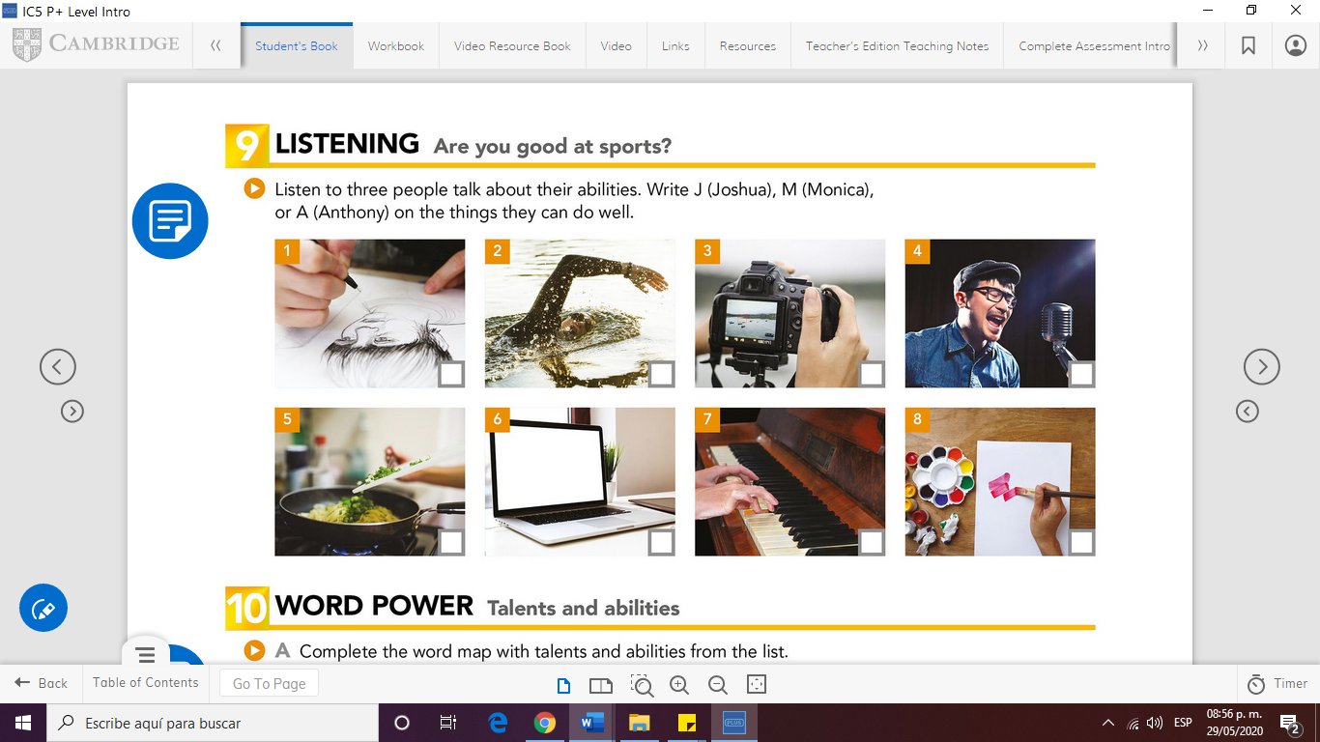

Now, study the following chart and complete the exercises below.

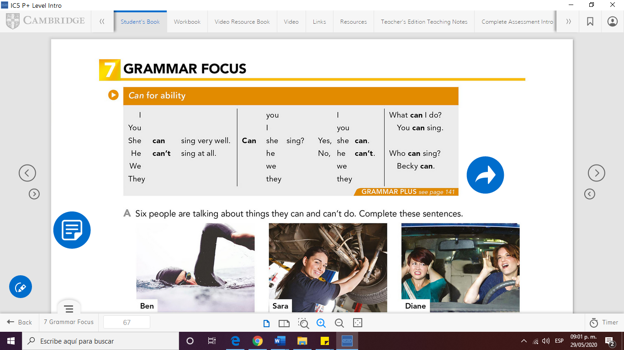

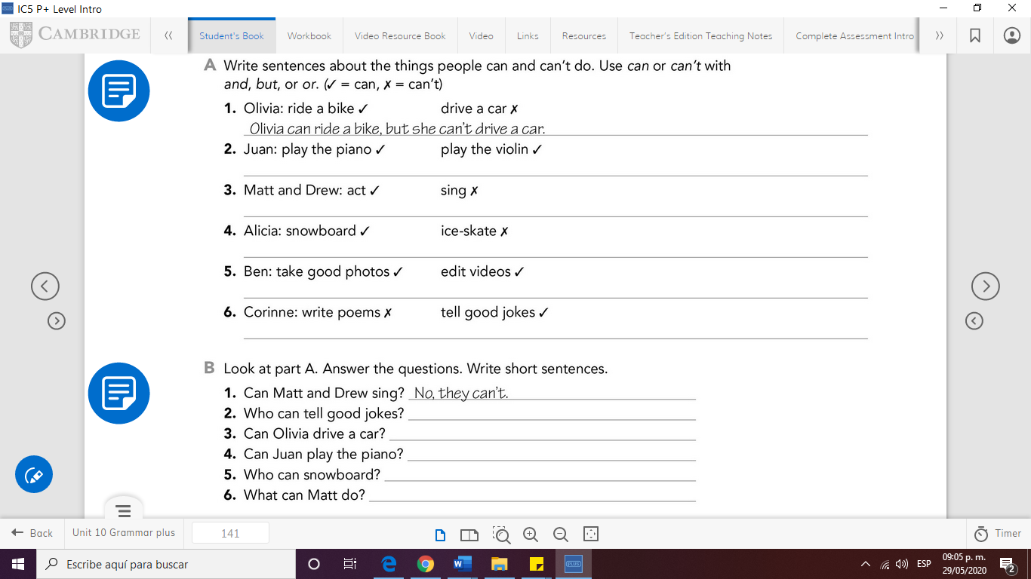

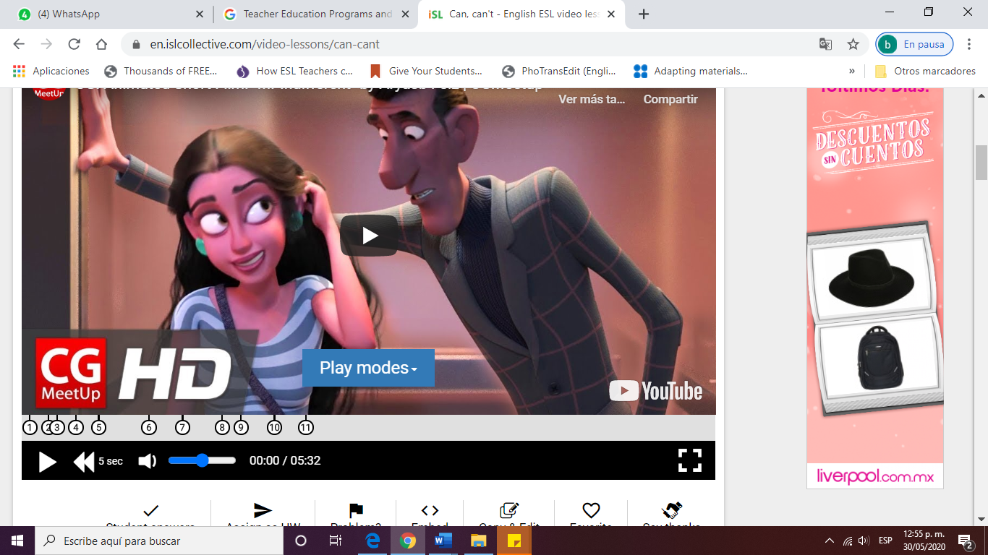Need more practice??? Watch this wonderful video and complete the activity!!!

Click on and play CASINO ! bet your money and report how

much you won!

<https://en.islcollective.com/video-lessons/can-cant>

**Do you want to practice the pronunciation of CAN and CAN’T?**

**Then click on the following link and listen to the PODCAST!!! Podcast are super popular teaching and learning tools.**

<https://www.myhappyenglish.com/217-can-vs-cant-pronunciation-lesson/>

Write each sentence in a different way. Use the sentences in the box.

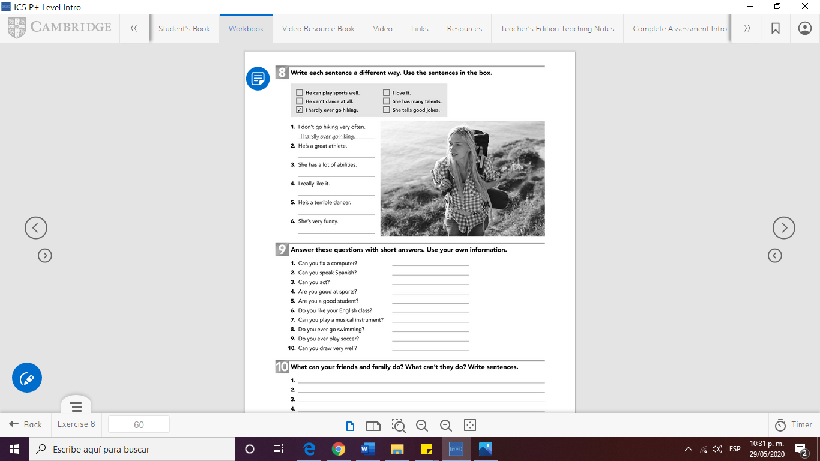

Answer these questions with short answers. Use your own information

1. Can you speak English? _________________
2. Can you rap?
3. Are you good at sports?
4. Are you a good student?
5. Do you like your English class?
6. Can you play a musical instrument?
7. Do you ever go bike riding?
8. Can you draw well?
9. Can you act?



What can your friends or family do? Write 5 sentences.

1. __________________________________________
2. _
3. _
4. _
5. _