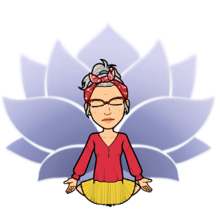

**Dear all,**

**We are beginning a new cycle and it is important to remember that we are in an unusual situation. We need to be ready to face the challenges. MINDFULNESS and SOCIO- EMOTIONAL TOOLS will be very IMPORTANT.**

We will start with an appreciation exercise :

Make a list!

Start a gratitude journal. List 5 people, experiences, or things you are grateful for. Spend a few minutes on each item savoring your appreciation. Check your list every week.

**Example:**

**I am grateful for my …**

**I give thanks for…**

**What I appreciate more is…**

**Now you need to make a good plan to begin this new cycle**

**(you can complete this exercise in SPANISH to express your thoughts better)**

**In each area, write about how to set yourself up for success this school year.**