This activity will help you give your opinion and develop communication skills. Complete each exercise and upload a 30-second video on your own personal opinion.

**LEARNING GOALS:**

1. Students will examine a real hero and write about that person’s traits.
2. Students will express their opinion and practice communication skills.

**INSTRUCTIONS:**

1. Check the following rubric.
2. Write an essay about your hero.
3. Present your hero in a 2-minute video that holds the audience's attention and provides a complete summary of the information.
4. Upload the video to Flipgrid with your details.

<https://flipgrid.com/8fc6bd29>

**Heroes Around Us**

Word-process a three-paragraph report on your hero.

1. The first paragraph should introduce your hero and include a brief chronological description of your hero’s life or special experiences.
2. The second paragraph will explain how your hero’s life and deeds demonstrated heroism.
3. The last paragraph will describe characteristics of a hero that you feel your hero’s behavior reflects and should conclude with a lesson that you feel this person’s life or behavior teaches us.

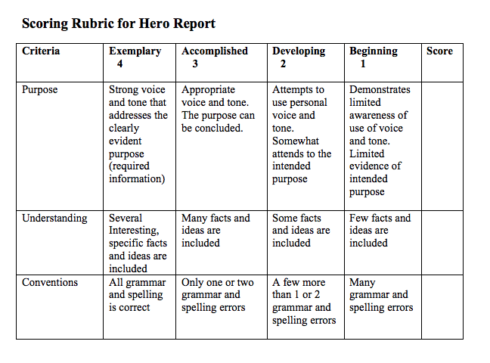

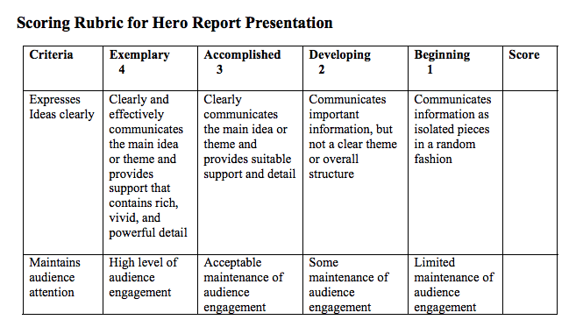

**/20**

**VIDEO - 2-minute video answering the following question.**

[**https://flipgrid.com/8fc6bd29**](https://flipgrid.com/8fc6bd29)

1. Present their hero to the class in a manner that holds the audience's attention and provides a complete summary of the information.
2. Share what is the most important thing you learned about when working on this project.