ESCUELA NORMAL DE EDUCACIÓN PREESCOLAR

ENGLISH A2.1

UNIT 1 – WHERE ARE YOU FROM?

VOCABULARY

**Hello dear students, in this unit we will learn how *to introduce our selves and others*. Please complete the following activities and upload your product to Escuela en Red.**

1. **EXPRESSIONS TO SAY HELLO AND GOOD BYE**

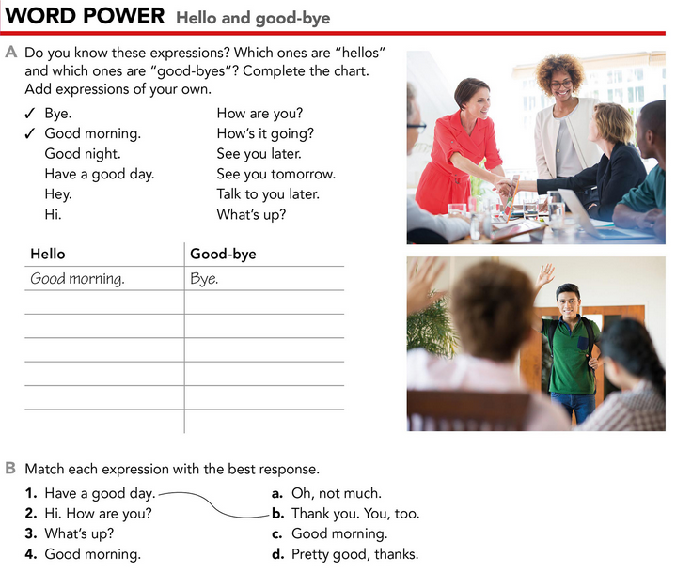

1. **COUNTRIES, NATIONALITIES AND LANGUAGES**

Complete the chart writing the correct country, nationality or language.

|  |  |  |
| --- | --- | --- |
| **COUNTRY** | **NATIONALITY** | **LANGUAGE** |
|  | Mexican |  |
| Guatemala |  |  |
|  |  | French |
|  | Brazilian |  |
| United States of America |  |  |
|  | Canadian |  |
|  |  | Arabian |
| Germany |  |  |
|  | Italian |  |
| Peru |  |  |

1. **INFORMATION QUESTIONS AND YES/NO QUESTIONS**

Re-write the following questions in the correct column.

* What’s your name?
* Is Mr. Harris from the United States?
* Are you in my English class?
* Where is she from?
* Is your Math class in the morning?
* What do people call you?
* How do you spell your name?
* Are you and Luis from Monterrey?
* What’s Saltillo like?
* How are your classes?
* Are your classess interesting?
* Who is Lisa?

|  |  |
| --- | --- |
| **INFORMATION QUESTIONS** | **YES/NO QUESTIONS** |
|  |  |

1. **VERB BE AND POSSESIVE ADJECTIVES**

Fill in the blanks with the correct form of the verb BE (am/is/are) or possessive adjectives (my, your, our, their, its)

Hello, I _____ Arturo, _____ last name is Valdez. I _____ from México and all _____ family lives in the United States. _____ best friend _____ Alexa, _____ last name is Costa and she _____ from Brazil. _____ favorite subject is science, we love science.

1. **DISCOURSE MANAGEMENT**

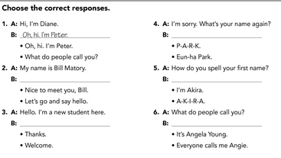



1. **INFORMATION ABOUT YOU AND QUESTIONS FOR A PARTNER**

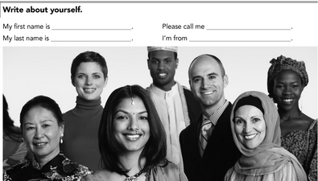

Write *five questions* for a partner asking about his/her personal information.