Learning Evidence Unit 1
THIS IS US!

Aims: | - Introduce oneself and others  - Talk about oneself and learn about others.

- DATE: 10/09/2021
- TEAM INFORMATION:
Kathia Anahi Castañuela Salas
Maria Ximena Avalos Flores
Valeria Torres Gutierrez
- LINK TO YOUR VIDEO: https://youtu.be/k3bo2twrvT4
Plan
TRIO WORK
Create a conversation where you meet for the first time.
Get to know your classmates. Use these questions and your own questions.
Ximena
Valeria
Kathia

- Hi !!!
- Hello, good morning friends
- Good morning
- Hey, who are you?
- Pretty good, thanks and you?
- Very good also thank you
- Are your sisters?
- No, she´s not. She is my class mate
- ooh, What’s she name?
- she´s name is Valeria
- I’m sorry. What’s your last name again, Valeria ?
- My last name is Torres
- Okey, How do you spell it?
- T-O-R-R-E-S
- Wow, is you last name is Torres ?
- Yes, I am
- What do people call you?
- My people call is Vale
- Is your name trendy or unusual and unique?
- Yes, it is
- How did your family get your name?
- Oh, of an actress in a movie
- Wow, what cool vale
- Where are you from?
- I’m from BRASIL
- Yeah, I’m from FRNACE , how a bout you, valeria ?
- I’m from INGLAND
- What’s your town/city like?
- It´s really nacie. It´s a very exciting city
- How many people are in your family?
- We are all 20 people
- It´s Really valeria?
- Yes, it is
- How many people are in your family, Ximena?
- There are 12 people
- What is your brother’s/sister’s name, valera?
- My brothers names are Oscar, Rodrigo, Angela and Maria
- Where’s your family from, kathia ?
- They are from New York
- Where’s your family?
- There are visiting Mexico
- How are your classes, valeria?
- Very good, I like my classes
- What are your classmates like?
- they are very studious
- Are you and kathia in the same class?
- Yes, we are
- Is your English class in the morning?
- No, it´s not
- Yes, it is
- Are they free after class?
- yes, we are free
- Yes, we free
- Perfect, after school we go for an ice cream,
- Okey, se you later
- Have a good day
- Good bye

Write down other questions you want to use:
5 questions

Write down the language (vocabulary and expressions) from unit 1 you want to use:
In the teams

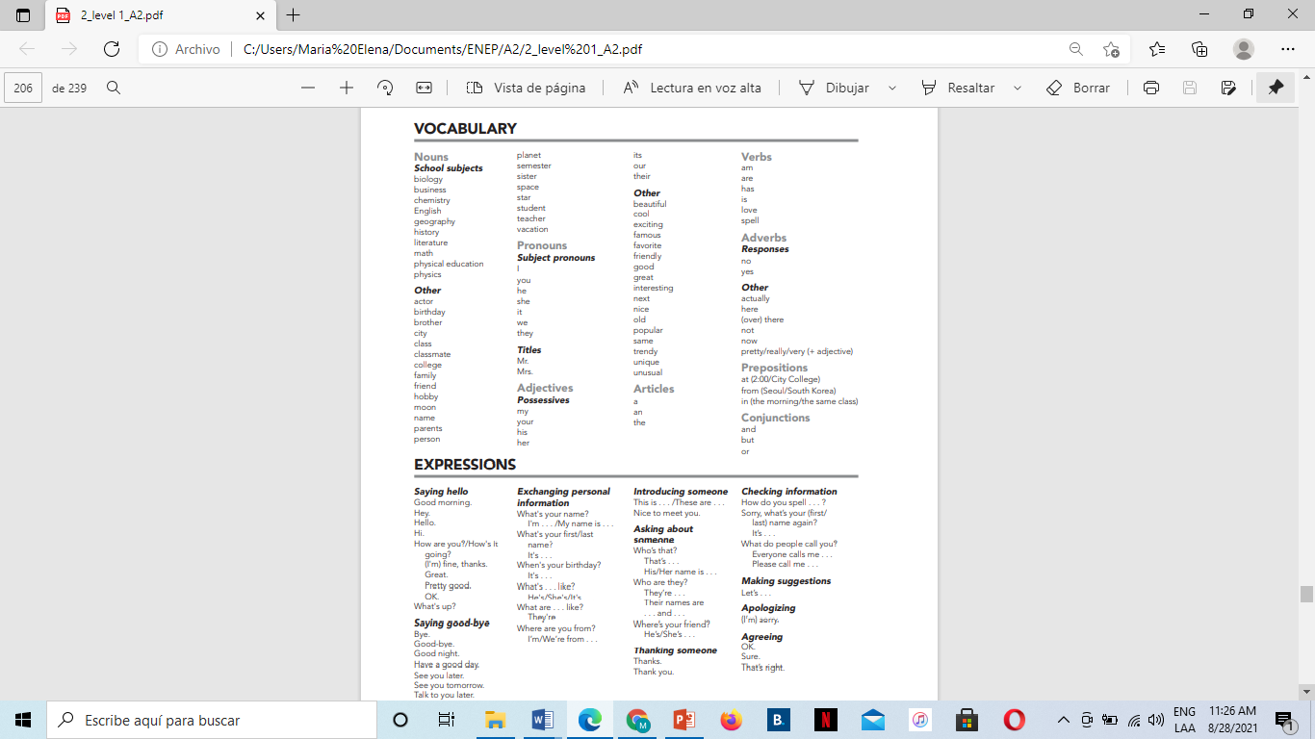 | RESOURCES:  All your Cambridge Interchange book’s material (PowerPoint Presentations, Escuela en Red uploaded information).  ADDITIONAL RESOURCES:  2 Hours of English Conversation Practice - Improve Speaking Skills  https://www.youtube.com/watch?v=NNamZZsggM4
Prepare
Practice your dialogues and pronunciation. Use photos to introduce your family members.

Present
Perform your conversation naturally without reading your dialogues. Be spontaneous. Use the proper intonation.
Video record yourselves and turn in you evidence of work by sharing the link to your video on this Word file.
Use the electronic device of your preference, but remember there’s a TEAMS video conference meeting option.

This activity is due to Monday September 6th, 2021.
All and each of the team members have to turn this project in.

- SPEAKING EVALUATION CRITERIA
 |  | Poor | Fair | Good | Very good | Excellent
Fluency | 0 | 1 | 2 | 3 | 4 | 5
Grammar | 0 | 1 | 2 | 3 | 4 | 5
Vocabulary | 0 | 1 | 2 | 3 | 4 | 5
Pronunciation | 0 | 1 | 2 | 3 | 4 | 5

Fluency = ability to speak quickly, naturally, and without many pauses.
Grammar = ability to use correct grammar and sentence structure.
Vocabulary = ability to understand and use vocabulary words and phrases.
Pronunciation = ability to use correct stress, rhythm, and intonation patterns.

