Learning Evidence Unit 1
THIS IS US!

Aims: | - Introduce oneself and others  - Talk about oneself and learn about others.

- DATE:
- TEAM INFORMATION:
- LINK TO YOUR VIDEO:
Plan
TRIO WORK
Create a conversation where you meet for the first time.
Get to know your classmates. Use these questions and your own questions.

- What’s your name?
- I’m sorry. What’s your last name again?
- How do you spell it?
- What do people call you?
- Is your name trendy or unusual and unique?
- How did your family get your name?
- Where are you from?
- What’s your town/city like?
- How many people are in your family?
- What is your brother’s/sister’s name?
- Where’s your family from?
- Where’s your family?
- How are your classes?
- What are your classmates like?
- Are you and [classmate’s name] in the same class?
- Is your English class in the morning?
- Are you free after class?
Write down other questions you want to use:

Write down the language (vocabulary and expressions) from unit 1 you want to use:

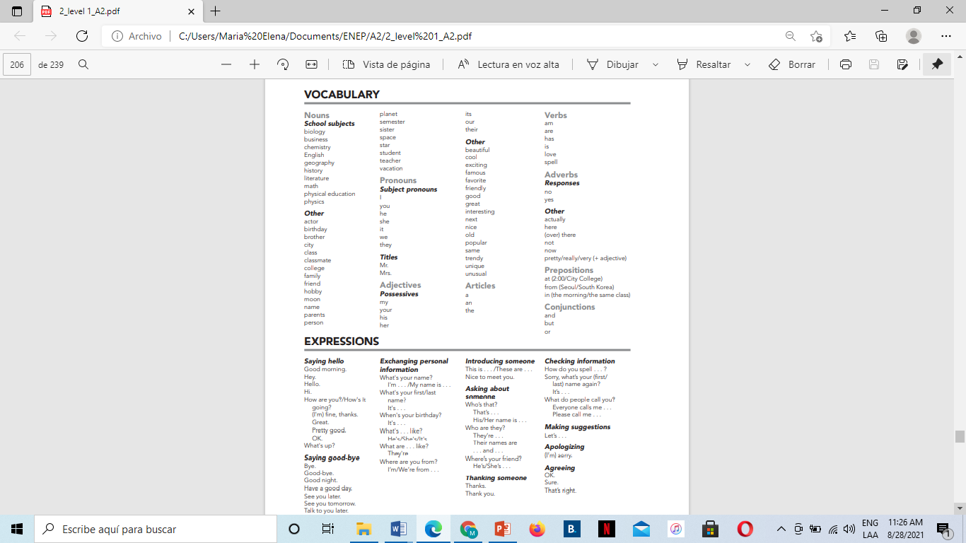 | RESOURCES:  All your Cambridge Interchange book’s material (PowerPoint Presentations, Escuela en Red uploaded information).  ADDITIONAL RESOURCES:  2 Hours of English Conversation Practice - Improve Speaking Skills  https://www.youtube.com/watch?v=NNamZZsggM4
Prepare
Practice your dialogues and pronunciation. Use photos to introduce your family members.

Present
Perform your conversation naturally without reading your dialogues. Be spontaneous. Use the proper intonation.
Video record yourselves and turn in you evidence of work by sharing the link to your video on this Word file.
Use the electronic device of your preference, but remember there’s a TEAMS video conference meeting option.

This activity is due to Monday September 6th, 2021.
All and each of the team members have to turn this project in.

- SPEAKING EVALUATION CRITERIA
 |  | Poor | Fair | Good | Very good | Excellent
Fluency | 0 | 1 | 2 | 3 | 4 | 5
Grammar | 0 | 1 | 2 | 3 | 4 | 5
Vocabulary | 0 | 1 | 2 | 3 | 4 | 5
Pronunciation | 0 | 1 | 2 | 3 | 4 | 5

Fluency = ability to speak quickly, naturally, and without many pauses.
Grammar = ability to use correct grammar and sentence structure.
Vocabulary = ability to understand and use vocabulary words and phrases.
Pronunciation = ability to use correct stress, rhythm, and intonation patterns.

Link del videoooo
https://youtu.be/t6kRzy4Q0mM
Dhanya Guadalupe Saldivar Martinez

