* 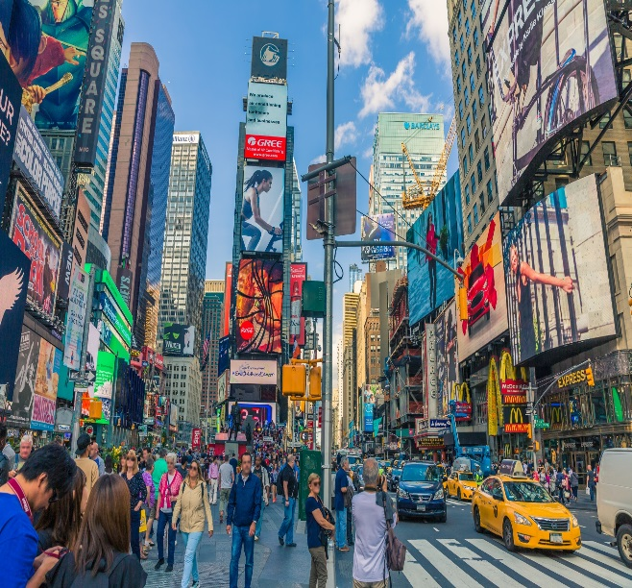DESTINATION: NAME OF THE CITY

**In New York, Estados unidos:**

NAME THREE THINGS YOU CAN DO THERE: IN LONDON YOU CAN….

* You can visited in the best time is amazing.
* You can buy the clothings, accesories and shoes.
* You can buy the cosmetics and the make up.

WHAT SHOULD YOU SEE/EAT/TRY THERE?

* You should visit the amazing and buildings interesting.
* You should try burgers and hot-dogs are true delicious
* You should visit the statue the liberty, and take out the helicopter tour.
* You should the visit zoologic and see the animals.

WHAT TIME OF THE YEAR SHOULD YOU GO THERE? IN WINTER, IN SUMMER, IN AUGUST.

* New York weather is very hot
* In Winter it´s very cold.

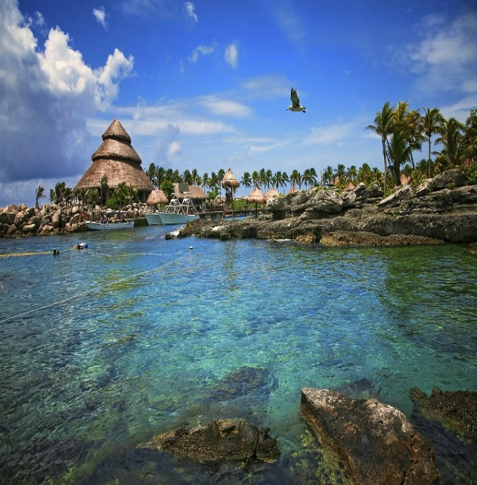

* DESTINATION: NAME OF THE CITY

**In Riviera Maya, México:**

NAME THREE THINGS YOU CAN DO THERE: IN LONDON YOU CAN….

* You can buy tequila and clothes the incredible colors.
* You can visit the best time chritmas in december.
* You can visit the diverse beaches.

WHAT SHOULD YOU SEE/EAT/TRY THERE?

* You should eating the cochinita pivil, it´s a popular dishes in Riviera Maya on the maya culture.
* You should visit Tulum, Chichen Itzan, Playa del Carmen and Cenotes
* Its a good place to visit.
* It´s one the most Tuning the yucatan península and diversed natural.
* It´s very clean and very fairly.
* Its really interesting, it´s not too old.
* You should eating the coffee flan.

WHAT TIME OF THE YEAR SHOULD YOU GO THERE? IN WINTER, IN SUMMER, IN AUGUST.

* The weather it´s very hot.
* The best time and waether to visit the Riviera Maya it´s december (christmas).
* In the Mayan Riviera the hurricane season is in October.