ESCUELA NORMAL DE EDUCACIÓN PREESCOLAR

Licenciatura en Educación preescolar

Ciclo escolar 2021 – 2022

Project: ***Celebrity dating game.***

TEAM INFORMATION:

* María Ximena Avalos Flores
* Samantha Bueno Moreno
* Mónica Guadalupe Bustamante Gutiérrez
* María de los Ángeles Guevara Ramírez
* Aidé Patricia Machorro García

Teacher: María Elena Meza Aguado.

DATE: 25/11/2021

**ENGLISH III. SHARING INFORMATION AND IDEAS**

**Semester I**

**Learning Evidence**

**Interchange units 1 - 4**

**CELEBRITY DATING GAME**

**A celebrity in search for a special connection**

|  |  |  |
| --- | --- | --- |
| ***Aims:*** | * *Introduce oneself and others, and talk about oneself and learn about others.* * *Ask and answer questions about jobs, and describe routines and daily schedules.* * *Ask about and describe prices and discuss preferences.* * *Discuss entertainment likes and dislikes and make, accept, and decline invitations.* | Game Show The Dating Game Show - Neon Entertainment Booking Agency  Corporate College Entertainment |

**TEAM WORK. Teams of five people (1 host, 1 celebrity and 3 contestants)**

In a dating game show there’s a celebrity on one side of the wall and three contestants on the other side of the wall, so they can´t see each other. And so, the celebrity doesn’t know what the contestants look like. They get to know each other based upon questions and answers. At the end of the game the celebrity has to pick one of those contestants to go on a date with.

**REFERENCE:**

Zooey Deschanel & Michael Bolton Preview 'The Celebrity Dating Game' <https://www.youtube.com/watch?v=x7GfBJ_bvz4>

**1. Plan a ROLE-PLAY**

GROUP WORK   Imagine you are an American television producer and host, creator of the new Dating game show.

Watch the following video and get your creativity flowing. Toni Braxton In "The Dating Game"| The Queen Latifah Show <https://www.youtube.com/watch?v=6JJfsSnGBPo>

The game show needs 1 host, 1 celebrity, 3 contestants and 1 camera woman.

**2. Prepare (BE CREATIVE)**

GROUP WORK   Prepare the game show. Decide who will play each of the roles. Find a costume for the celebrity and host roles. If necessary, ask members from other teams to be part of your team.

Use VOCABULARY and EXPRESSIONS from the course contents UNITS 1, 2, 3 and 4 to create your ROLE-PLAY. Write the conversation on this file. Use **follow up expressions** to help the communication flow and sound natural.

The game show must include the following parts:

1. Greetings (Saying hello).
2. Introductions.

* Game description:

“Contestants will answer a series of questions…”

* Must include:
* Giving personal information
* Talking about school / work.
* Talk about daily schedule.

1. Questions – answers.

* Use these questions to learn as much as possible about the contestants.

1. Do you watch / like / play / listen to / go to…?
2. How often do you…?
3. What are some hobbies or activities that give you pleasure?
4. What kinds of…do you…?
5. What musical instrument do you…?
6. What’s your favorite kind of…?
7. When…?
8. Where…?
9. Which…?
10. Who do you like?
11. Who’s your favorite…?
12. Would you like to …?
13. Time is up! Who’s the perfect date?
14. Leave taking (Saying good-bye and thanking the audience).

**FOLLOW UP EXPRESSIONS**

|  |  |  |
| --- | --- | --- |
| 1. Actually, | 8. Let’s see . . . | 15. That’s cool. |
| 2. And you, _Sam_? | 9. Oh, really? | 16. That’s right. |
| 3. And, how about you, _Andy_? | 10. Oh, yeah? | 17. Well . . . |
| 4. And, what about you, _Arleth_? | 11. Oh… | 18. Well, I like… |
| 5. Hey! | 12. OK. | 19. Wow! |
| 6. Hmm. | 13. Really? | 20. Yeah, |
| 7. Let´s | 14. So . . . | 21. That’s cool. |

**3. Present.**

CLASS ACTIVITY   Disguise and perform your game show for the class.

**SPEAKING:** Use the proper intonation. **Reading the dialogue is not valid.**

**WRITING:** Send your written TEXT on a PDF format file. All teammates have to upload the file.

|  |  |
| --- | --- |
| **DUE TO:** | * **Friday 26th group 1** * **Wednesday Dec 1st group 2** |

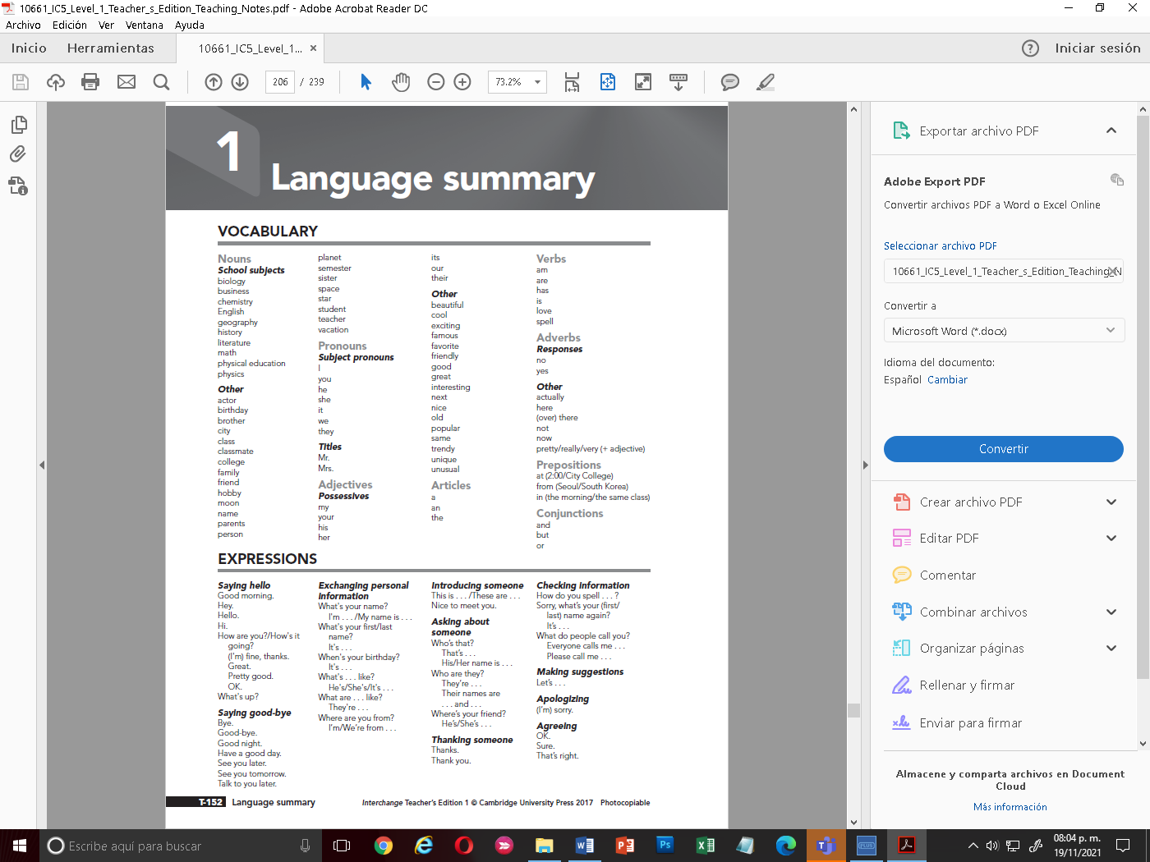 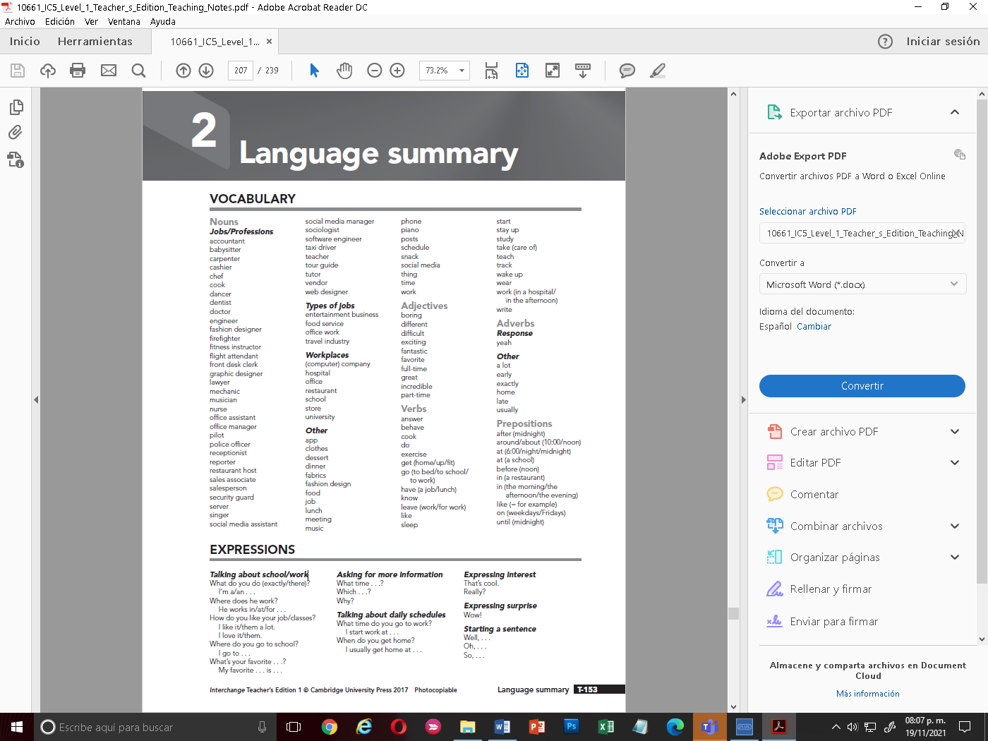

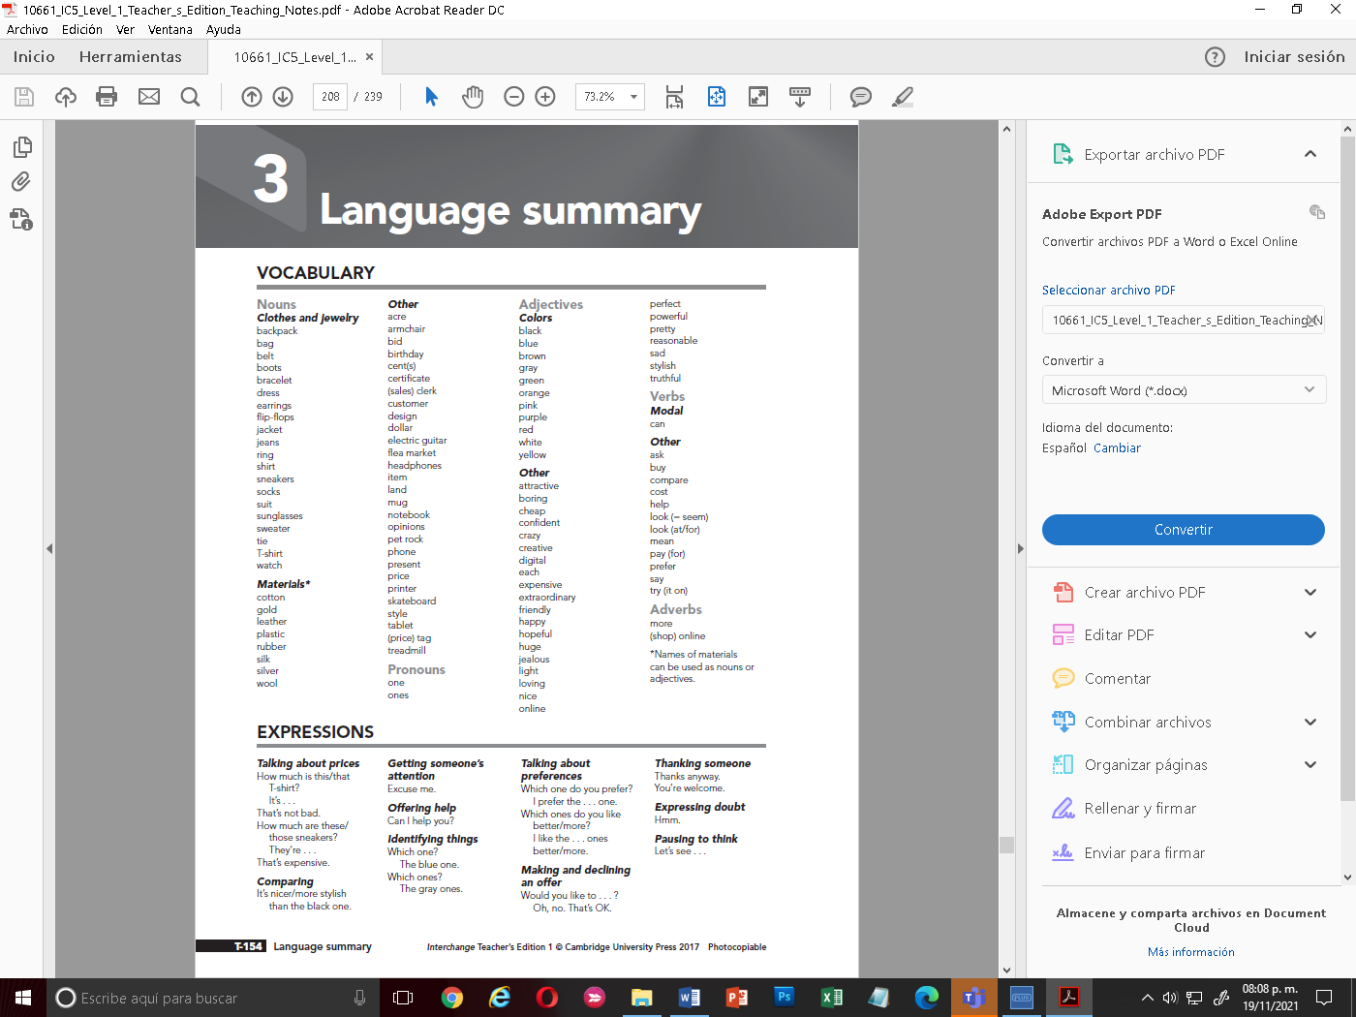 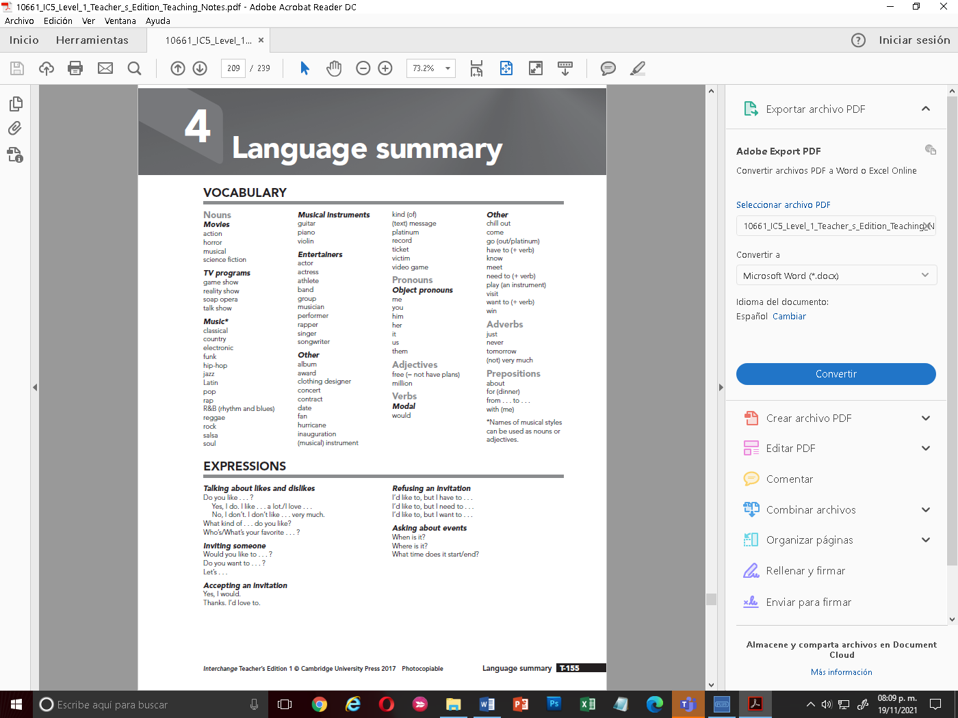

* **SPEAKING EVALUATION CRITERIA**

|  |  |  |  |  |  |  |
| --- | --- | --- | --- | --- | --- | --- |
|  |  | **Poor** | **Fair** | **Good** | **Very good** | **Excellent** |
| **Comprehension** | **0** | **1** | **2** | **3** | **4** | **5** |
| **Fluency** | **0** | **1** | **2** | **3** | **4** | **5** |
| **Grammar** | **0** | **1** | **2** | **3** | **4** | **5** |
| **Vocabulary** | **0** | **1** | **2** | **3** | **4** | **5** |
| **Pronunciation** | **0** | **1** | **2** | **3** | **4** | **5** |
| **Follow instructions** | **0** | **1** | **2** | **3** | **4** | **5** |

**Comprehension - ability to understand questions and respond appropriately.**

**Fluency = ability to speak quickly, naturally, and without many pauses.**

**Grammar = ability to use correct grammar and sentence structure.**

**Vocabulary = ability to understand and use vocabulary words and phrases.**

**Pronunciation = ability to use correct stress, rhythm, and intonation patterns.**

EXCELLENT: 10

VERY GOOD: 9

GOOD: 8

FAIR: 7

POOR: 6

* **WRITING EVALUATION CRITERIA**

|  |  |  |  |
| --- | --- | --- | --- |
| Punctuation and spelling | 1 | 2 |  |
| Correct use of simple grammatical structures | 1 | 2 |  |
| Sufficient vocabulary | 1 | 2 |  |
| Simple connectors and cohesive devices | 1 | 2 |
| Follow instructions | 1 | 2 |
|  |  |  |

**1 HOST:** Mónica

**1 CELEBRITY**: Ximena

**3 CONTESTANTS**: Samantha, Aide y María.

**HOST (MONICA):** Hello, my name is Jenny Fallon and welcome to the most romantic program on television where we unite soulmates.

Today we have a beautiful lady. Her name is Niurka Henderson. She is looking for a man who lights the flame of love in her life come in here

**CELEBRITY (XIMENA):** Hello, my name is Niurka Henderson. My ideal man is that he likes to dance a lot, I prefer that he dance norteñas, I want a man who is very funny and makes me laugh until I cry. I hope to find someone who will take me to know new things and take me out of my comfort zone.

I am too excited to meet the candidates and choose the best one for me.

I know I will find love in this show.

**HOST(MONICA):** I’m sure you will find the love today. well, well. Nice to meet you, honey. We will be back with you in a moment. Please come here the participants.

Welcome to the program Derek, Carlos and Gignac. Let’s meet you, guys. What do you do, Derek?

**PARTAKER 1 (AIDE):** I am a general doctor.

**HOST (MONICA):** It’s an excellent job. What do you do, Carlos?

**PARTAKE 2 (MARIA):** I am an investment man and a millionaire person.

**HOST (MONICA):** That sounds great! And what do you do, Gignac?

**PARTAKE 3 (SAM)**: I am a soccer player in the Mexican league.

**HOST (MONICA)**: They are wonderful jobs, guys. What are some hobbies or activities that give you pleasure?

**PARTAKER 1 (AIDE):** My hobbies are playing the guitar and soccer

**HOST (MONICA):** Tell me, what are some hobbies or activities that give you pleasure, Carlos?

**PARTAKER 2 (MARIA):** My hobbies are playing golf, go to the theater, travel, and spend money.

**HOST (MONICA):** Okey, and what are some hobbies or activities that give you pleasure, Gignac?

**PARTAKER 3 (SAM):** I love to play soccer and they pay me for it, and also, I go to the cinema.

**HOST (MONICA)**: Guys, tell me What do you look for in a partner?

**PARTAKER 1 (AIDE):** She must be a loving person, must time to travel and must be a very attractive person.

**HOST (MONICA):** That sounds great, Derek. And tell me what do you look for in a partner?

**PARTAKER 2 (MARIA):** She must be loving, very pretty, and intelligent and she must love me very much.

**HOST (MONICA):** Okey, and what about you, Gignac?

**PARTAKER 3 (SAM):** I want her to love me and to go watch my games.

**HOST (MONICA)**: What kind of music do you like, Derek?

**PARTAKER 1 (AIDE):** I like classical music and pop, but I don´t like country.

**HOST (MONICA):** Oh, so you don’t like Taylor swift?

**PARTAKER 1(AIDE):** No really.

**HOST (MONICA):** That’s a shame. Well, what kind of music do you like, Carlos?

**PARTAKER 2 (MARIA):** I like classical and rock music, but I hate pop music.

**HOST (MONICA):** Really? Wow. And what about you, Gignac?

**PARTAKER 3 (SAM):** I like northern music, I like Intocable band.

**HOST (MONICA)**: What would the perfect date be like for you? **PARTAKER 1 (AIDE):** my perfect date would be on the beach with a beautiful sunset and eating pasta and drinking wine

**HOST (MONICA):** Sounds good. What about you, Carlos?

**PARTAKER 2:** Going to a very romantic restaurant, surrounded by candles, eating salad and white wine**.**

**HOST:** Great! And you, Gignac?

**PARTAKER 3:** In a private place where only her and me are, and I can show my love.

**HOST (MONICA):** Now that we know a bit about the participants. Tell me, please, Niurka. Which one would you like to have a date?

**CELEBRITY (XIMENA):** Yes, I would like to go out with Carlos.

**HOST (MONICA):** Congratulations, Carlos. You keep the girl.

**QUESTIONS…**

* What to you do?
* What are some hobbies or activities that give you pleasure?
* What kind of movies de you like?
* What you look for in a partner?
* What kind of music do you like?
* Which one would you like to have a date?