**Escuela Normal de Educación Preescolar**

**Licenciatura en Educación preescolar**

**Ciclo escolar 2021-2022**

**Nombre del curso: Inglés A2.1 Sharing Information And Ideas Profesora: Maria Elena Meza Aguado Título del trabajo:**

**Project unit 4 RADIO SHOW Segundo Semestre Alumna:**

**Andrea Elizabeth Aguirre Rodríguez**

**Rosario Guadalupe Arroyo Espinoza**

**Jatziry Wendolyne Guillén Cabello**

**Kathia Anahí Castañuela Salas**

**Saltillo, Coahuila de Zaragoza noviembre2021**

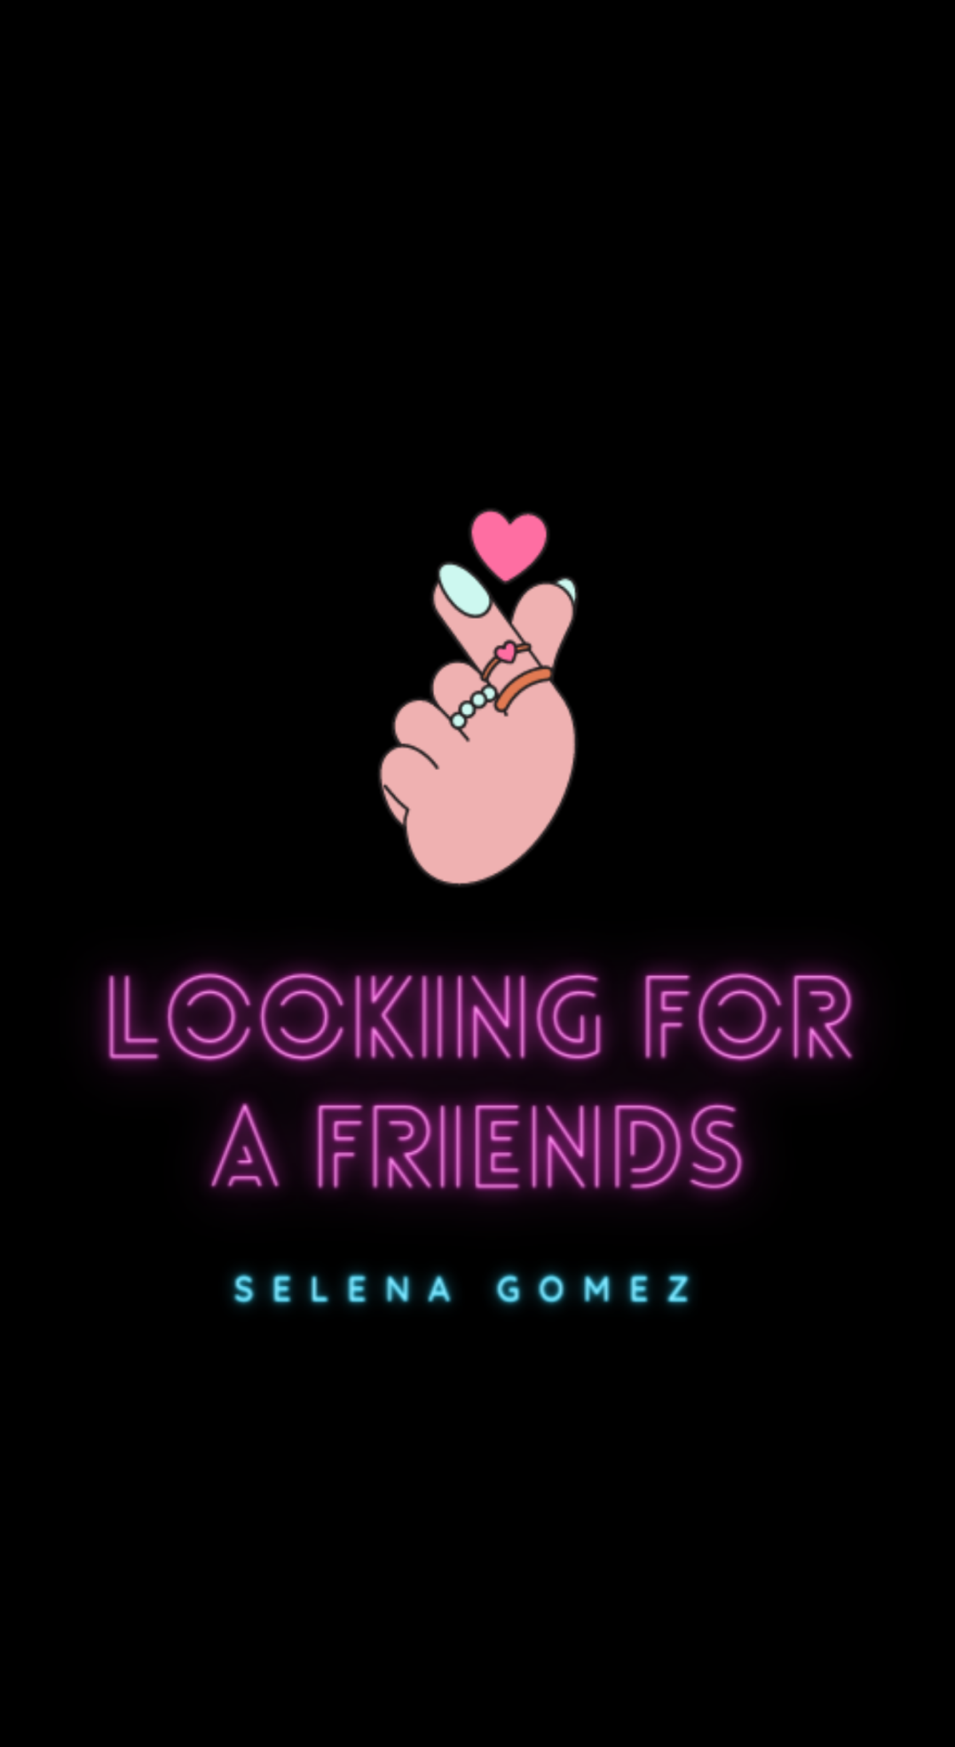

**Presentation**

Sam: Hey!!! What’s up? How’s it going? Welcome to the program Looking for a friends. Today we have Selena Gómez as a special guest.

Ley’s give a clap to Selena Gómez!!!

Wen: Hello! It’s a pleasure to be here on your program Looking for a friends.

Sam: Today we have three people who want to be friends with Selena.

First we have Chayis!!!

Chayis: Hi, I’m Chayis and I have 20 years old and I’m student. I would like to win this contest, and I’m an admirer of Selena.

Sam: Yeah! Well we continue with the next participant and she is Andrea.

Andrea: Hi, I’m Andrea and I have 18 years old. I’m student. Well I really like her music.

Sam: Oh ok! The last participant is Kathya. Come on!

Kathya: Hi, I’m Kathya, nice to meet you. I would like to win because I would like to make music with her.

Sam: Wow! Really?

Kathya: Yes, I want.

Sam: Ok, they are all the participants.

Let’s start with this contest!

Wen: Hi girls!!! Nice to meet you. Okay, the first question is… Do you like the sing?

Sam: As the questions are asked, they will answer in order as they are seated.

Kathya: Yes, I do. I have always liked.

Chayis: Yes, I have always liked his music.

Andrea: I like a bit.

Wen: That’s cool! Next question… What is your favorite kind of music?

Kathya: I like band songs, boleros, classics, well i like all of them.

Chayis: The genre that I like the most is pop.

Andrea: My favorite music is pop.

Wen: Ok! Next question… What are some hobbies or activities that give you pleasure?

Kathya: I like to sing and play instruments, oh and I like to watch horror movies. I love them.

Chayis: One of them is to train in the tube, go out and have fun.

Andrea: I like watch series and movies.

Wen: That’s cool! Next question… Why do you think you would be her best friend?

Kathya: Because we like to make music. Because I´m that person who will always support her in her bad and good days.

Chayis: Because I'm cool jajaja. Because I know how to have fun, to be a good friend and support.

Andrea: Because I’m kind and funny.

Wen: Perfect! Last question… Would you like yo be my friend?

Kathya: Yes, I would. I will be the best of the best.

Chayis: Yes, I would very much like to be your friendship.

Andrea: Yes, I would like to be your friend.

Wen: Ok, thanks for your answers girls.

Sam: Time is up. Who is your perfect friend Selena?

Wen: My perfect friend is Chayis!!!

Chayis: Thanks for choosing me.

Sam: Thank you very much for being here, see you soon.