**ESCUELA NORMAL DE EDUCACIÓN PREESCOLAR**

**ENGLISH A2.2**

**UNIT 3**

**WHAT WOULD YOU LIKE?**

In our last sessions we learned some vocabulary about food and some expressions to agree and disagree when talking about likes and dislikes.

Complete the following activities, these tasks will be your **attendance and participation** in today’s class.

Student: Daniela Guadalupe López Rocha.

**TASK 1 – VOCABULARY**

**Complete the chart in exercise 5 of your student’s book.**

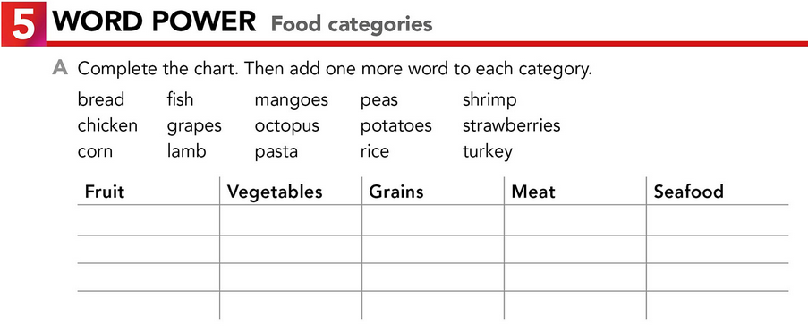

fish

shrimp

octopus

chicken

lamb

turkey

Pasta

bread

Corn

Rice

Peas

Potatoes

Grapes

Strawberries

Mangoes

**TASK 2 – SO, TOO, NEITHER, EITHER**

**Check your notes from last class and complete the exercises.**

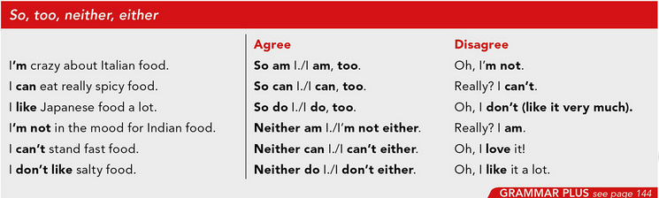

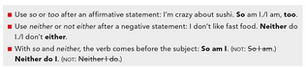

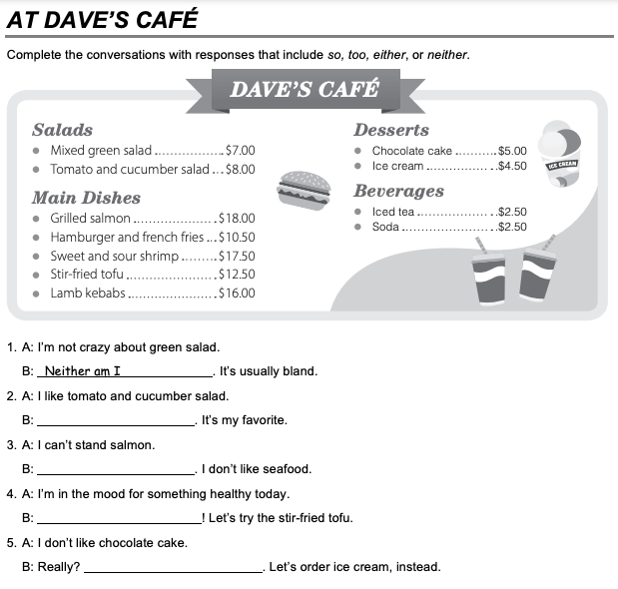

Oh, I like it a lot.

I am, too.

I can’t either.

I do too.

**TASK 3 – ORDERING FOOD IN A RESTAURANT**

**Go to** [**https://www.youtube.com/watch?v=bgfdqVmVjfk**](https://www.youtube.com/watch?v=bgfdqVmVjfk) **and watch the video. Analyze the conversation.**

**Read the conversation in your student’s book.**

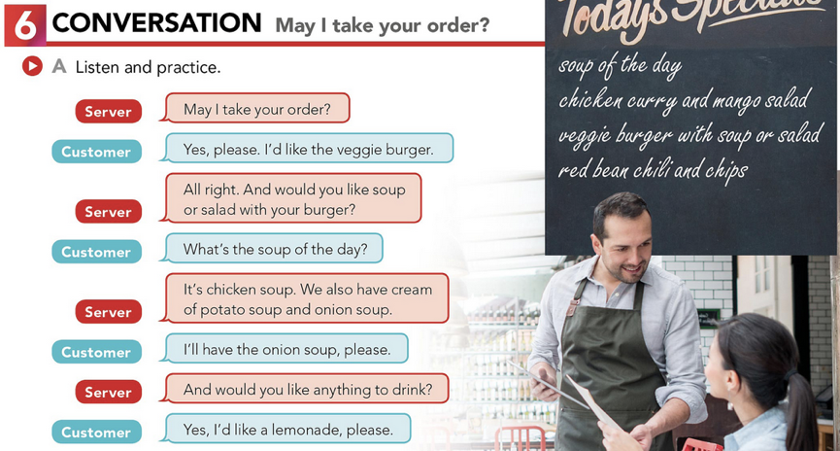

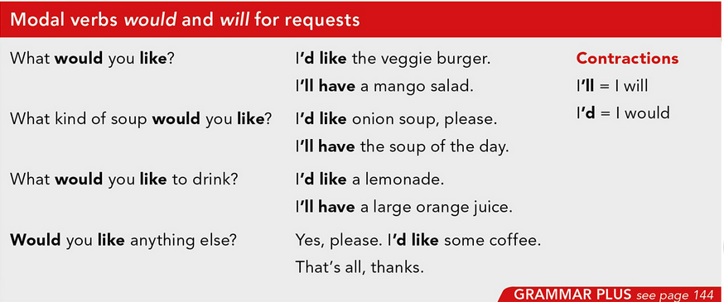

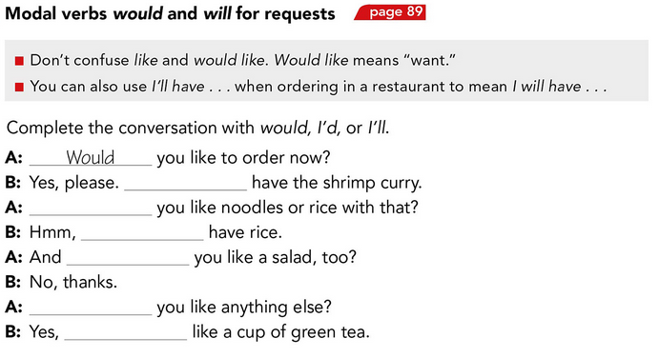

Would

I’d

Would

Would

I Will

I’ll

**TASK 4 – LISTENING EXERCISE**

Go to <https://www.cambridge.org/files/2814/9745/2806/IC5_TSS_L1U13.mp3> and listen to the conversation. Then, complete the following activities.

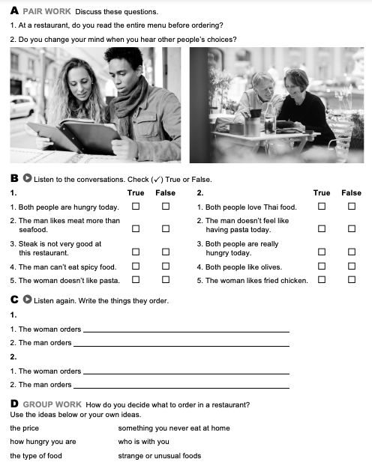

Greek salad.

Thai chiken

Spinach pasta

Salad and steak with fries

* When I go to a restaurant I usually order food that I know I like, in addition to looking at the price. I also like to try new things and experience flavors.

**TASK 5 – READING EXERCISE**

Complete the assignment 5 in your Cambridge Platform (Reading exercise 1 and 2).