**ESCUELA NORMAL DE EDUCACIÓN PREESCOLAR**

**ENGLISH A2.2**

**UNIT 3**

**WHAT WOULD YOU LIKE?**

In our last sessions we learned some vocabulary about food and some expressions to agree and disagree when talking about likes and dislikes.

Complete the following activities, these tasks will be your **attendance and participation** in today’s class.

**TASK 1 – VOCABULARY**

**Complete the chart in exercise 5 of your student’s book. En la última hoja esta la foto de la evidencia de esta actividad.**

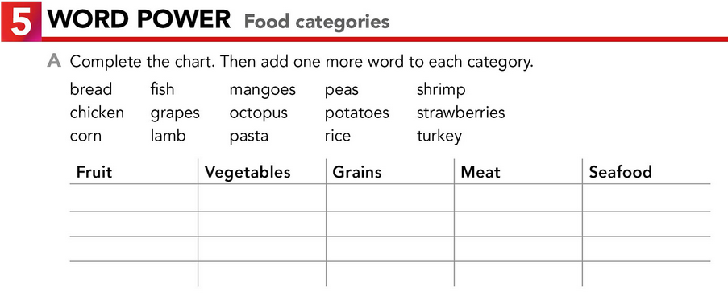

**TASK 2 – SO, TOO, NEITHER, EITHER**

**Check your notes from last class and complete the exercises.**

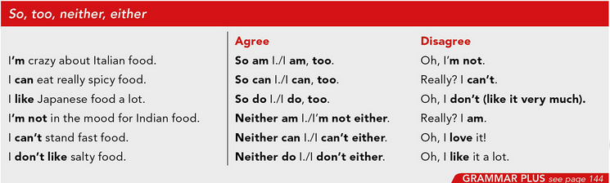

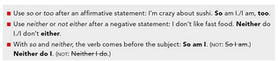

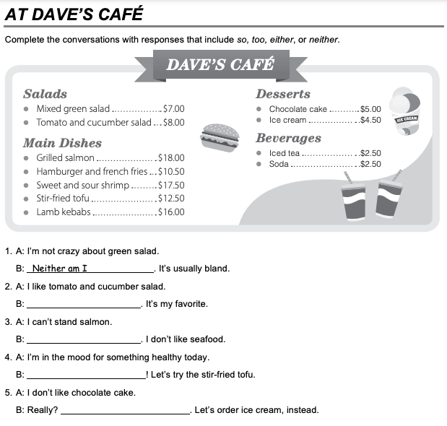

Neither do I

So am I

Neither can I

So do I.

**TASK 3 – ORDERING FOOD IN A RESTAURANT**

**Go to** [**https://www.youtube.com/watch?v=bgfdqVmVjfk**](https://www.youtube.com/watch?v=bgfdqVmVjfk) **and watch the video. Analyze the conversation.**

**Read the conversation in your student’s book.**

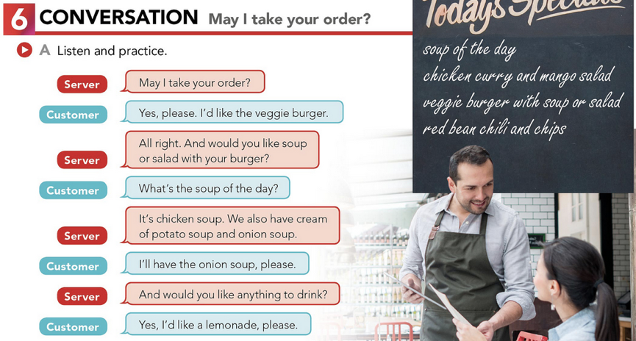

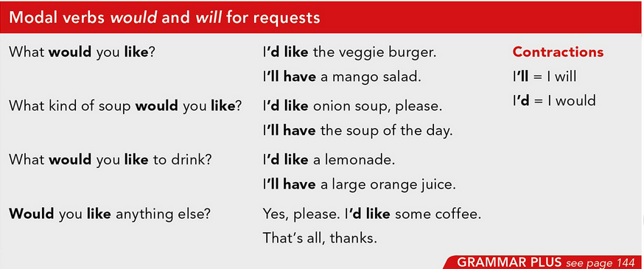

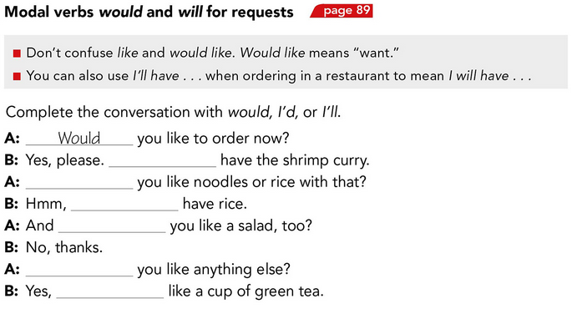

Would

Would

I’d

I’ll

Would

I´ll

**TASK 4 – LISTENING EXERCISE**

Go to <https://www.cambridge.org/files/2814/9745/2806/IC5_TSS_L1U13.mp3> and listen to the conversation. Then, complete the following activities.

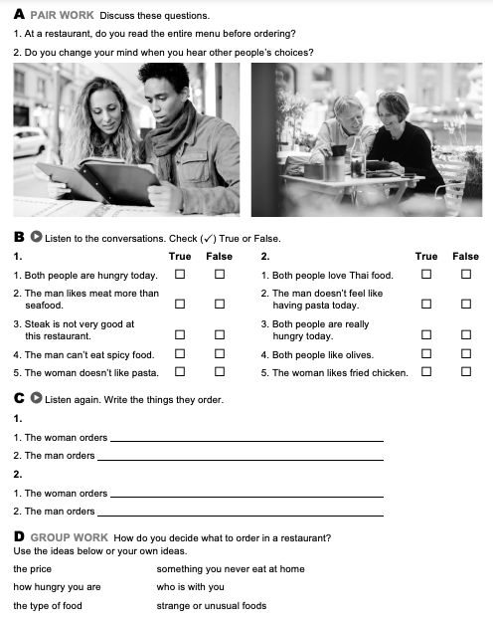

I choose what I want the most and something I never eat at home.



Thai chicken

Salad with olivies

Pasta with spinach

Pasta and steak and patatoes

Yes, I do

Yes, I do

**TASK 5 – READING EXERCISE**

Complete the assignment 5 in your Cambridge Platform (Reading exercise 1 and 2).

