**ESCUELA NORMAL DE EDUCACIÓN PREESCOLAR**

**ENGLISH A2.2**

**UNIT 3**

**WHAT WOULD YOU LIKE?**

In our last sessions we learned some vocabulary about food and some expressions to agree and disagree when talking about likes and dislikes.

Complete the following activities, these tasks will be your **attendance and participation** in today’s class.

**TASK 1 – VOCABULARY**

**Complete the chart in exercise 5 of your student’s book.**

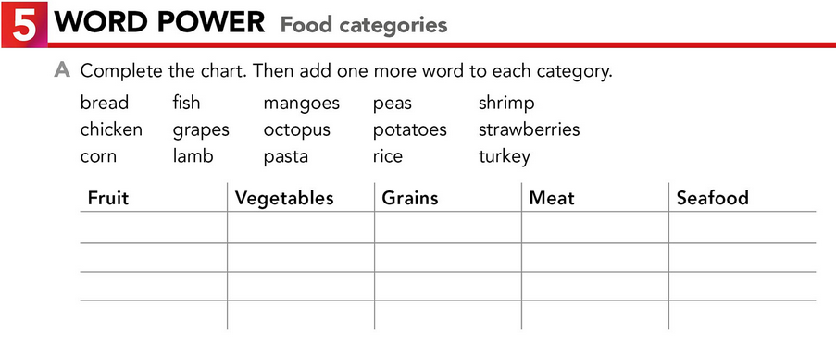

grapes potatoes rice turkey shrimp

mangoes carrot peas chicken fish

strawberries lettuce corn lamb octopus

apples avocado oatmeal pork squid

grapes potatoes rice turkey shrimp

mangoes carrot peas chicken fish

strawberries lettuce corn lamb octopus

apples avocado oatmeal pork squid

**TASK 2 – SO, TOO, NEITHER, EITHER**

**Check your notes from last class and complete the exercises.**

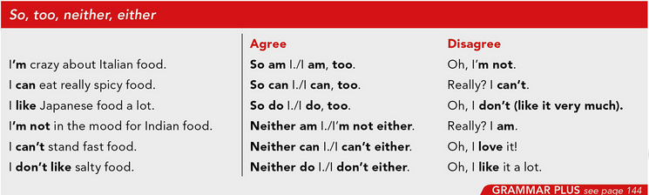

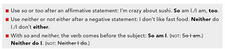

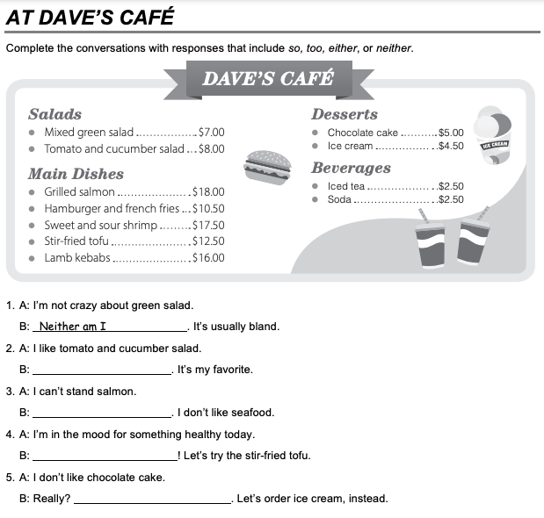

I don´t either

So do I

Neither can I

I am too

**TASK 3 – ORDERING FOOD IN A RESTAURANT**

**Go to** [**https://www.youtube.com/watch?v=bgfdqVmVjfk**](https://www.youtube.com/watch?v=bgfdqVmVjfk) **and watch the video. Analyze the conversation.**

**Read the conversation in your student’s book.**

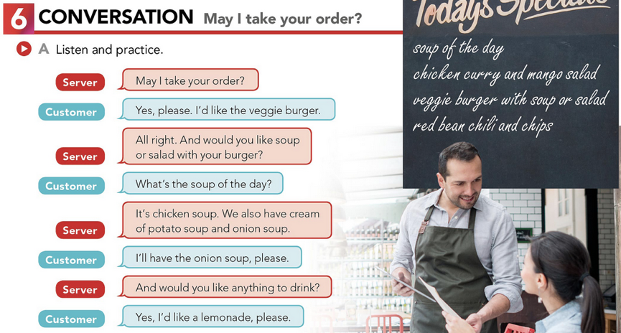

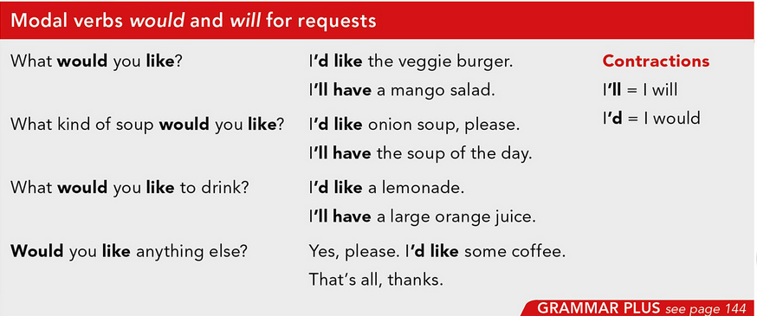

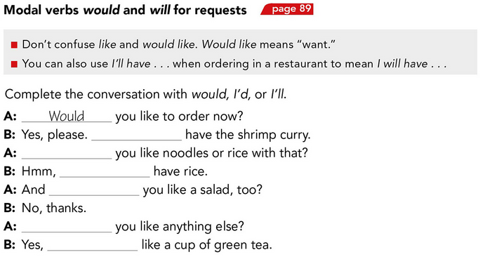

Would

I’d

I would

I’ll

would

I’ll

**TASK 4 – LISTENING EXERCISE**

Go to <https://www.cambridge.org/files/2814/9745/2806/IC5_TSS_L1U13.mp3> and listen to the conversation. Then, complete the following activities.

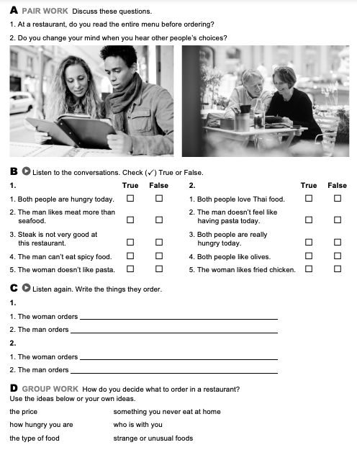

Greek salad.

Fried chicken with fries.

She’ ll start with a Salad and steak with fries

He order greek salad.

**TASK 5 – READING EXERCISE**

Complete the assignment 5 in your Cambridge Platform (Reading exercise 1 and 2).