**ESCUELA NORMAL DE EDUCACIÓN PREESCOLAR**

**ENGLISH A2.2**

**UNIT 3**

**WHAT WOULD YOU LIKE?**

In our last sessions we learned some vocabulary about food and some expressions to agree and disagree when talking about likes and dislikes.

Complete the following activities, these tasks will be your **attendance and participation** in today’s class.

**TASK 1 – VOCABULARY**

**Complete the chart in exercise 5 of your student’s book.**

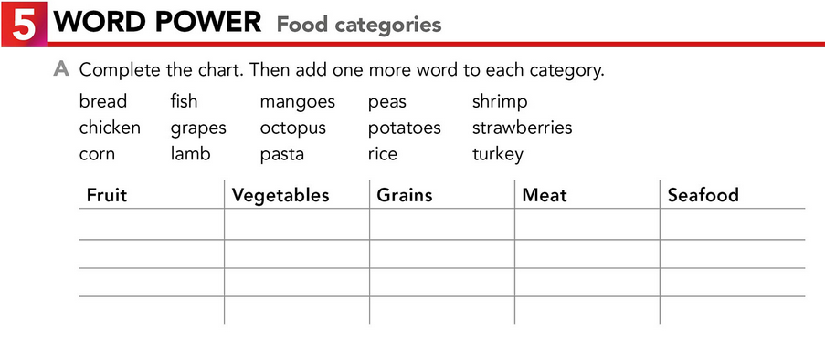

Grapes

Mangoes

strawberries

Corn

Rice

Bread

Pasta

peas

Chicken

turkey

lamb

Fish

Octopus

Potatoes

**TASK 2 – SO, TOO, NEITHER, EITHER**

**Check your notes from last class and complete the exercises.**

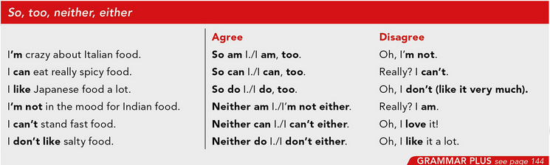

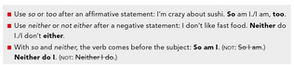

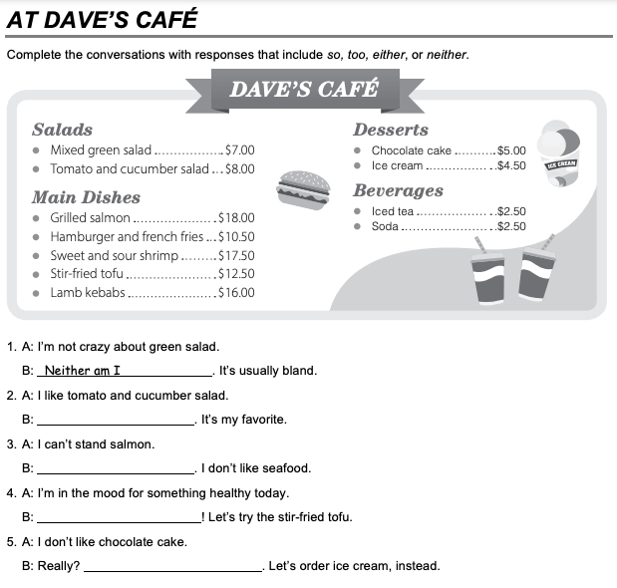

Neither do

I am, too

I can´t either

I do, too

**TASK 3 – ORDERING FOOD IN A RESTAURANT**

**Go to** [**https://www.youtube.com/watch?v=bgfdqVmVjfk**](https://www.youtube.com/watch?v=bgfdqVmVjfk) **and watch the video. Analyze the conversation.**

**Read the conversation in your student’s book.**

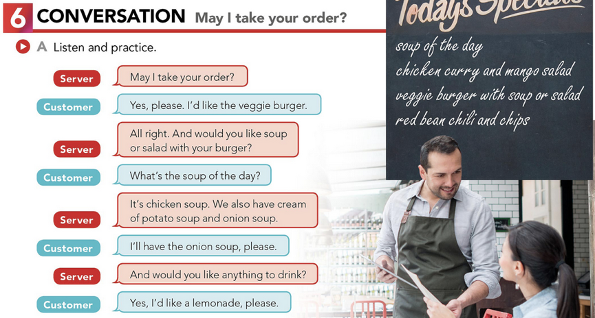

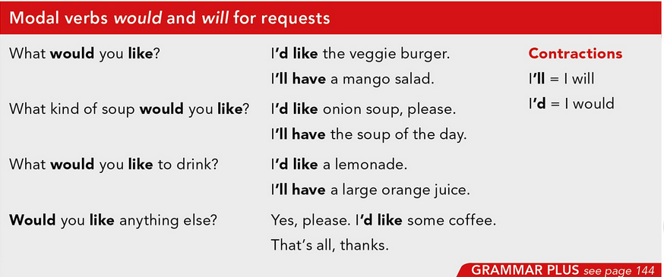

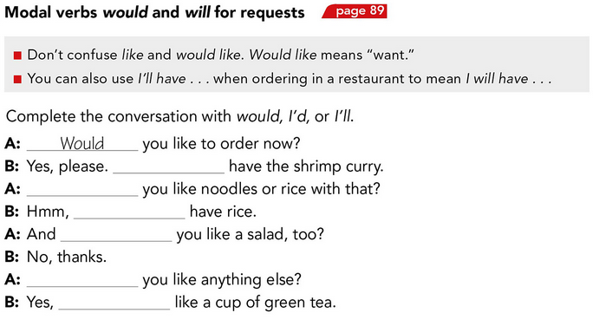

I’d

Would

Would

I will

Would

I’ll

**TASK 4 – LISTENING EXERCISE**

Go to <https://www.cambridge.org/files/2814/9745/2806/IC5_TSS_L1U13.mp3> and listen to the conversation. Then, complete the following activities.

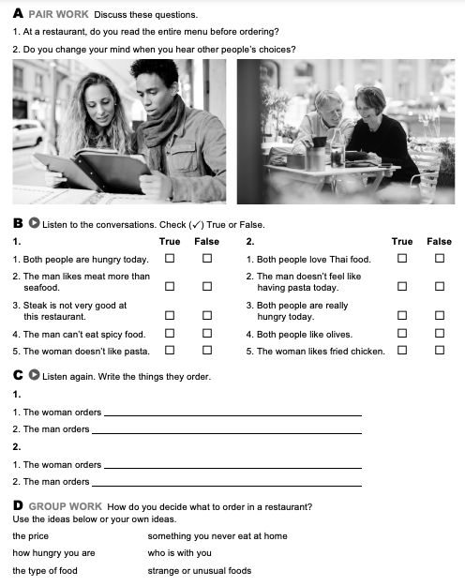

Spinach pasta with tomatoes and cheese.

Start with salad,and she have steak with fries.

.

Greek salad with olivies..

**TASK 5 – READING EXERCISE**

Complete the assignment 5 in your Cambridge Platform (Reading exercise 1 and 2).

