**ESCUELA NORMAL DE EDUCACIÓN PREESCOLAR**

**ENGLISH A2.2**

**UNIT 3**

**WHAT WOULD YOU LIKE?**

In our last sessions we learned some vocabulary about food and some expressions to agree and disagree when talking about likes and dislikes.

Complete the following activities, these tasks will be your **attendance and participation** in today’s class.

**TASK 1 – VOCABULARY**

**Complete the chart in exercise 5 of your student’s book.**

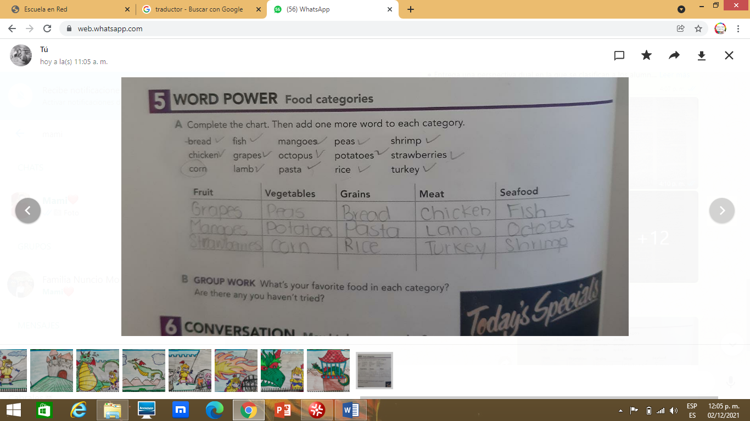

**TASK 2 – SO, TOO, NEITHER, EITHER**

**Check your notes from last class and complete the exercises.**

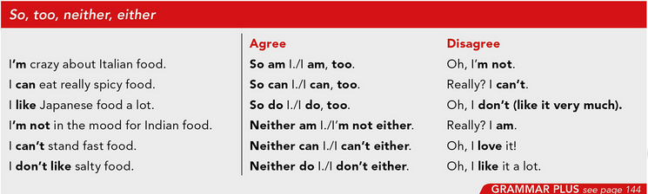

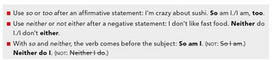

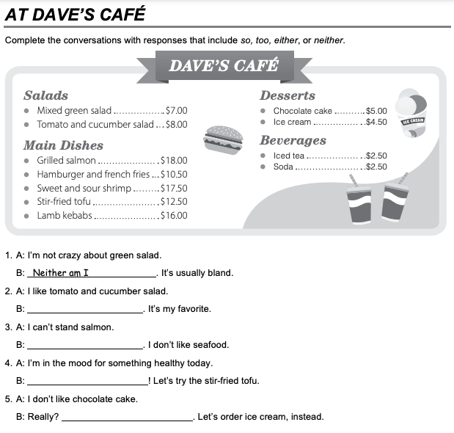

I am, too

I can’t either

Neither do

I do, too

**TASK 3 – ORDERING FOOD IN A RESTAURANT**

**Go to** [**https://www.youtube.com/watch?v=bgfdqVmVjfk**](https://www.youtube.com/watch?v=bgfdqVmVjfk) **and watch the video. Analyze the conversation.**

**Read the conversation in your student’s book.**

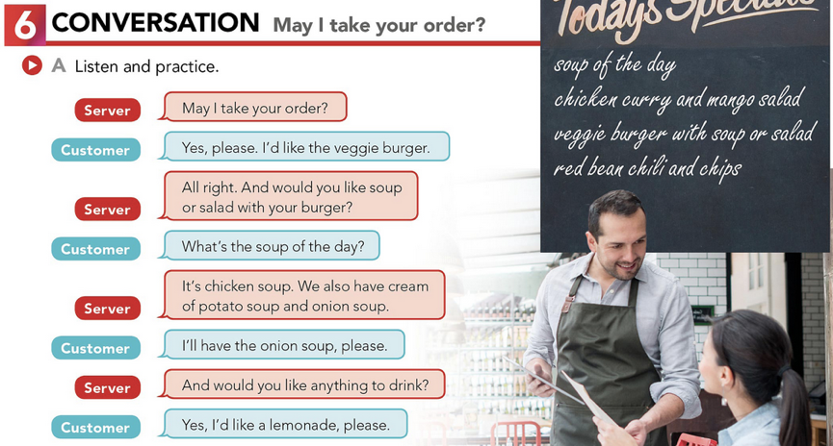

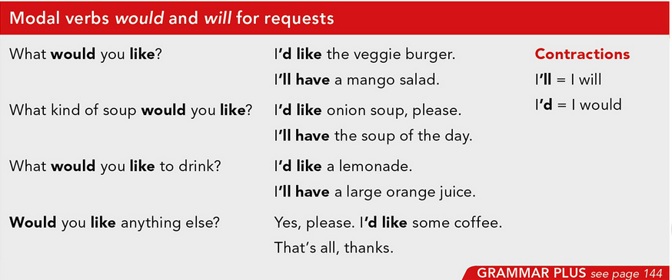

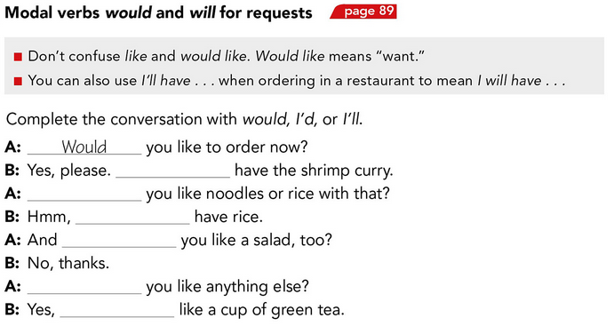

I’d

would

would

I will

Would

I’ll

**TASK 4 – LISTENING EXERCISE**

Go to <https://www.cambridge.org/files/2814/9745/2806/IC5_TSS_L1U13.mp3> and listen to the conversation. Then, complete the following activities.

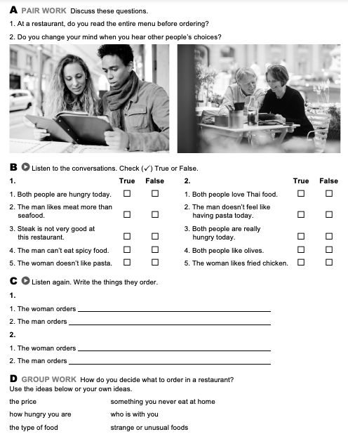

Salad, and she have steak with fries

Greek salad with olives

Spinach pasta with tomatoes and cheese

Salad, and she have steak with fries

**TASK 5 – READING EXERCISE**

Complete the assignment 5 in your Cambridge Platform (Reading exercise 1 and 2).