**ESCUELA NORMAL DE EDUCACIÓN PREESCOLAR**

**ENGLISH A2.2**

**UNIT 3**

**WHAT WOULD YOU LIKE?**

In our last sessions we learned some vocabulary about food and some expressions to agree and disagree when talking about likes and dislikes.

Complete the following activities, these tasks will be your **attendance and participation** in today’s class.

**TASK 1 – VOCABULARY**

**Complete the chart in exercise 5 of your student’s book.**

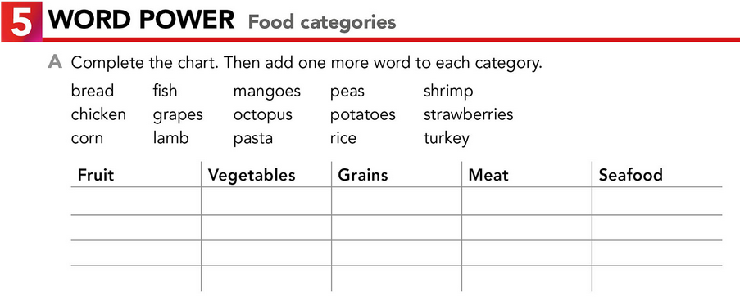

**TASK 2 – SO, TOO, NEITHER, EITHER**

**Check your notes from last class and complete the exercises.**

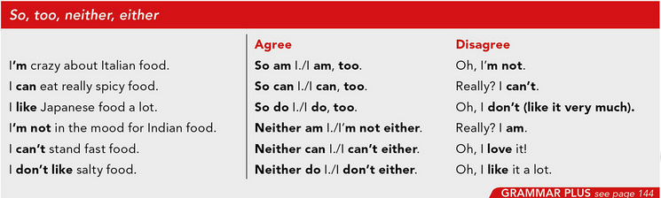

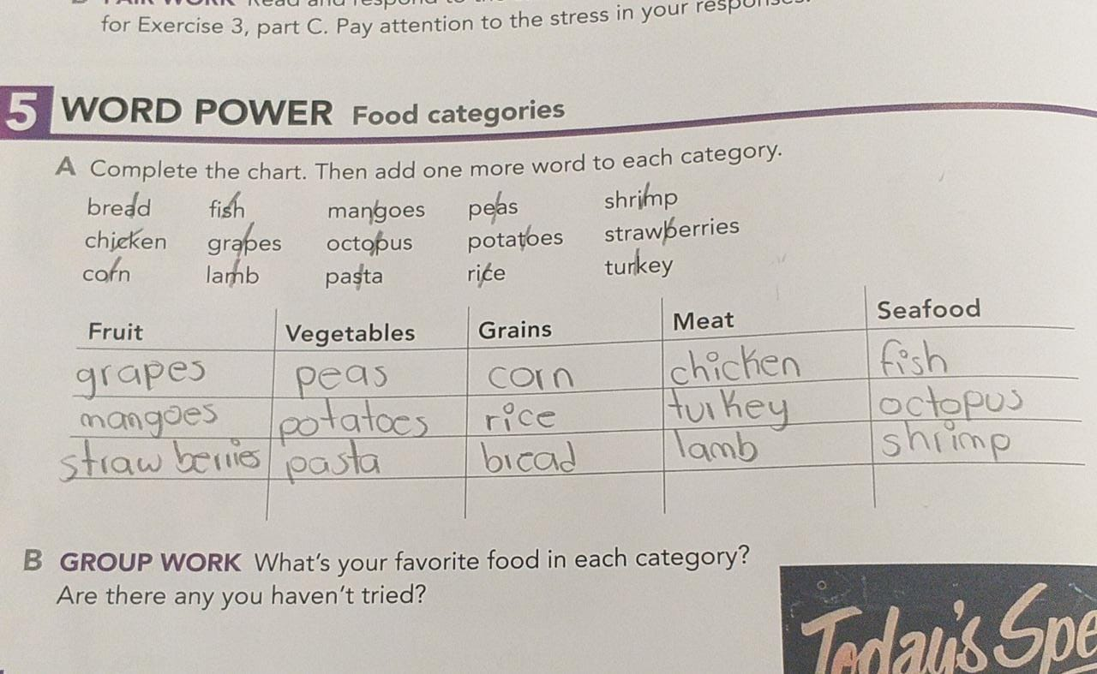

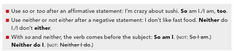

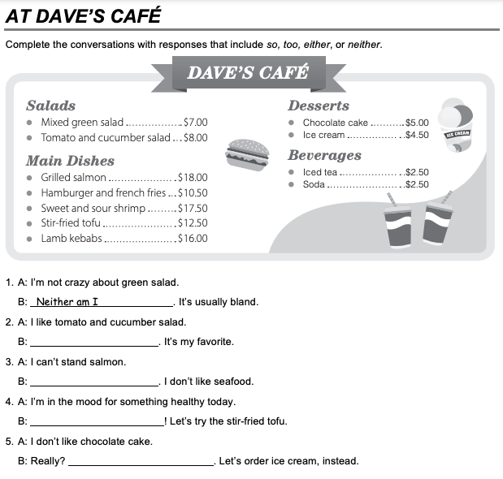

Neither can I.

So am l.

Neither do l.

So do I

**TASK 3 – ORDERING FOOD IN A RESTAURANT**

**Go to** [**https://www.youtube.com/watch?v=bgfdqVmVjfk**](https://www.youtube.com/watch?v=bgfdqVmVjfk) **and watch the video. Analyze the conversation.**

**Read the conversation in your student’s book.**

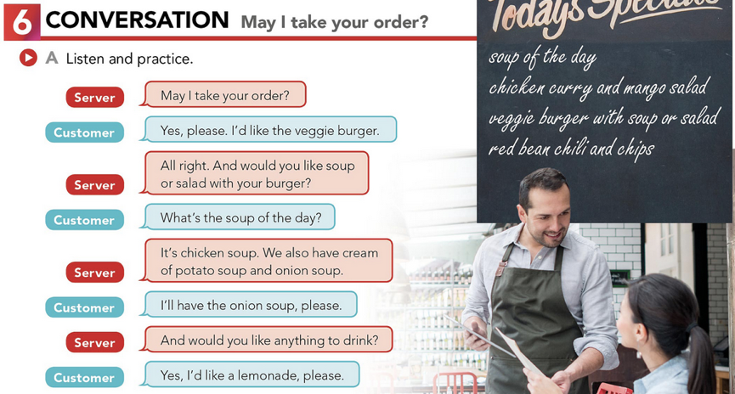

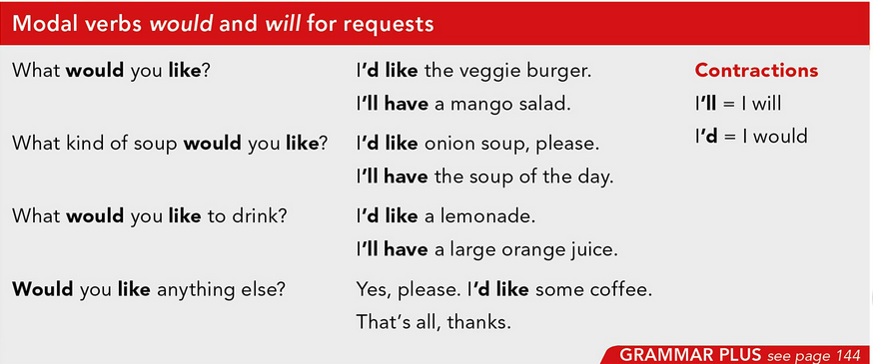

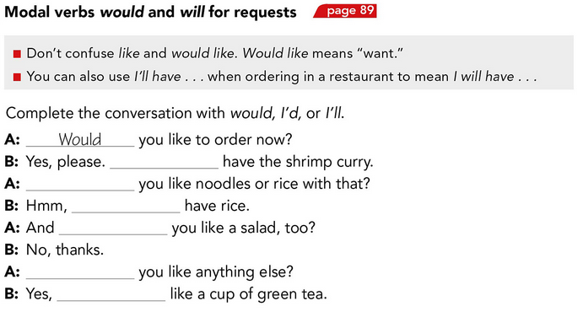

**TASK 4 – LISTENING EXERCISE**

I’ll

Would

I’d

Would

Would

I’d

Go to <https://www.cambridge.org/files/2814/9745/2806/IC5_TSS_L1U13.mp3> and listen to the conversation. Then, complete the following activities.

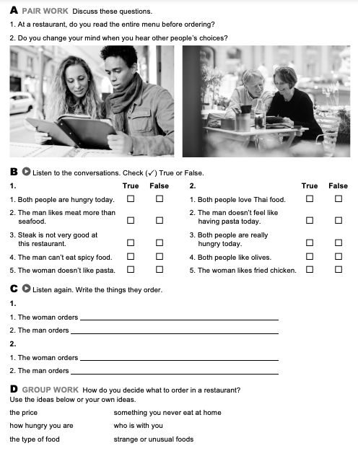

Spicy food.

Spanich pasta with tomatoes and chesse

Greek salad with olivies.

Start with salad, and she have steak with fries.

D) I see the type of food, the price, and I ask for what I like the most

**TASK 5 – READING EXERCISE**

Complete the assignment 5 in your Cambridge Platform (Reading exercise 1 and 2).