**ESCUELA NORMAL DE EDUCACIÓN PREESCOLAR**

**ENGLISH A2.2**

**Carolina Estefanía Herrera Rodríguez**

**UNIT 3**

**WHAT WOULD YOU LIKE?**

In our last sessions we learned some vocabulary about food and some expressions to agree and disagree when talking about likes and dislikes.

Complete the following activities, these tasks will be your **attendance and participation** in today’s class.

**TASK 1 – VOCABULARY**

**Complete the chart in exercise 5 of your student’s book.**

**TASK 2 – SO, TOO, NEITHER, EITHER**

**Check your notes from last class and complete the exercises.**

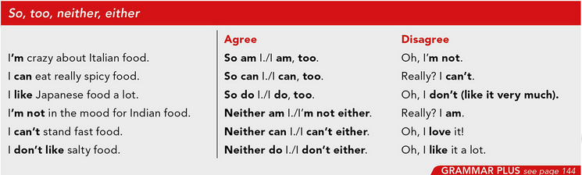

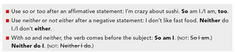

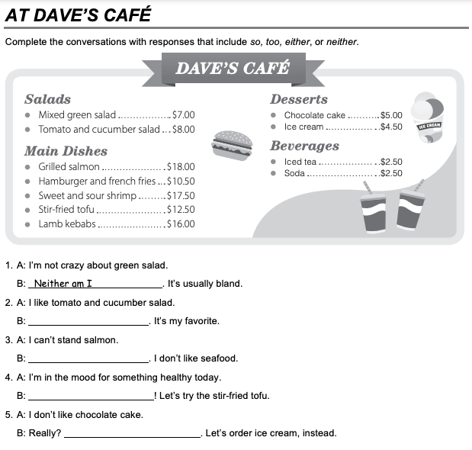

So do I.

I can´t either.

So am I.

Oh, Ii like it a lot.

**TASK 3 – ORDERING FOOD IN A RESTAURANT**

**Go to** [**https://www.youtube.com/watch?v=bgfdqVmVjfk**](https://www.youtube.com/watch?v=bgfdqVmVjfk) **and watch the video. Analyze the conversation.**

**Read the conversation in your student’s book.**

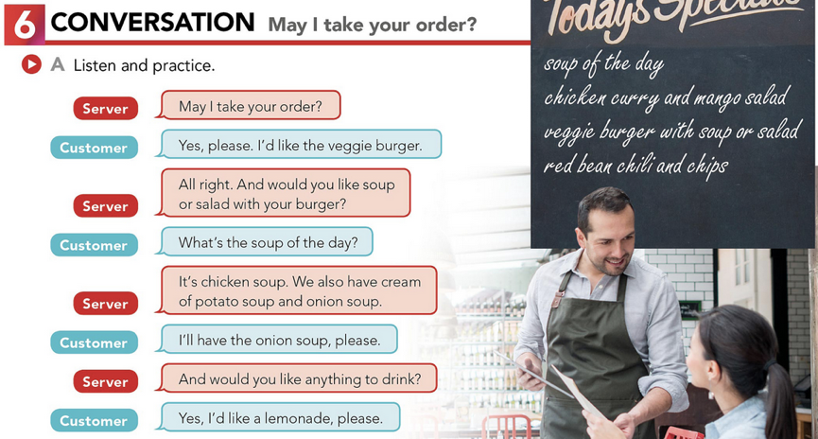

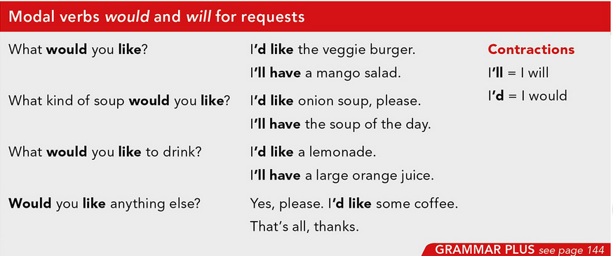

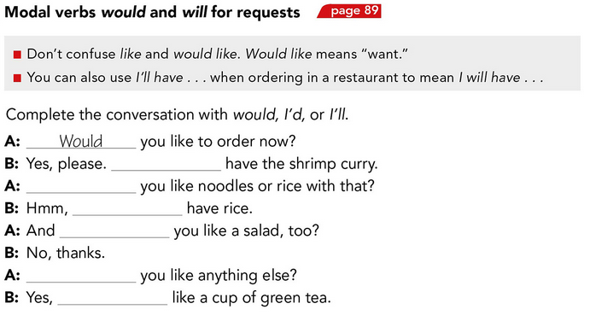

What would

I´II

What would

Would

Please. I ´d

I´d like

**TASK 4 – LISTENING EXERCISE**

Go to <https://www.cambridge.org/files/2814/9745/2806/IC5_TSS_L1U13.mp3> and listen to the conversation. Then, complete the following activities.

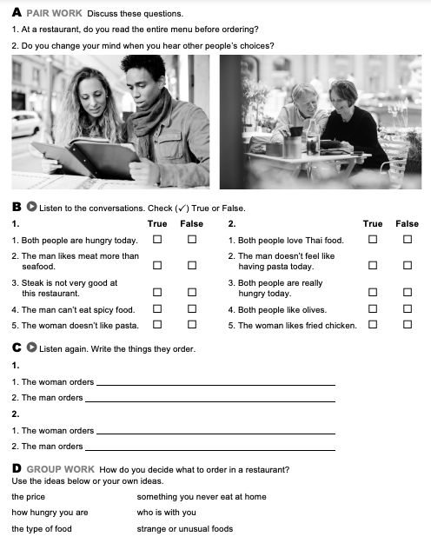

How hungry you are

The type of food

The Price

Who is with you

Something yoy never eat at home

Strange are unusual foods.

Seafood

Spicy food Pasta

Pasta, Thai food, Fried chicken

Salad

**TASK 5 – READING EXERCISE**

Complete the assignment 5 in your Cambridge Platform (Reading exercise 1 and 2).