**ESCUELA NORMAL DE EDUCACIÓN PREESCOLAR**

**ENGLISH A2.2**

**UNIT 3**

**WHAT WOULD YOU LIKE?**

In our last sessions we learned some vocabulary about food and some expressions to agree and disagree when talking about likes and dislikes.

Complete the following activities, these tasks will be your **attendance and participation** in today’s class.

**TASK 1 – VOCABULARY**

**Complete the chart in exercise 5 of your student’s book.**

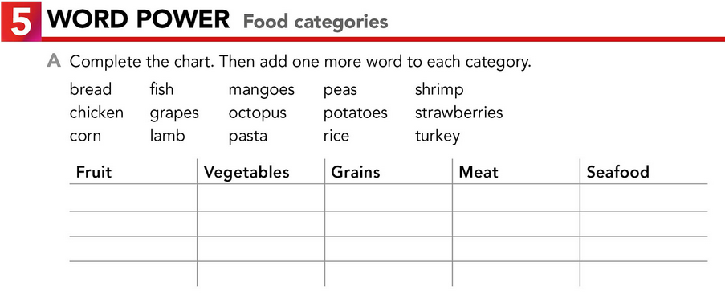

Potatoes

Octopus

Shrimp

Fish

Chicken

Turkey

Lamb

Peas

Rice

Corn

Mangoes

Grapes

Strawberries

**TASK 2 – SO, TOO, NEITHER, EITHER**

**Check your notes from last class and complete the exercises.**

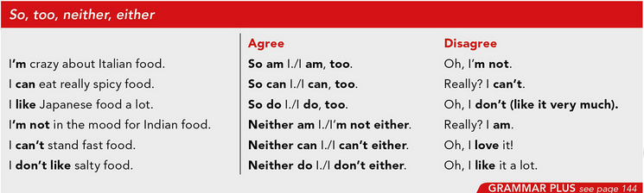

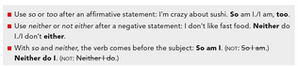

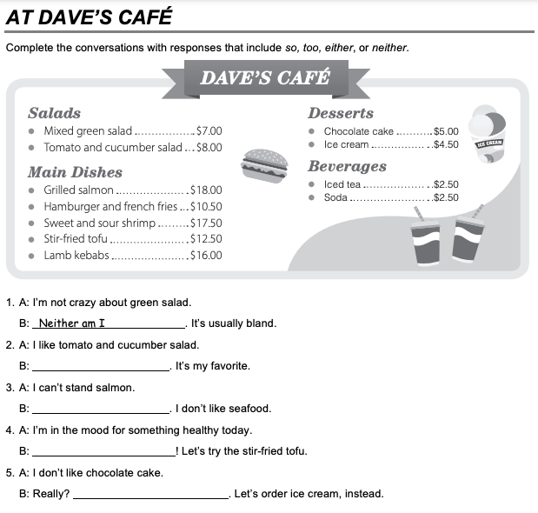

Neither do I/ I don´t either

So am I / I am, too

Neither can I / I can´t either

So do I / I do, too

**TASK 3 – ORDERING FOOD IN A RESTAURANT**

**Go to** [**https://www.youtube.com/watch?v=bgfdqVmVjfk**](https://www.youtube.com/watch?v=bgfdqVmVjfk) **and watch the video. Analyze the conversation.**

**Read the conversation in your student’s book.**

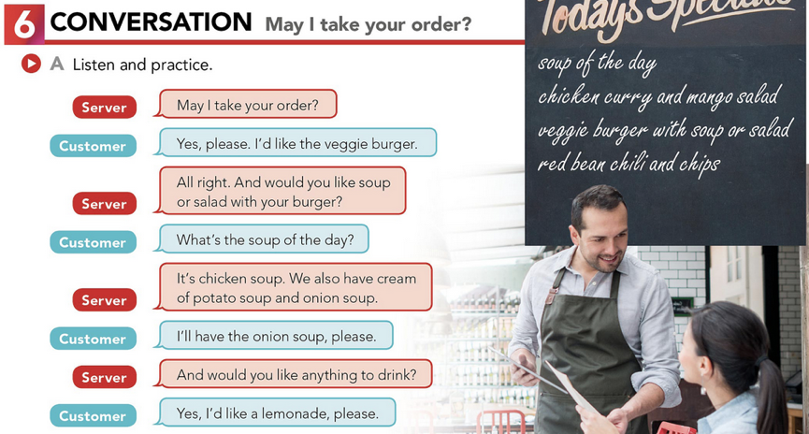

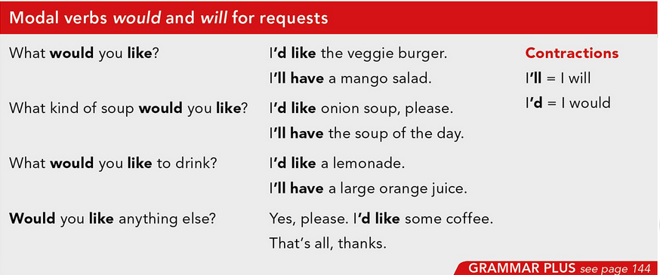

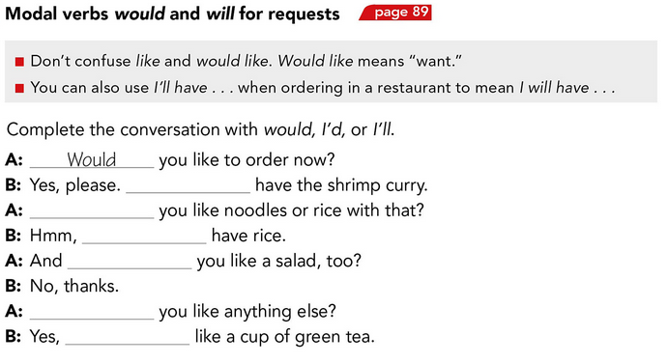

I´d

Would

Would

I will

Would

I´II

**TASK 4 – LISTENING EXERCISE**

Go to <https://www.cambridge.org/files/2814/9745/2806/IC5_TSS_L1U13.mp3> and listen to the conversation. Then, complete the following activities.

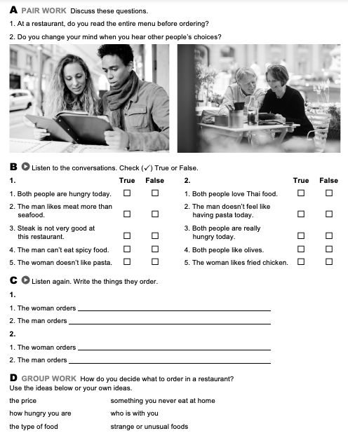

Start with salad and she have steak with fries.

Greek salad with olives.

Spinach pasta with tomatoes and cheese.

Start with salad, and she have steak with fries.

Ordering food

Waiter: Can I take your order, Madam?

Faela: I’ll have the Grilled Steak and a side order of fries.

Waiter: OK, steak and fries. What would you like to drink?

Faela: Can I see the drinks menu?

Waiter: Of course, here you are.

Faela: I’ll have a glass of wine.

**TASK 5 – READING EXERCISE**

Complete the assignment 5 in your Cambridge Platform (Reading exercise 1 and 2).