**ESCUELA NORMAL DE EDUCACIÓN PREESCOLAR**

**ENGLISH A2.2**

**UNIT 4 – VOCABULARY**

**DECEMBER 6TH, 2021**

**TASK 1 – STUDENT’S BOOK**

Open your student’s book in the first page of unit 4 and match the words from the list to the letters in the pictures.

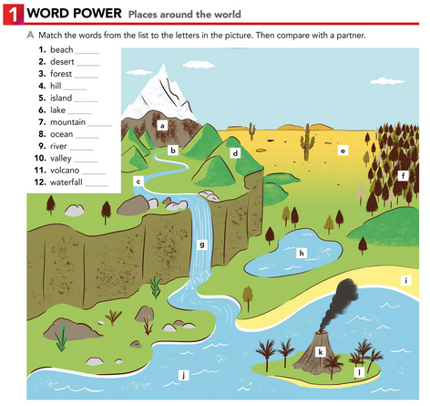

i

e

f

d

l

h

a

j

c

d

k

g

**TASK 2 – VOCABULARY LOG - NOTEBOOK**

Copy the words from the list in your notebook and write the name of a famous place in your country or in the world. Check the example.

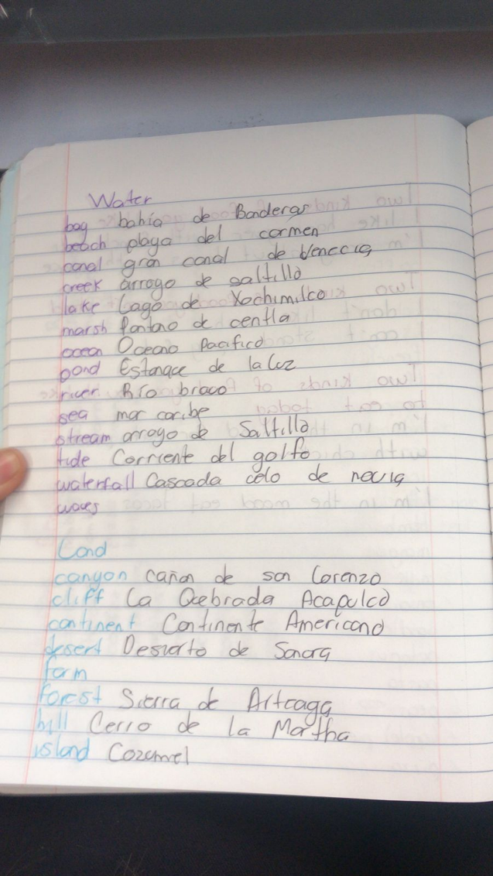

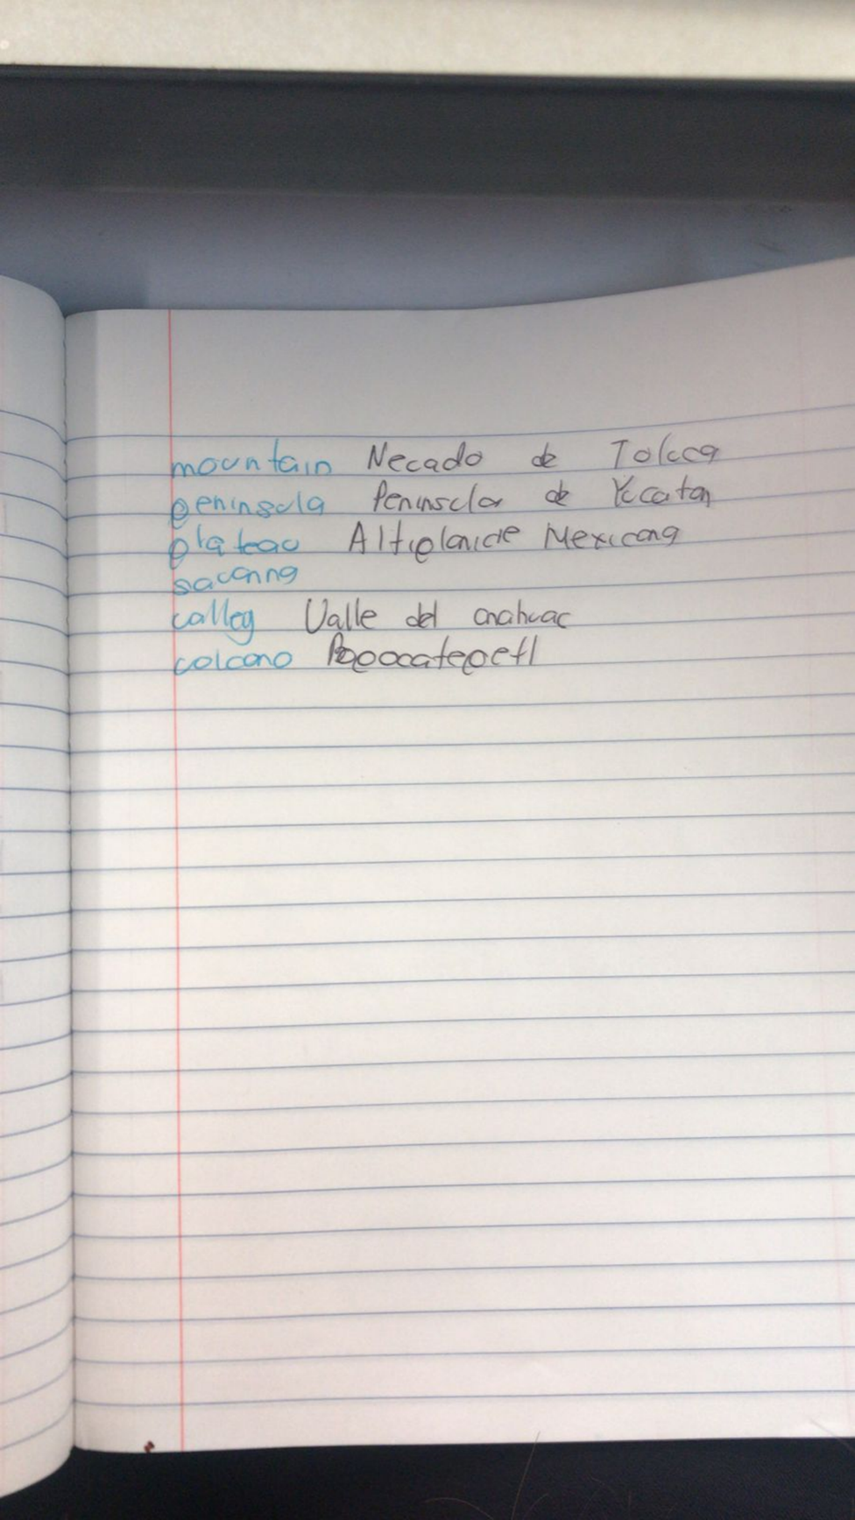

**TASK 3 – VIDEO**

Go to <https://www.youtube.com/watch?v=-wiFx9UgmMo> look at the pictures, find the meaning of the words and practice pronunciation.

**TASK 4 – WORKBOOK**

Open your workbook in the first page of unit 4 and complete exercise 1 parts A and B.

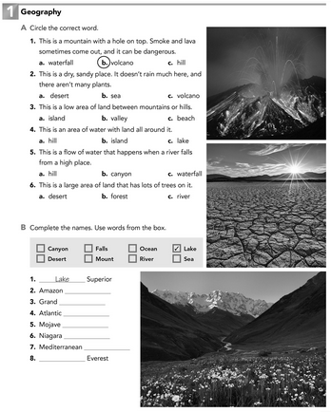

Mount

sea

desert

falls

ocean

canyon

river

**TASK 4 – CAMBRIDGE PLATFORM**

Log in the Cambridge Platform and complete the Assignment 7 (2 vocabulary exercises)

**NOTA: EN CASO DE NO HABER TERMINADO EL ASSIGNMENT 6, FAVOR DE REALIZARLO PUESTO QUE SE CIERRA EL DÍA DE HOY.**