**ESCUELA NORMAL DE EDUCACIÓN PREESCOLAR**

**ENGLISH A2.2**

**UNIT 4 – VOCABULARY**

**DECEMBER 6TH, 2021**

**TASK 1 – STUDENT’S BOOK**

Open yourstudent’sbook in thefirst page of unit 4 and match thewordsfromthelist to theletters in thepictures.

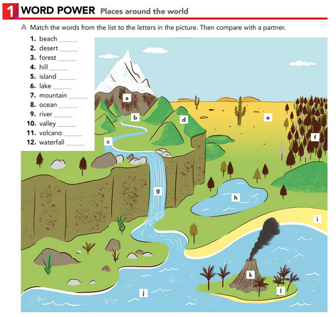

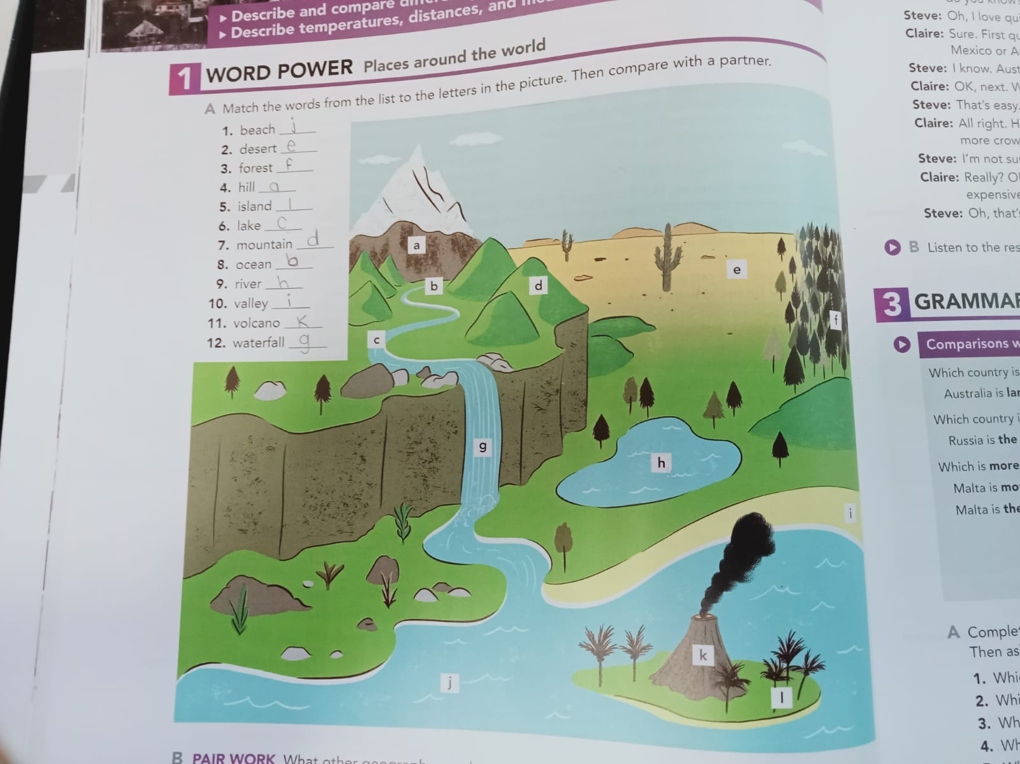

**TASK 2 – VOCABULARY LOG - NOTEBOOK**

Copythewordsfromthelistin your notebook and writethename of a famous place in your country or in theworld. Checktheexample.

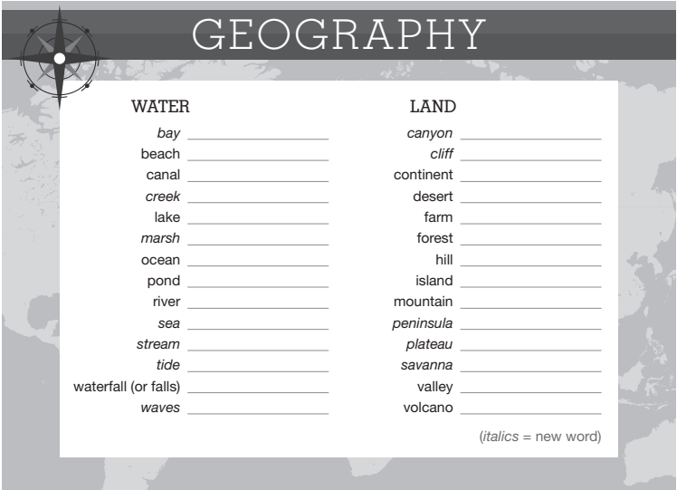

Bahía de Banderas

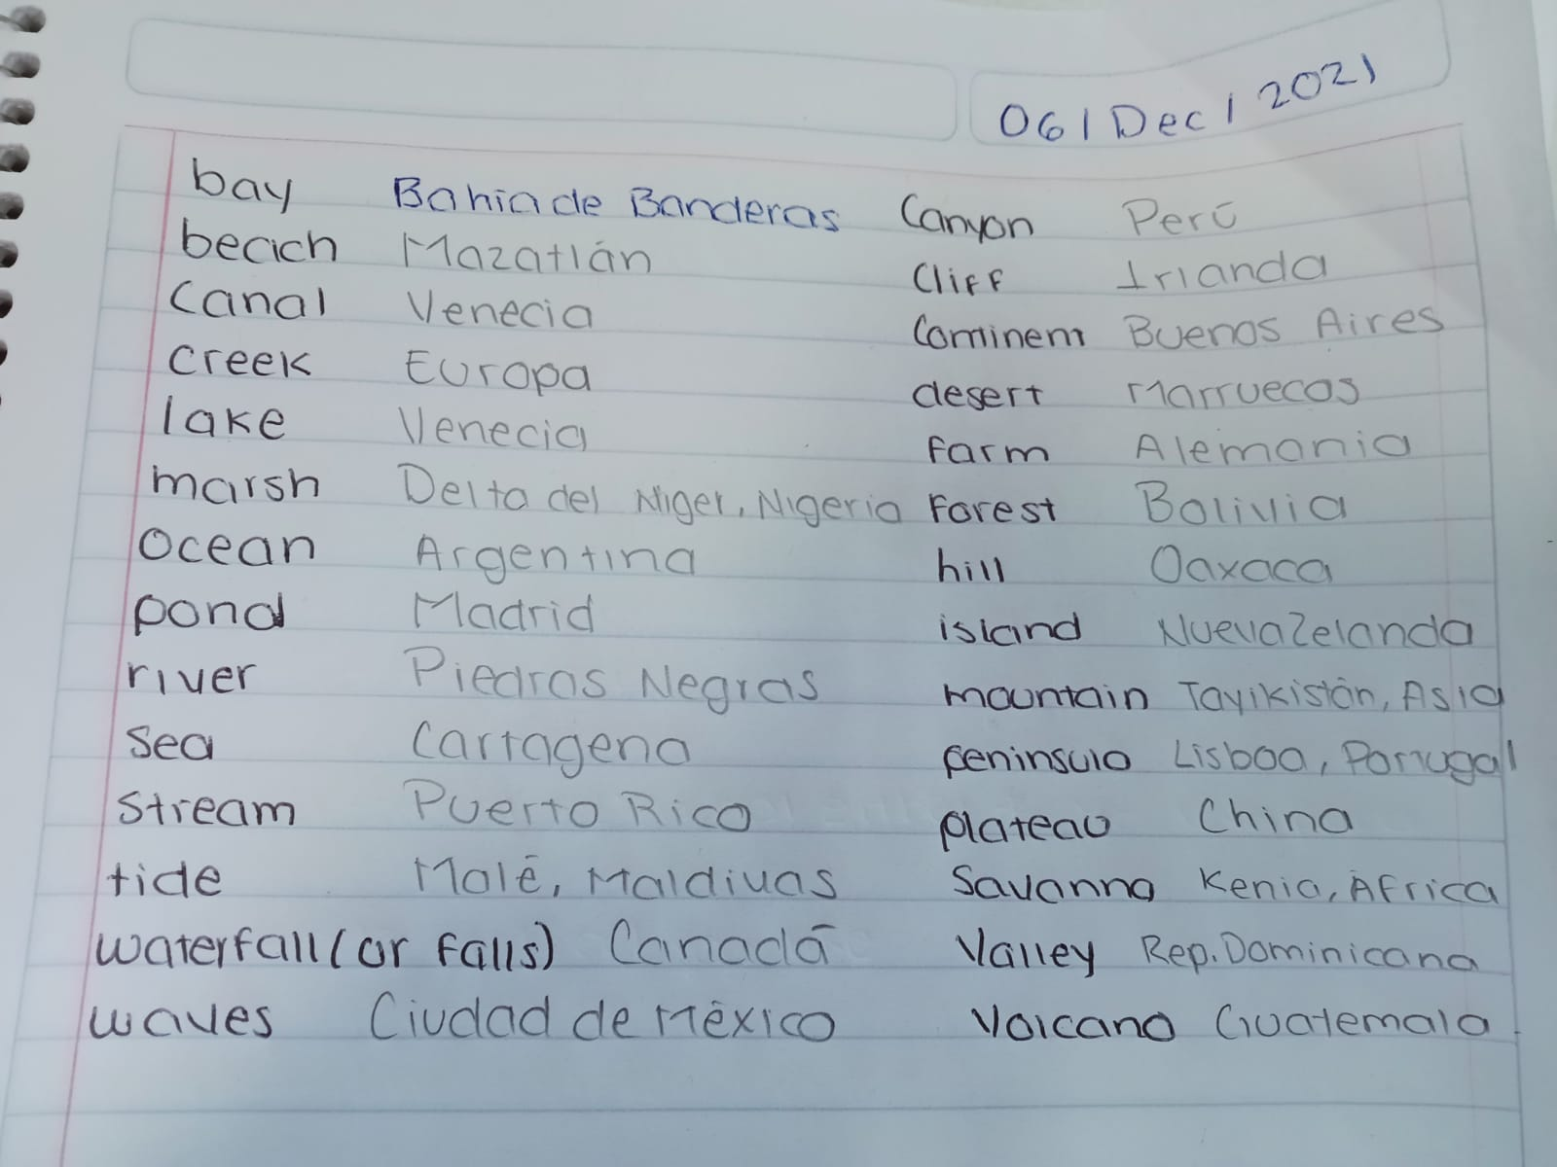

**TASK 3 – VIDEO**

Go to <https://www.youtube.com/watch?v=-wiFx9UgmMo>look at thepictures, findthemeaning of thewords and practicepronunciation.

**TASK 4 – WORKBOOK**

Open yourworkbook in thefirst page of unit 4 and complete exercise 1 parts A and B.

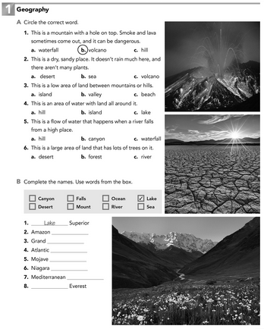

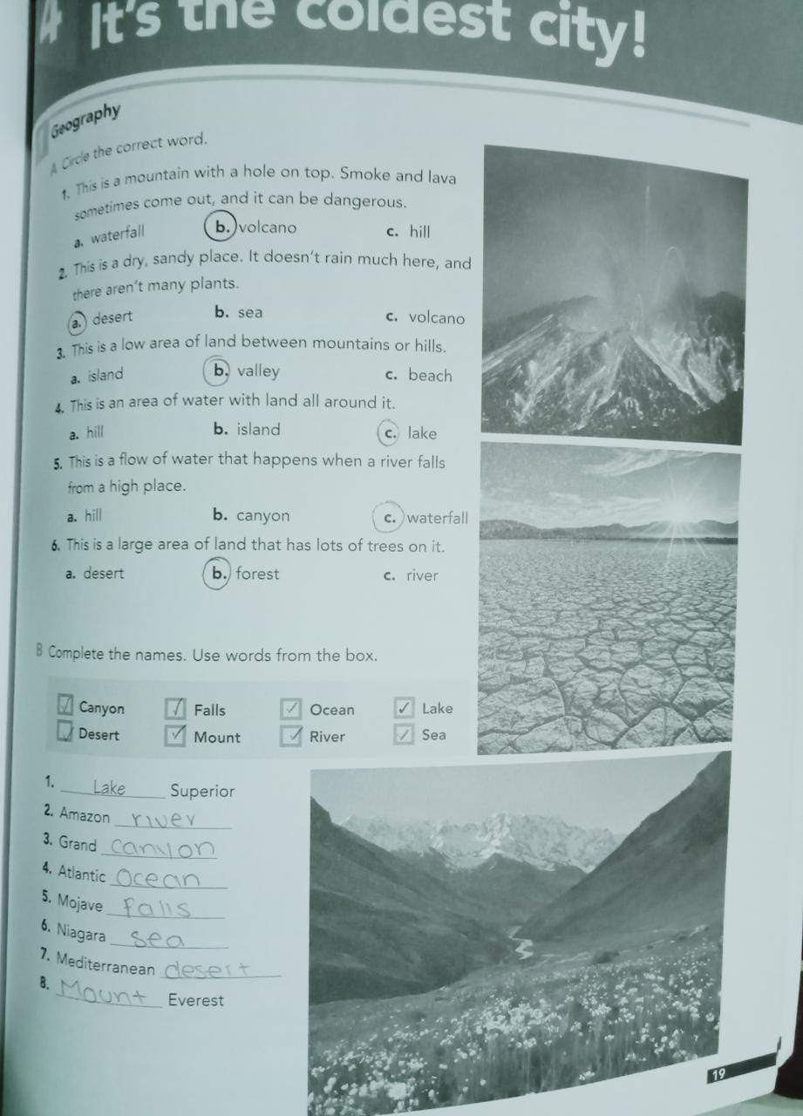

**TASK 4 – CAMBRIDGE PLATFORM**

Log in theCambridge Platform and complete theAssignment 7 (2 vocabularyexercises)

**NOTA: EN CASO DE NO HABER TERMINADO EL ASSIGNMENT 6, FAVOR DE REALIZARLO PUESTO QUE SE CIERRA EL DÍA DE HOY.**