ESCUELA NORMAL DE EDUCACIÓN PREESCOLAR
ENGLISH A2.2
Carolina Estefanía Herrera Rodríguez
UNIT 4 – VOCABULARY
DECEMBER 6TH, 2021

TASK 1 – STUDENT’S BOOK

Open your student’s book in the first page of unit 4 and match the words from the list to the letters in the pictures.

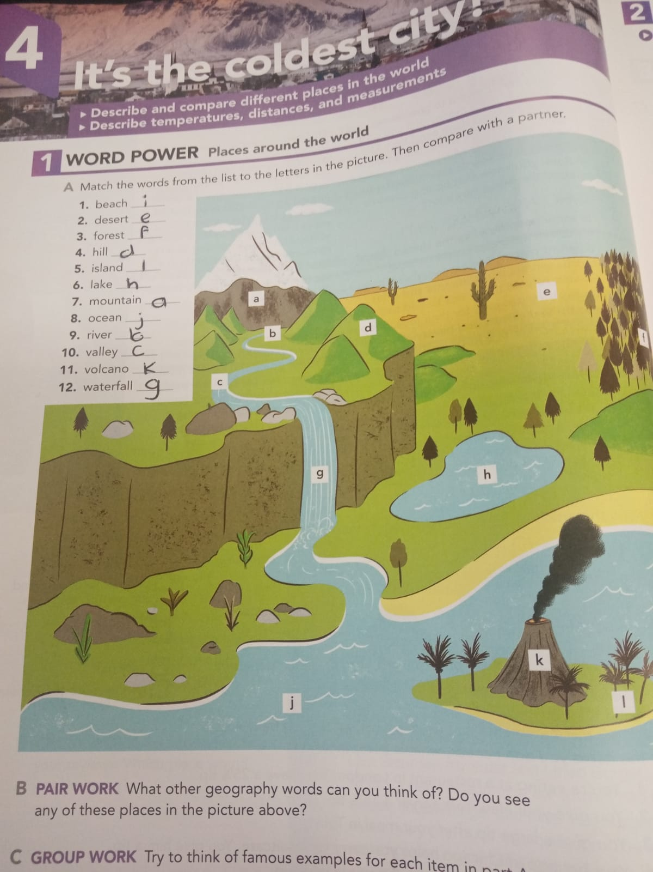

TASK 2 – VOCABULARY LOG - NOTEBOOK

Copy the words from the list in your notebook and write the name of a famous place in your country or in the world. Check the example.

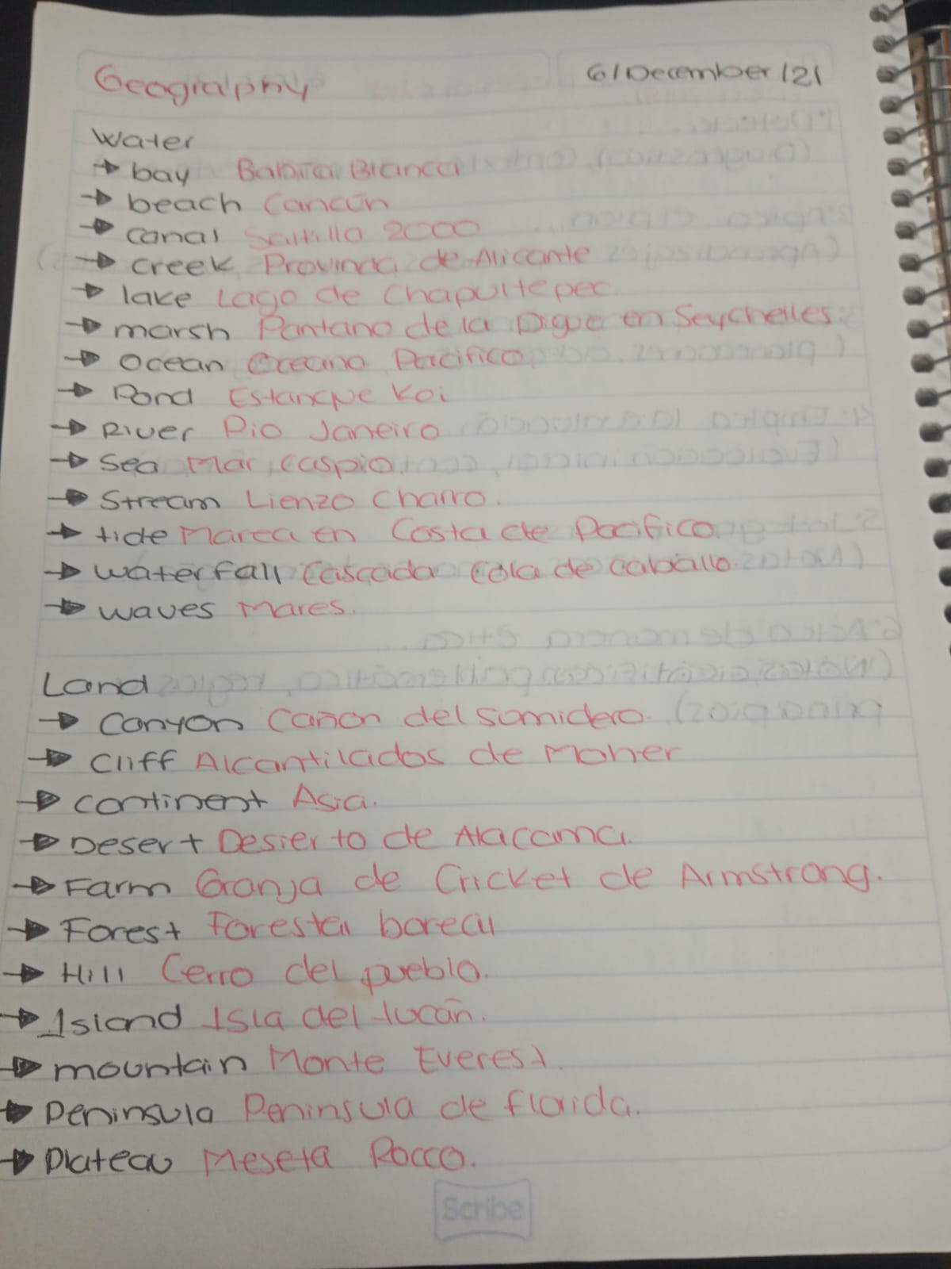
Sumidero

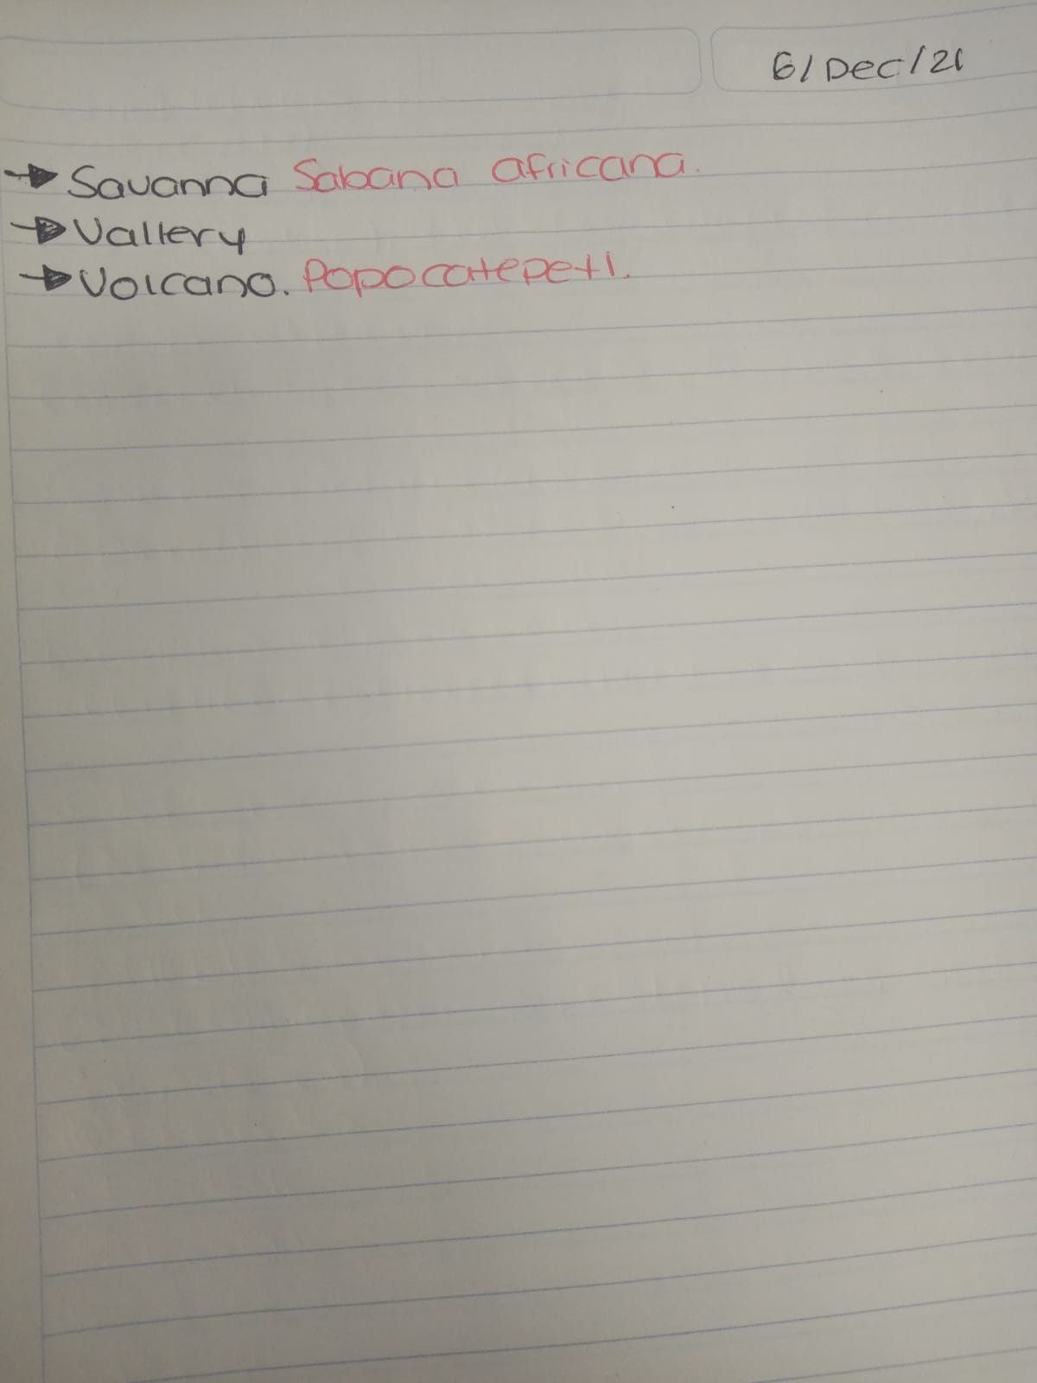

TASK 3 – VIDEO

Go to https://www.youtube.com/watch?v=-wiFx9UgmMo look at the pictures, find the meaning of the words and practice pronunciation.

TASK 4 – WORKBOOK

Open your workbook in the first page of unit 4 and complete exercise 1 parts A and B.

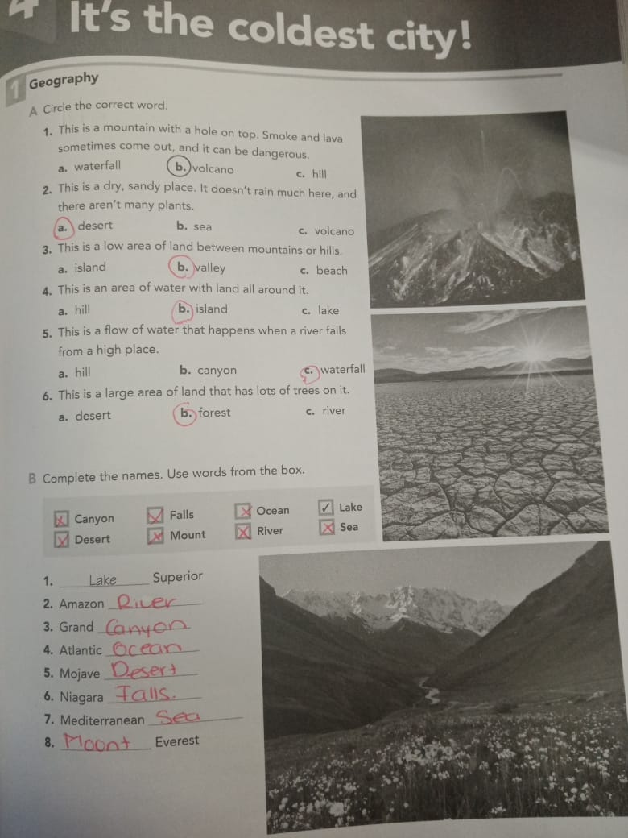

TASK 4 – CAMBRIDGE PLATFORM

Log in the Cambridge Platform and complete the Assignment 7 (2 vocabulary exercises)

NOTA: EN CASO DE NO HABER TERMINADO EL ASSIGNMENT 6, FAVOR DE REALIZARLO PUESTO QUE SE CIERRA EL DÍA DE HOY.

