In this document you will find a video with the answer key to check the answers for the exercises in your student’s book.

<https://drive.google.com/open?id=1e9CRoXNRS_jbXtCWoIwYedQKXJw7OGCl>

Once you have checked and corrected your answers, take pictures of the activities in your book and paste them in THIS document .

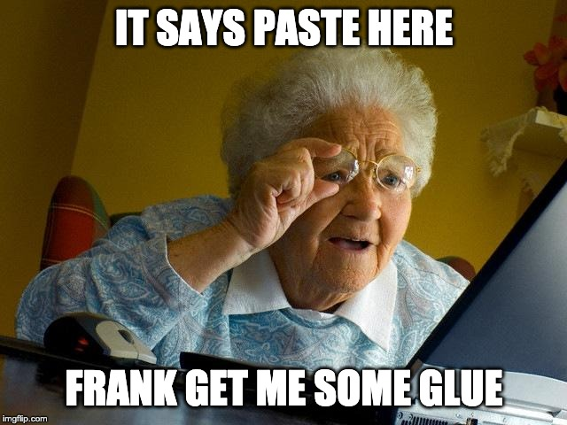

FOR A NICE SURPRISE CLICK HERE!!

<https://drive.google.com/open?id=1NTzhE9MUzYzD0NyM5QE_J8mhoZRmv8j8>