**ESCUELA NORMAL DE EDUCACIÓN PREESCOLAR**

**ENGLISH B1.1.2 BECOMMING INDEPENDENT COMMUNICATORS**

**ONLINE ACTIVITIES - MONDAY, APRIL 20th**

**UNIT 11 – PASSIVE VOICE**

**ACTIVITY 1**

Review the information of your last activity in Escuela en Red, check the video and the Power Point presentation to review grammar.

Change the following sentences into the passive voice.

1. The Greeks built the Parthenon in the fifth century BCE.

    The Parthenon was built by the Greeks in the fifth century BCE.

2. Russia sold Alaska to the United States in the 1860s.

3. Over one million workers constructed the Suez Canal in the 1860s.

4. The U.S. government named Yellowstone a national park in 1872.

5. The French architect Gustave Eiffel designed the Eiffel Tower.

**ACTIVITY 2**

Go to the following link and listen to the audio: <https://www.cambridge.org/files/4414/9745/2967/IC5_TSS_L2U11.mp3>

Complete the following activities.

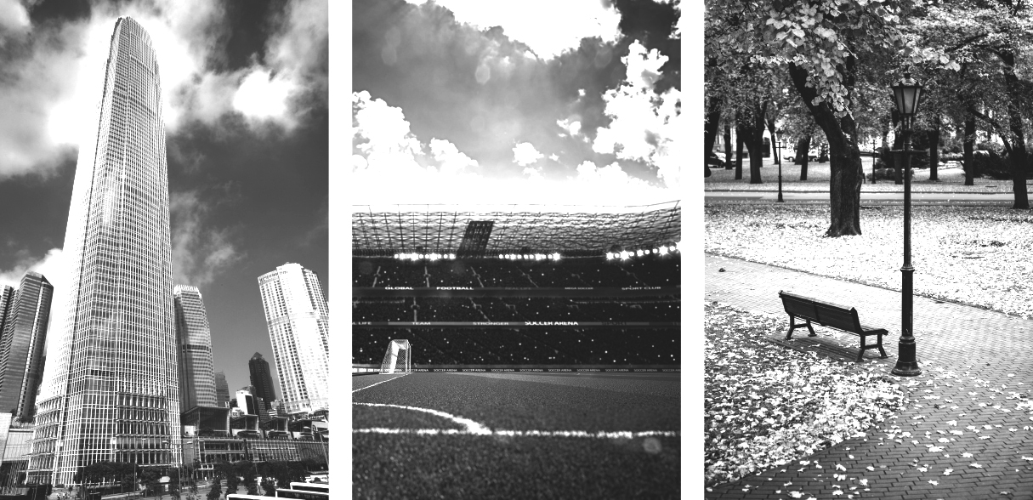

**skyscraper stadium park**

A  Listen to a tour guide talk about the places. Number the pictures   
from 1 to 3.

B  Listen again. Complete the sentences.

1. The place was opened ________________ years ago. It’s a good place to ________________,

________________, ________________, and ________________.

2. This place was finished ________________ years ago. It’s over ________________ stories high.

There’s a ________________ at the top. On a clear day, you can see

for ________________ kilometers or more.

3. This place was opened ________________ years ago. It was built for ________________ and

________________ teams. It can hold over ________________ people.

C Choose four special or interesting places in your city or town.   
Write three features of each place.

**ACTIVITY 3**

Listen to the audio uploaded in Escuela en Red and answer the questions for each monument.

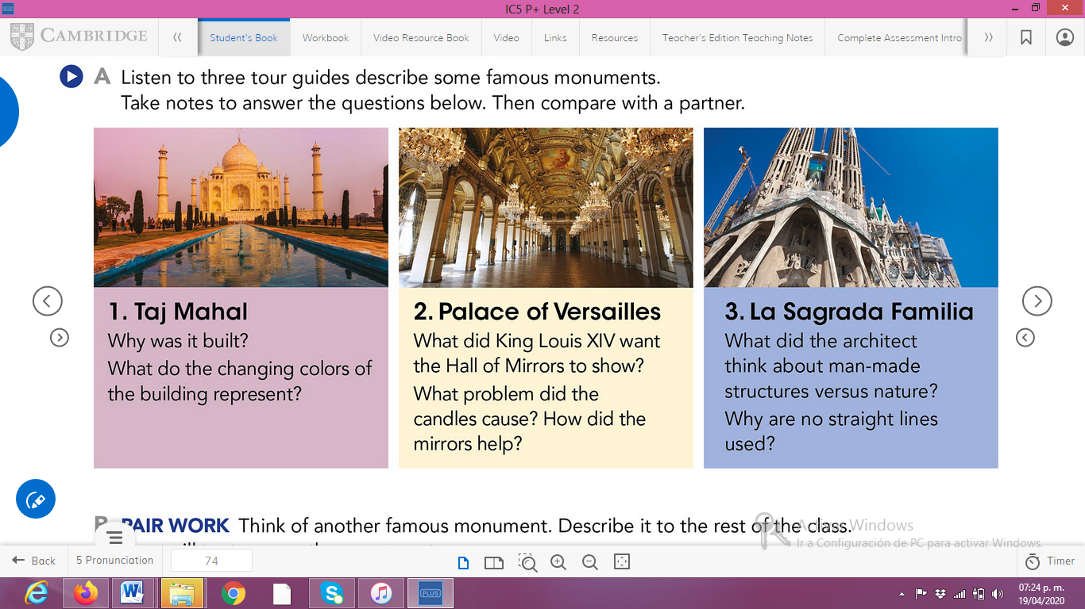

ANSWERS TO THE QUESTIONS:

1. **Taj Mahal**
2. **Palace of Versailles**
3. **La Sagrada Familia**

**ACTIVITY 4**

Write a description of another famous monument using the passive voice. **(50 words minimum)**

[Escriba una cita del documento o el resumen de un punto interesante. Puede situar el cuadro de texto en cualquier lugar del documento. Use la ficha Herramientas de dibujo para cambiar el formato del cuadro de texto de la cita.]