Hello dear students!

In your last activity you learned about vocabulary related to the food we eat. In the following activities you will learn about ***countable and uncountable nouns***, and the use of ***a, an, some and any*** to talk about food.

**COUNTABLE AND UNCOUNTABLE NOUNS**

|  |  |
| --- | --- |
| **COUNTABLE NOUNS** | **These are the nouns that you *can* count.**  You can say:   * 3 bananas * 4 sausages * 2 lemons |
| **UNCOUNTABLE NOUNS** | **These are the nouns that you *cannot* count.**   * Sugar (you don’t say “2 sugars”) * Flour * Bread (you don’t say “3 breads” / you say “3 slices of bread or 3 pieces of bread) |

Go to <https://www.youtube.com/watch?v=1SbJ1B1MTQg&t=68s> and watch the video to learn more and to see more examples about countable and uncountable nouns.

**ACTIVITY 1**

**Complete the chart with countable and uncountable food items from the video.**

|  |  |  |  |
| --- | --- | --- | --- |
| **COUNTABLE NOUNS** | | **UNCOUNTABLE NOUNS** | |
| oranges |  | butter |  |
|  |  |  |  |
|  |  |  |  |
|  |  |  |  |
|  |  |  |  |

USE OF *A*, *AN*, *SOME* AND *ANY*

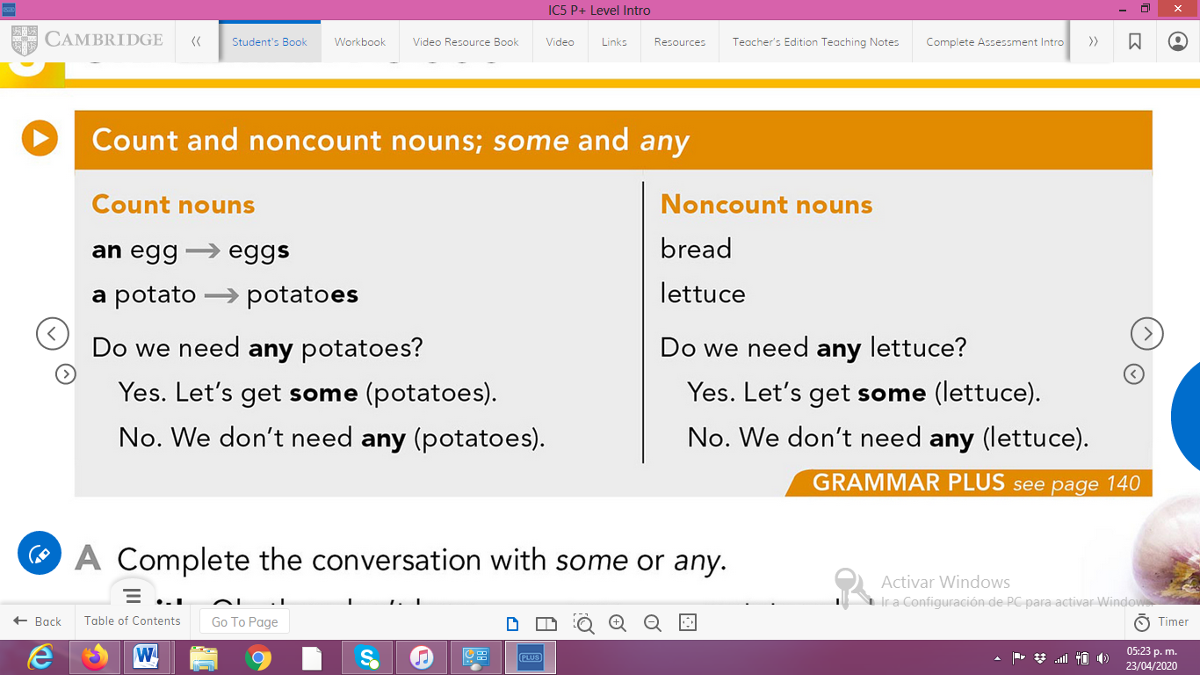

**ACTIVITY 2**

Analyze the examples and complete the sentences with the words in the box.

**some any a an cucumber vowel**

We use ***an*** with nouns beginning in a __________ (a, e, I, o, u). Example: _____ orange.

We use __________ with nouns beginning in a ***consonant***. Example: a __________.

We use __________ with ***countable and uncountable*** nouns in ***affirmative sentences***. Example: I need some bread for my sandwich.

We use __________ with ***countable and uncountable*** nouns in ***negative sentences and in questions***. Example: Do we have any cheese in the refrigerator? / We don’t need any fish to make a cake.

**ACTIVITY 3**

Go to <https://kahoot.it/challenge/03122195?challenge-id=3a17a0cc-a7de-4a91-b9c3-0214c8d1c6b9_1587679184554> and make the challenge.