Dear all,

These phrases and sentences (upssi!) were taken from your “childhood stories” activity

Let’s spot some slips here and improve our writing skills!

**Instructions:**

Spot the mistake in each line.

Read the comment next to each line

Correct the phrases/sentences below

HAVE FUN!!

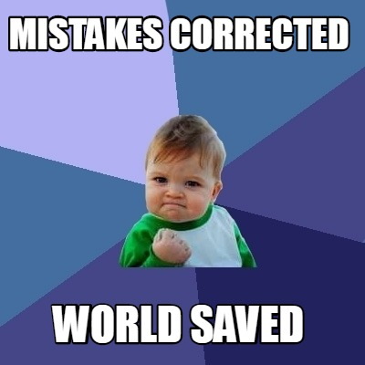

some laughed  at me however, that habit of speaking alone never left her,

My brother and I had a walk in the **bicycles**, but we bored and thought in made stunts.

but don´t found anything

I had many **gifts**

after that, [ ] did not happen again.

my bunny go out and I never saw it

the shoes my mom put on [ ] did not fit me,

we played on the ceiling,

I used the same **uniform**